

Dinosaur Evolution Workshop

Task 1: *Add to this outline of a velociraptor to show what you think it might have looked like*

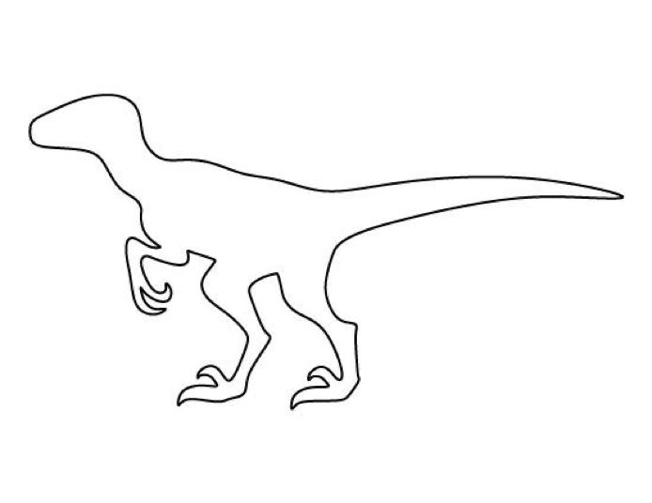

Starting Task: *Look at the pictures of the animals on your table – can you name them?*

Task 2: *Answer these questions whilst watching the YouTube video*

1. What does the presenter say caused the extinction of most of the dinosaurs? When did this happen?

____________________________________________________________________________________

1. How did some of the dinosaurs and other animals survive?

____________________________________________________________________________________

1. Why could the biggest dinosaurs not survive?

____________________________________________________________________________________

____________________________________________________________________________________

1. In which country was this study made?

_______________________________________________

1. What did this study find about how the size of dinosaurs changed after this time?

____________________________________________________________________________________

1. What do scientists now think about dinosaurs and feathers?

____________________________________________________________________________________

1. How might these feathers have been useful for the dinosaurs?

____________________________________________________________________________________

**ind out what this means and draw it here.NA and write/draw it here.ikely to receive if they follow your advice.ng British farme**

Task 3: *Discuss with your table and list any features these dinosaur fossils have that stand out to you*

1. Nodosaurus 2. Sinosauropteryx 3. Archaeopteryx

______________ ______________ ______________

______________ ______________ ______________

______________ ______________ ______________

______________ ______________ ______________

______________ ______________ ______________

Task 5: *Improving your Velociraptor drawing*

Think about the features we have seen that dinosaurs had from these fossils. Go back to your original drawing and improve it to make it more realistic.

In order to show that the new things you have learnt, add some labels to your diagram for the new features that you have added.

Plenary: *In order to show how you have completed the success criteria today, complete the following sections:*

1. What event happened on earth about 62 million years ago in order for the dinosaurs to go extinct?

__________________________________________________________________________________________________________________________________________________________________

1. What features did you add to your dinosaur drawing when improving it? How did you know to add them?

__________________________________________________________________________________________________________________________________________________________________

1. How did you know that Sinosauropteryx and Archaeopteryx are more closely related to each other than they are to Nodosaurus?

_________________________________________________________________________________

1

2

3

Task 4: *where do you think these dinosaurs should go on this tree?*

Remember that the two that you think are most closely related should go

on the tips 2 and 3. What do you think?

Tip 1 =

Tip 2 =

Tip 3 =