

**Title** Differential offer analysis and contextual data evaluation

**Circulation** Teaching and Learning Executive Committee

**From** Stephanie Lee, Head of Widening Participation and Outreach

**Date** December 2019

**Summary** An analysis of differential offers for 2018 and 2019 entry and qualitative feedback on the University’s 2019 contextual offer process.

**Action** For discussion

1. **Differential offer-making analysis**

1.1 The University introduced contextual offer-making for students flagged as WP+ for 2019 entry, reducing offers for eligible students by one grade. Whilst this increased the proportion of WP+ students being made offers (15.9% of CF offer holders were flagged as WP+ in 2019 compared with 14.6% in 2018), it did not made a significant difference to the proportion of WP students being accepted into the University for 2019 entry. Further analysis shows that around 60 more WP+ students could have entered the University if they had been admitted with a further one grade drop. Admitting students with a further two grade drop would have resulted in around 100 more WP+ students being accepted. This additional flexibility would therefore have made substantial progress towards our access target where we need to be admitting an additional 282 students by 2024/25.[1]

1.2 A detailed analysis undertaken by the Planning Office is provided in Appendix 1. This shows that a third of students who were eligible for a one-grade reduced offer achieved these grades. 55% of students achieved grades that were more than one grade below the published typical offer. In terms of acceptances, 96% of CF WP Plus applicants in the 2019 cycle who met or exceeded their contextual offer were admitted (n = 306). Just under half of CF WP Plus applicants in 2019 who missed their contextual offer by one grade (i.e. two grades below the typical minimum offer) were admitted (n = 61).

1.3 The analysis also looked at the acceptance rates of students who have completed the Manchester Access Programme, comparing 2018 and 2019 entry data. Due to the caveats of the data highlighted at the start of appendix 1, the MAP analysis includes 81 students whereas data held by the MAP team shows that 147 MAP students were accepted by the University for 2019 entry[2]. Of the MAP students included in the analysis:

* 39% of CF MAP applicants in met or exceeded their lower offer (reduced by 2 grades), compared to 46% in 2018.
* In 2019, 13% of MAP students met the typical minimum offer for the course (i.e. 2 grades higher than their MAP offer), compared to 19% in 2018.
* 86% of 2019 MAP applicants who met or exceeded their MAP offer (2 grade reduction) are known to have been admitted which is equal to the figure for 2018.
* Only 6% of MAP applicants in 2019 who missed their MAP offer by an additional grade (3 grades below the typical minimum) were admitted, compared to 19% in 2018.

**2. Qualitative feedback on the contextual offer process**

2.1 Alongside analysis of the impact of contextual offers on admissions data, qualitative evaluation with students has been undertaken through a survey and focus groups. The key findings are included below, the full report is available in the APSG section of [SharePoint](https://xorg.manchester.ac.uk/sites/sra/comittees/_layouts/PowerPoint.aspx?PowerPointView=ReadingView&PresentationId=/sites/sra/comittees/Documents/Contextual%20Offer%20Evaluation_SIT_220719.pptx&Source=https%3A%2F%2Fxorg%2Emanchester%2Eac%2Euk%2Fsites%2Fsra%2Fcomittees%2FPages%2FAccess%2Dand%2DParticipation%2DStrategy%2DGroup%2D%2Easpx%3FInitialTabId%3DRibbon%252EDocument%26VisibilityContext%3DWSSTabPersistence&DefaultItemOpen=1&DefaultItemOpen=1)[3].

**Key Findings from the survey and focus groups undertaken with students who were eligible for a contextual offer – includes accepters and decliners.**

**1) What are students’ perceptions of Contextual Offers?**

* The Contextual Offer scheme has been well received and consequently UoM is perceived as Welcoming, Fair and Inclusive – especially among accepters.

**2) What impact do Contextual Offers have on university choice?**

* Receiving a Contextual Offer is often important but not the only factor in a student’s decision on which university to attend.

**3) How can the Contextual Offer process be improved?**

* Drive awareness earlier in the cycle
* Explain what a Contextual Offer is
* Clarify to applicants who is eligible
* Students would have preferred to have been informed about the availability of the contextual offer process via email

**4) Can the Contextual Offer be made more inclusive?**

* Removing the condition that applicants have to firm UoM to be eligible could help attract more high achieving WP students
* Additional support for Care Leavers e.g. greater flexibility in entry requirements

2.2 These findings have been considered by colleagues from the central Student Recruitment, Widening Participation, Admissions and Student Marketing and Communication teams to agreement ways to improve the communication of our contextual offer process. This includes featuring case studies from students who have entered the University via the contextual offer route; harnessing the opportunities through the new CRM system to tailor and segment content; providing contextual offer holders with information about the support they could access once studying here e.g. financial assistance, peer support etc. Input from Faculties will be sought through the Widening Access Working Group.

**Discussion:**

* Do colleagues have any observations on the analysis of offer rates to WP+ and MAP students?
* Is there any additional analysis which would be helpful?
* What implications do the analysis and evaluation have for the contextual offer process for 2020 confirmation and clearing and the future development of the use of contextual data, particularly in light of our APP access target?

*Appendix 1*

**Contextual Offers 2019 Admissions Cycle**

**Cohort**

* Applications in the 2018 and 2019 cycles who held a Conditional Firm or Conditional Insurance Offer
* Applicants who had achieved at least three A*-E grades verified through the ABL exam board data

**Data Caveats**

* This data relates **only** to those applications listed in the cohort above – it does not cover applicants who applied with alternative entry qualifications (e.g. BTEC, International Qualifications)
* Actual offers made to individuals have been assumed based on the published entry requirement data, and do not reflect specific subject requirements (e.g. A in Mathematics).

**Headline Figures**

*Contextual Offers (WP Plus flags)*

* Of the just under 12,000 applications in 2019 in this cohort, 1162 were Conditional Firm offer holders with a WP Plus flag and would therefore have been eligible for the contextual offer (Table 1).
* Assuming that these applicants were made the minimum contextual offer for their course[4], 55% of them missed it by more than one grade (n= 624) and an additional 14% missed it by one grade. This leaves just 31% who met the contextual offer; of which 17% were above the contextual offer and therefore did not need the grade reduction[5] (Figures 1-6).
* 96% of CF WP Plus applicants in the 2019 cycle who met or exceeded their contextual offer are known to have been admitted[6] (n = 306). Just under half of CF WP Plus applicants in 2019 who missed their contextual offer by one grade (i.e. two grades below the typical minimum offer) have also been admitted (n = 61) (Table 2 and Figures 7 and 8).

*MAP*

* Due to the caveats of the data highlighted above, the MAP analysis includes 81 students whereas data held by the MAP team shows that 147 MAP students entered the University in 2019.
* 39% of CF MAP applicants in 2019 met or exceeded their lower offer (reduced by 2 grades), compared to 46% in 2018. In 2019, 13% of MAP students met the typical minimum offer for the course (i.e. 2 grades higher than their MAP offer), compared to 19% in 2018 (Figure 9).
* 86% of 2019 MAP applicants in this cohort who met or exceeded their MAP offer (2 grade reduction) are known to have been admitted[7] - this is equal to the figure for 2018.
* Only 6% of MAP applicants in 2019 who missed their MAP offer by an additional grade (3 grades below the typical minimum) were admitted, compared to 19% in 2018 (Table 3 and Figure 10).

Table 1: Applications by Offer and WP status

Figure 1: Proportion of CF WP Plus applications in 2019 that met or missed their contextual offer

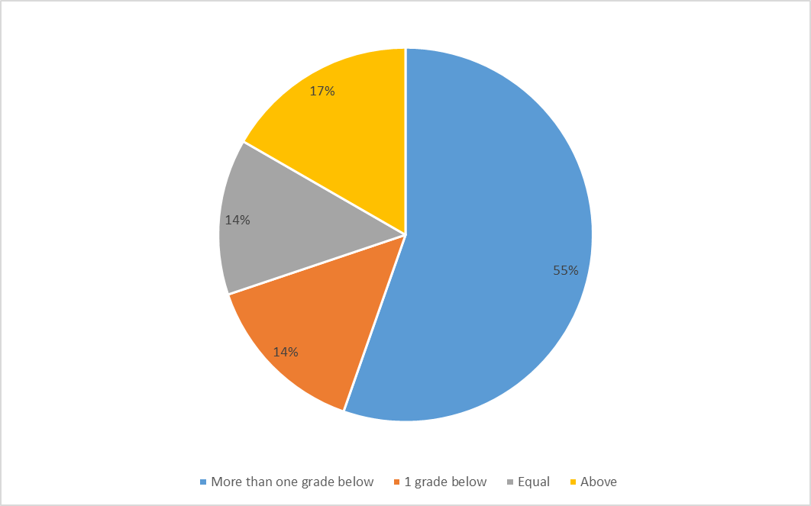

Figure 2: Spread of achieved grades of CF WP Plus applications in 2019 compared to contextual offer

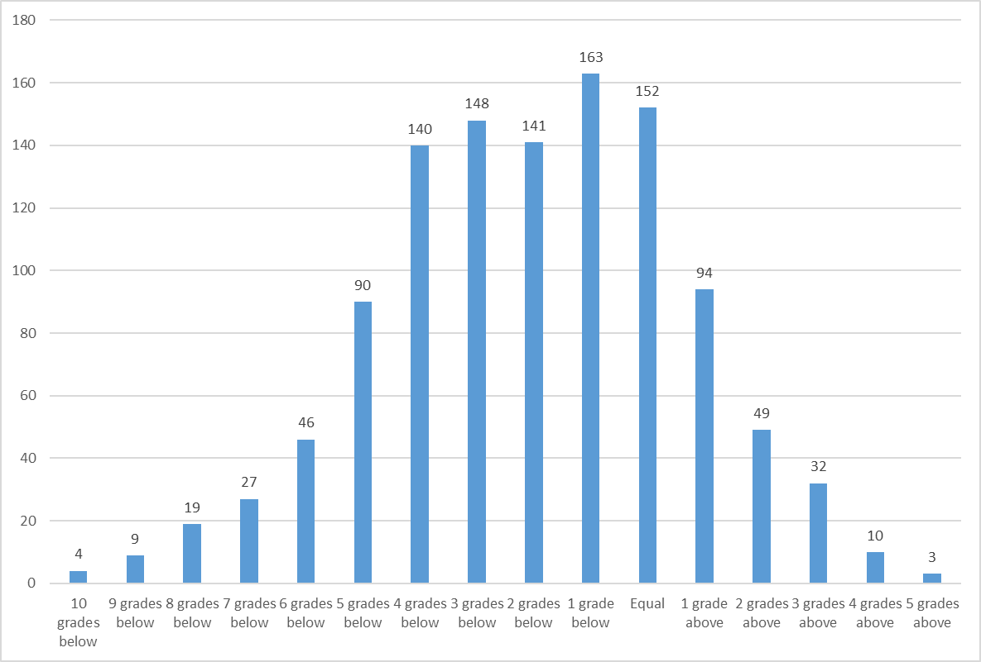

Figure 3: Spread of achieved grades of CF WP Plus applications in 2019 compared to contextual offer – Faculty of Science and Engineering applications only

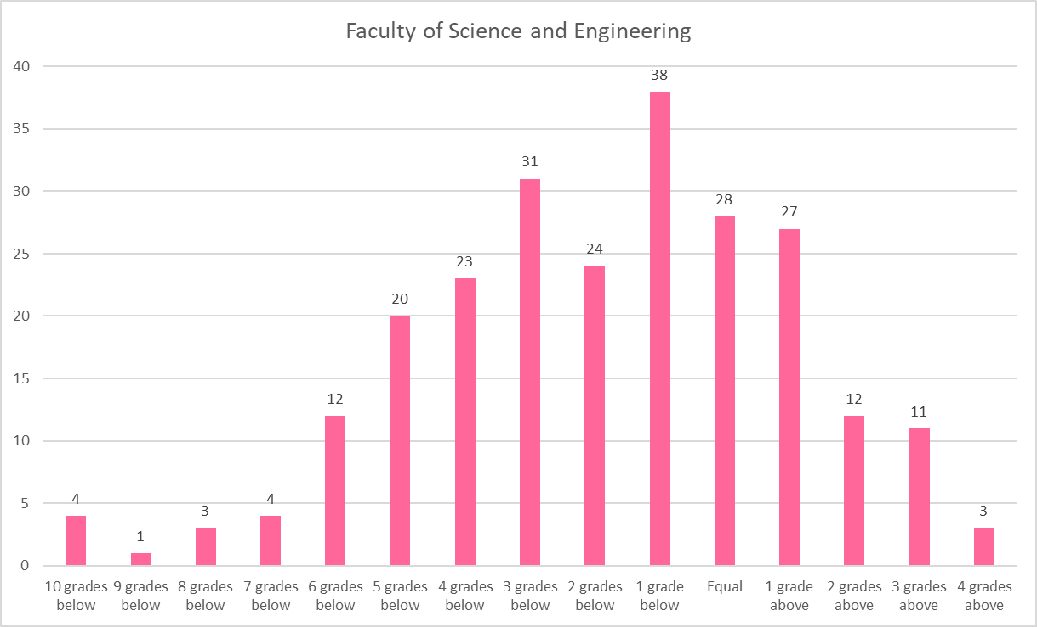

Figure 4: Spread of achieved grades of CF WP Plus applications in 2019 compared to contextual offer – Faculty of Humanities applications only

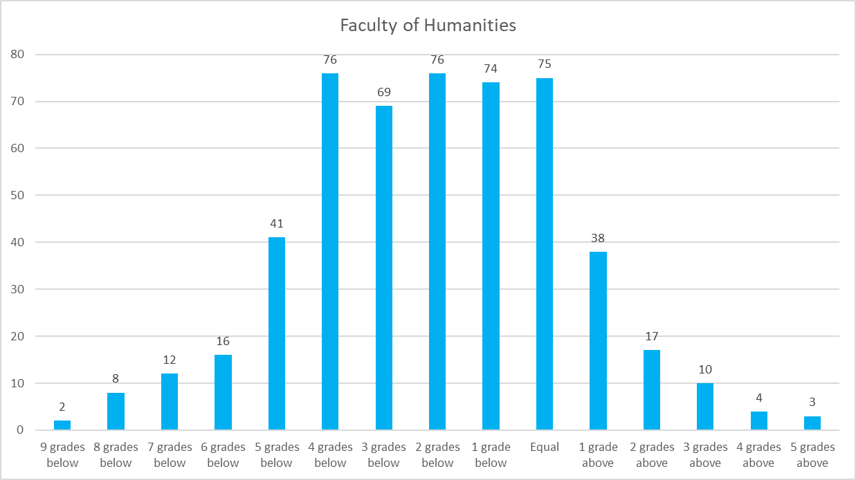

Figure 5: Spread of achieved grades of CF WP Plus applications in 2019 compared to contextual offer – Faculty of Humanities applications only

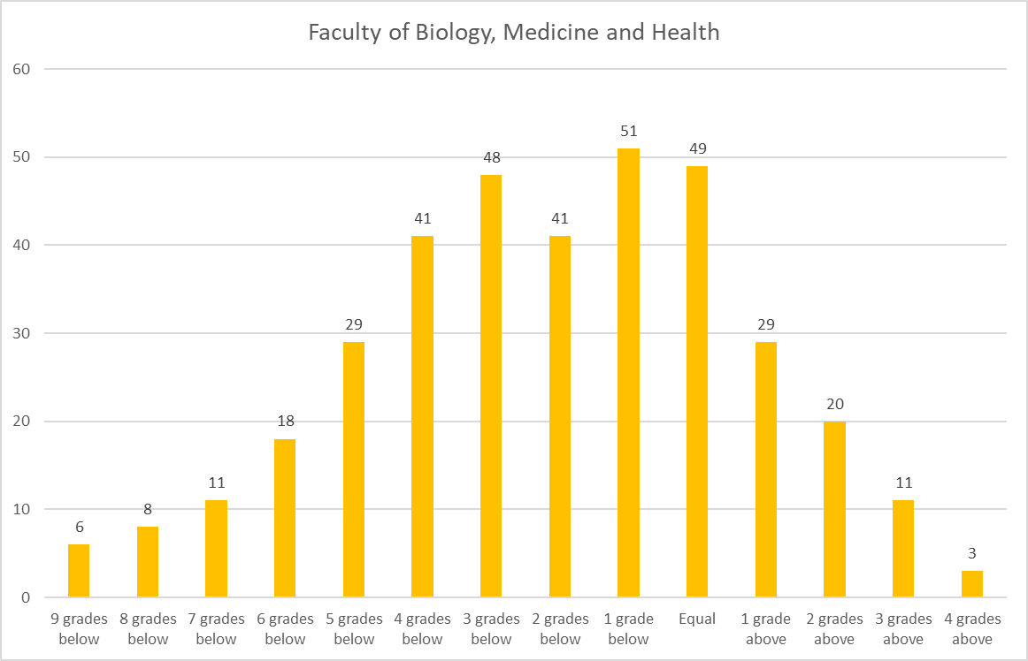

Figure 6: Spread of achieved grades of CF WP Plus applications in 2019 compared to contextual offer – Faculty split, shown as percentage of applications for comparison across Faculties

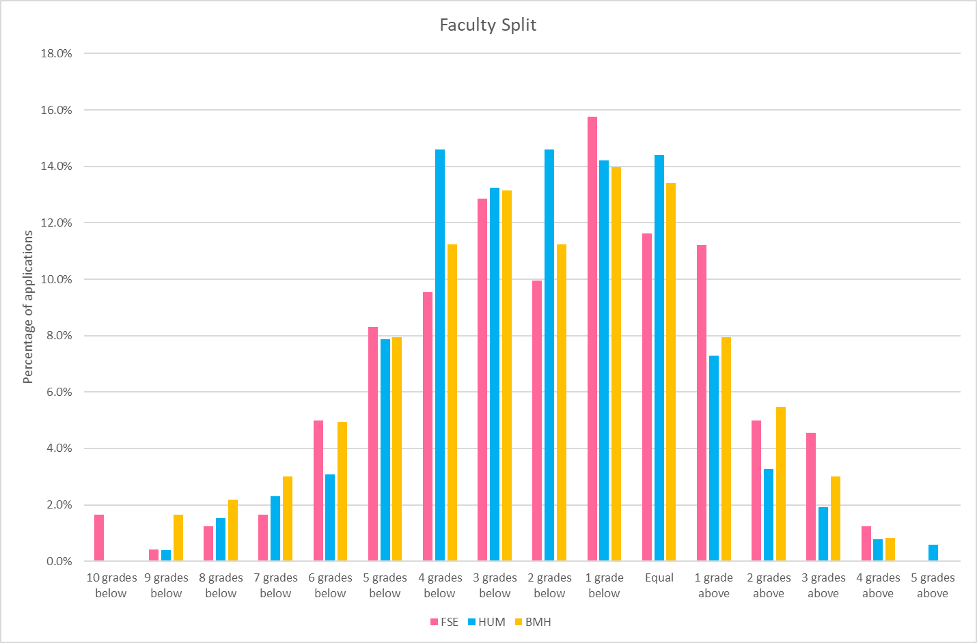

Table 2: Confirmation Decision of CF WP Plus applications in the 2019 cycle



Figure 7: Percentage of CF WP Plus applications in the 2019 cycle that were admitted

Figure 8: Percentage of CF WP Plus applications in the 2019 cycle that were admitted, by Faculty

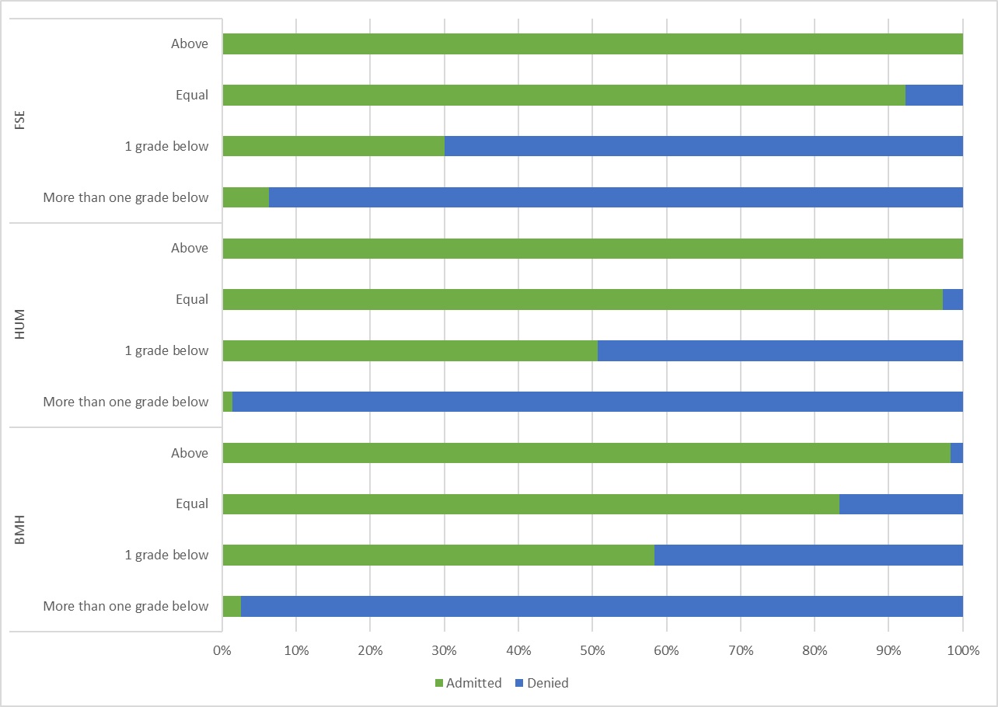

Figure 9: Spread of achieved grades of CF MAP applications in 2018 and 2019 compared to MAP offer (2 grades below typical for course)

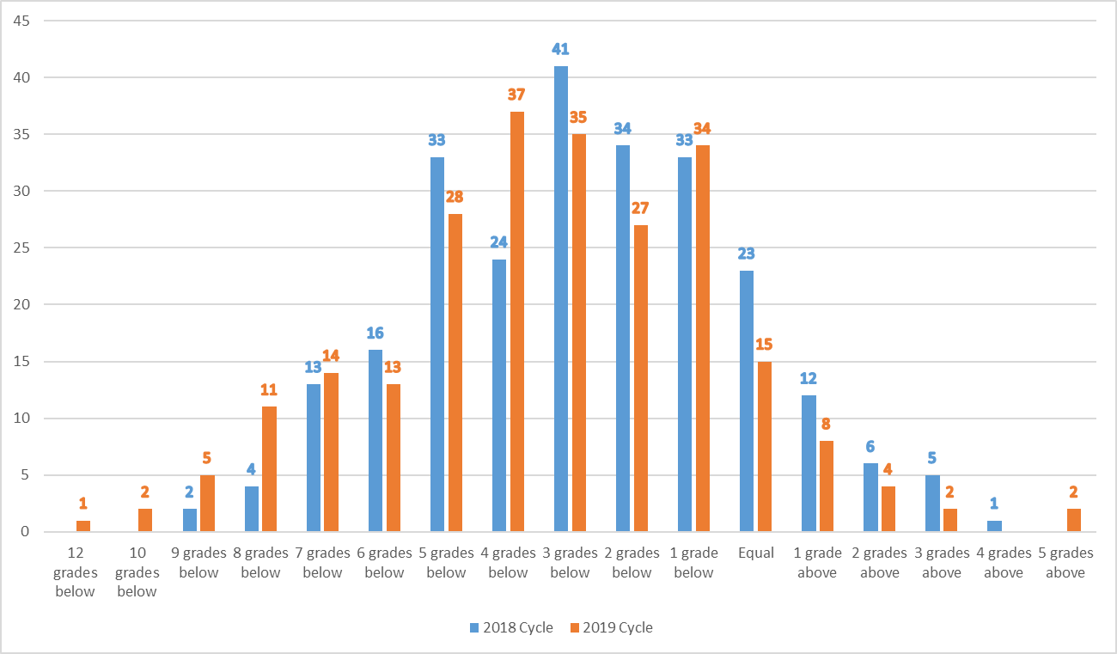

Table 3: Confirmation Decision of CF MAP applications in the 2018 and 2019 cycles



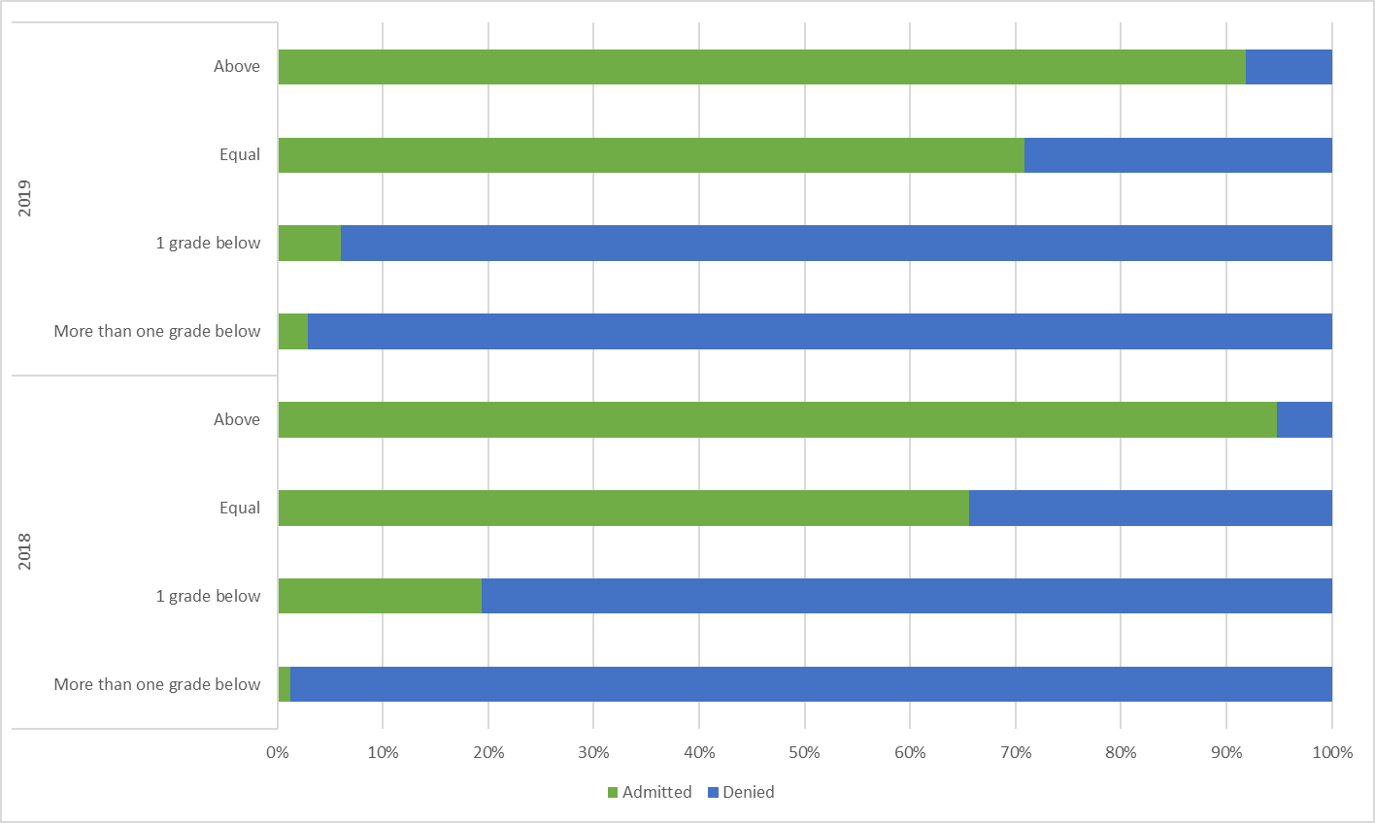Figure 10: Percentage of CF WP Plus applications in the 2018 and 2019 cycles that were admitted

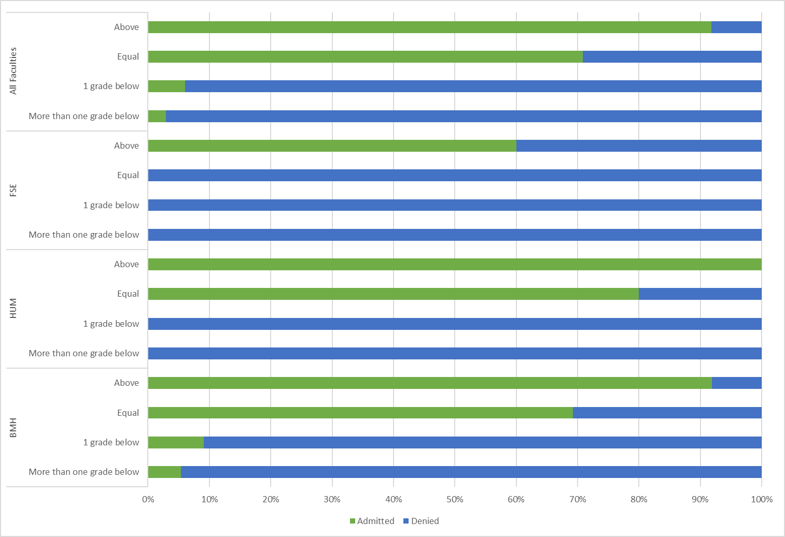Figure 11: Percentage of CF WP Plus applications in the 2019 cycle only that were admitted, by Faculty

*Appendix 2*

Table showing the ratio between advantaged and disadvantaged students by Faculty and School. The table also shows which School are participating in the Manchester Distance Access Scheme (MDAS) and the number of students admitted through MDAS and the Manchester Access Programme (MAP). The table also shows the number of students admitted through School-led access initiatives which operative in the School of Social Sciences.

1. It should be noted that not all the students who are flagged as being eligible for a contextual offer are from POLAR4 quintile 1 as we use an additional geo-demographic indicator called ACORN as part of our contextual data process.
2. An summary of which Schools MAP students were accepted in is provided in appendix 2.
3. If colleagues are unable to access this report and would like to have a copy please contact [Stephanie.lee@manchester.ac.uk](mailto:Stephanie.lee@manchester.ac.uk)
4. We are unable to match this data to actual individual offers made, therefore have matched it to the published typical offers
5. This does not include those applying for Foundation Years where we are unable to match to offer data, and Nurses who were not eligible for contextual offers
6. Admission Status is missing for about 9% of the CF WP Plus applications in this cohort (n=108)
7. Admission Status is missing for about 7% of the 2019 CF MAP cohort (n=16) and 9% of the 2018 cohort (n=23).