**School of Social Sciences Law and Criminology Department**

**Welcome Week September 2019**

**PGR INDUCTION FOR NEW PhD/MPhil STUDENTS**

Thank you for choosing to study your undergraduate degree with our School and a huge welcome to you all. The welcome week activities are designed to give you a better understanding of the degree programme and the options available to you to help you settle in.



On the afternoon of **Monday 16th September** we have organised a [walking tour of Manchester](https://www.visitmanchester.com/things-to-see-and-do/tours-and-sightseeing/walking-tours) for new PhD Students. The tour has a focus on Social Science and is very popular. If you would like to go on this please book your place by emailing [studentsupportpgsoss@manchester.ac.uk](mailto:studentsupportpgsoss@manchester.ac.uk). This is available to you free of charge, starts about 1:30pm and lasts a couple of hours.

**Tuesday 17 September 2019**

|  |  |  |
| --- | --- | --- |
| Time | Event | Location |
| 4:00pm – 6:30pm | **Faculty Induction** (info to follow) | *Whitworth Hall* |

**Wednesday 18 September 2019**

|  |  |  |
| --- | --- | --- |
| Time | Event | Location |
| 9:00am – 9:15am | Collection of **welcome packs** and refreshments | *Williamson Building,*  *room 4.08* |
| 9:15am – 9:30am | **Introduction to the TLSEO PGR Office** – PG Programmes and Student Experience Officer, Myra Knutton and PGR Student Experience Administrator, Jackie Boardman |
| 9:30am – 10:00am | **Expectations session**, led by Programme Director,  Dr Aristea Koukiadaki |
| 10:00am – 11:15am | **Introduction to the BMJ Programme** -  Professor of Medical Law, Nicola Glover-Thomas (*4.07*)  **Introduction to Law Programme** -  Programme Director, Aristea Koukiadaki (*4.08*)  **Introduction to Criminology Programmes** –  Professor of Criminology, Judith Aldridge (*4.59*) |
| 11:15am – 12:15pm | Session with later year PhD students **“life as a research student in the School of Social Sciences”** – and **introduction to PGR administration** |
| 12:15pm – 1:15pm | Buffet Lunch |
| 1:15pm – 1:45pm | **Library Induction** session |
| 1:45pm - 2:45pm | First formal meetings with PhD/MPhil supervisors in the Law and Criminology Department | *Individual Academic Offices* |

**Additional**

We would like to invite you to join our twitter feed [**@PhDSoSS**](https://twitter.com/PhDSoSS) follow us, and we’ll follow back.

**PhD Pop Up Social** – for your diaries. The **last Thursday of every month** (apart from December and possibly August) all PhD students in Social Sciences meet to socialise, network and share experiences in the cafe area of [Humanities Bridgeford Street Building](https://www.manchester.ac.uk/discover/maps/interactive-map/) at 4pm. Drinks and snacks are provided.

**PGR – IND001 PGR HEALTH AND SAFETY INDUCTION MANDATORY MODULE 1**

All new students and staff at the University of Manchester are required to complete a health and safety course. It is delivered online by the University’s Health & Safety Services. The course delivers basic information about how health & safety is managed at the University, and includes some simple tests to assess learning outcomes.

You will automatically be enrolled on this course unit which is delivered through your eProg progression page which can be accessed via <http://my.manchester.ac.uk/>

It will take you approximately 1 hour to complete. You are expected to complete the course and obtain a "pass" within the first two weeks of the formal registration/welcome period (week commencing **Monday 16 September 2019**).

The good news is that you don’t need to wait until you arrive on campus to complete the course. You can complete it once you have registered (On-line registration will be available from **1 September 2019**). We would advise you to complete this unit as soon as you register so that you are free to concentrate on your other induction activities.

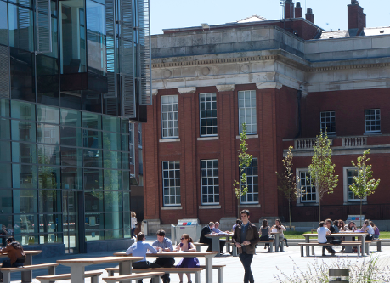

If you have any queries regarding your course, please contact:-

**PGR Student Experience Administrator** [jackie.boardman@manchester.ac.uk](mailto:jackie.boardman@manchester.ac.uk) Tel: + 44 (0) 0161 275 4792

**TLSEO** [tlseo.law@manchester.ac.uk](mailto:tlseo.law@manchester.ac.uk) Tel: +44 (0) 161 306 1260