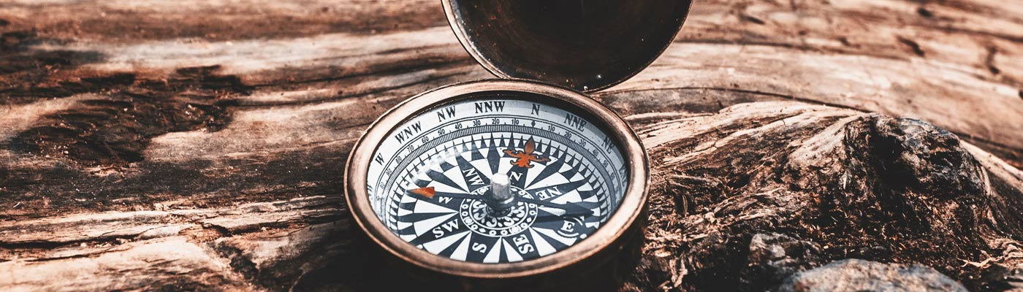

# Where do we go, how do we get there, and what do we do?

An international and virtual  
conference examining society’s  
consumption of recreation and  
leisure

|  |  |
| --- | --- |
| **Conference timetable (draft – subject to change)** | |
| 0800-0915 | Registration and Welcome beverages |
| 0915-0930 | Welcome from the University of Manchester |
| 0930-1030 | Keynotes 1 and 2 |
| 1030-1130 | Parallel session presentations |
| 1130-1145 | Break for refreshments and networking |
| 1145-1245 | Parallel session presentations |
| 1245-1330 | Lunch |
| 1330-1430 | Key notes 3 and 4 |
| 1430-1530 | Conference discussion in working groups |
| 1530-1545 | Conference close |
| 1900 | Conference dinner and awards |