From: Climate Network <climatenetwork@manchester.ac.uk>
Sent: 20 March 2023 15:40
To: CLIMATE-NETWORK@listserv.manchester.ac.uk
Subject: [CLIMATE-NETWORK] Newsletter


Hi everyone J

UoM Climate Network

Our recorded talks are now available on our YouTube channel.

UoM Events

Design and integrity assessment of offshore wind turbine structures
Department of Mechanical, Aerospace and Civil Engineering
21 Mar 2023 – 15:00 - 16:00
https://events.manchester.ac.uk/event/event:bu5-ld7hte7f-bdsyps

PAID EVENT: Eleanor Catton in Conversation
Creative Manchester
21 Mar 2023 – 19:00 - 20:15
https://events.manchester.ac.uk/event/event:uyk-ldswof2j-fashml

NCHS: Nature for Health – Beauty in The Everyday (Photography)
The Whitworth
23 Mar 2023 - 10:30 - 12:30
https://events.manchester.ac.uk/event/event:o16u-lf1hq3a6-xrhxq0

Gardening Can Speak Proper English: Exploring Early Modern Manuals
John Rylands Research Institute and Library
23 Mar 2023 - 12:00 - 12:45
https://events.manchester.ac.uk/event/event:z14u-leptlvo7-28b9iv

The Waste Tip & Introducing the Manchester Digital Strategy 2021-2026: Opportunities and Challenges for an Ethical and Sustainable Digital City
Sustainable Futures
23 Mar 2023 - 14:00 - 15:00
https://events.manchester.ac.uk/event/event:j13f-lemo8plf-3i6mxe

Engineering the Future Conference
Faculty of Science and Engineering
28-29 Mar 2023 – 09:00 - 16:00
https://events.manchester.ac.uk/event/event:l10g-le5mmpzr-uswkb4

Smart cities: what are they and who benefits?
Policy@Manchester
29 Mar 2023 - 13:00 - 14:30
https://events.manchester.ac.uk/event/event:u160-lewso155-4vpr5e

Unequal futures: addressing poverty, health and inequality for young people
Policy@Manchester
30 Mar 2023 - 12:00 - 13:00
https://events.manchester.ac.uk/event/event:j146-leo2dn0y-gn29o7

NCHS: Wildflower Management with City of Trees
The Whitworth
30 Mar 2023 - 12:00 - 14:00
https://events.manchester.ac.uk/event/event:u16r-lf1h8494-pq4ri8

Video Games & Sustainability and Climate Change, Ukraine, Economy
Sustainable Futures
20 Apr 2023 - 14:00 - 15:00
https://events.manchester.ac.uk/event/event:e13g-lemoccgt-97bp2c

Under the Weather: Reimagining mobility in the climate crisis (book launch)
Faculty of Humanities
23 May 2023 – 12:30 - 14:00
https://events.manchester.ac.uk/event/event:fr4-lckf1isd-8pmb0l

• For any sustainable actions you carry out as a staff or student member, you can log them via 50,000 actions webpage can be accessed here.
• UoM’s Environmental Sustainability Team has launched a new microsite to demonstrate how it is addressing UN SDGs here.
• Harriet Bickley has created an Easy Everyday Eco Actions booklet full of practical info to help UoM staff & students live, work & study in a more eco-friendly manner.
• Pooja Kishinani and Marion Smith, students at The University of Manchester, have created a Student Guide to the Climate Crisis centred around three themes: the emotions, basic information, and activist advice of climate change.
• Want Not Waste have recorded their various environmental talks, which you can view on their YouTube channel.

Greater Manchester Events

Birchfield Park Forest Garden work session
Birchfields Park Wildlife and Biodiversity Group
Various Days @ Various Times
https://www.manchesterfoe.org.uk/events/event/birchfield-park-forest-garden-work-session/

Olinda Community Garden volunteering morning
Olinda Community Gardens
Every Tuesday (for the foreseeable future) - 10:00 - 12:30
http://www.manchesterfoe.org.uk/events/event/olinda-community-garden-volunteering-morning/

Gardening and Clean Up
Olinda Community Gardens
First Sunday of every month (for the foreseeable future) starting 1 Jan 2023 - 10:30 - 13:30
https://www.manchesterfoe.org.uk/events/event/gardening-and-clean-up-2/

Stop EACOP documentary – EACOP: a crude reality (#Defund Climate Chaos)
Stop EACOP UK, Defund Climate Chaos and Global Justice Now Youth Manchester
21 Mar 2023 - 18:30 - 20:30
https://www.manchesterfoe.org.uk/events/event/stop-eacop-documentary-eacop-a-crude-reality-defund-climate-chaos/

Station Seed Swap
Station South
23 Mar 2023 - 18:00 - 21:30
https://www.manchesterfoe.org.uk/events/event/station-seed-swap/

Carbon Co-op AGM and celebration 2023 (includes film screening of ‘The Oil Machine’)
Carbon Co-op
25 Mar 2023 - 10:00 - 15:00
https://www.eventbrite.co.uk/e/carbon-co-op-agm-and-celebration-2023-tickets-562939014747

Wildlife Hedge Plant
Station South
28 Mar 2023 - 16:00 - 18:00
https://www.manchesterfoe.org.uk/events/event/wildlife-hedge-plant-station-south/

Manchester – People, Planet, Pint: Sustainability Meetup
Small99
30 Mar 2023 - 18:00 - 20:00
https://www.manchesterfoe.org.uk/events/event/manchester-people-planet-pint-sustainability-meetup-3/

Bike Friday
Manchester Friends of the Earth
31 Mar 2022 - 08:00 - 09:00
https://www.manchesterfoe.org.uk/events/event/bike-friday-2/

April Social Cycle Ride – Wilmslow Road Corridor and Parks to Fletcher Moss
Manchester Friends of the Earth
6 Apr 2023 - 18:00 - 21:30
https://www.manchesterfoe.org.uk/events/event/april-social-cycle-ride-wilmslow-road-corridor-and-parks-to-fletcher-moss/

Manchester Monthly Meet
Just Stop Oil
6 Apr 2023 - 18:30 - 20:30
https://www.manchesterfoe.org.uk/events/event/manchester-monthly-meet-just-stop-oil/

Of Walking on Thin Ice: A film about walking, family, connections, climate and a better future
Of Walking on Thin Ice
2 May 2023 - TBC
https://ofwalkingonthinice.com/

• There are a number of ways that you can recycle single-use plastics both within Manchester and further afield:

(1) Recycling points for single-use face masks across UoM campus are now available.

(2) Co-op have been running a soft plastics recycling scheme for plastic bags and product wrapping (plastics that can be scrunched and that ‘ping’ back) at their stores. As an aside, yet still very much relevant to sustainability, Co-op are also helping to expand Hubbub’s Community Fridge Network, a programme that can potentially tackle a number of societal ills, including: food waste, food poverty, and social isolation.

(3) Stockport-based Plastic Shed have temporarily stopped taking donations of specific types of plastic lids, soft stretchy plastic packaging, vinyl banners, straws, and plant pots but are creatively recycling and repurposing their existing stock into useful items. They also hold workshops and act as a community space; they share their Merseyway Workshop with a community-focussed design studio called Easy Peel Studios, who also run their own events too.

(4) An organisation called ReWorked partnered with Boots to offer beauty product recycling. They also offer the ability to recycle lateral flow tests / face masks / disposable gloves / visors and many other household items but a recycling box must be purchased from their online shop (starting at £50 for each box, it is likely to be more cost-effective to share boxes in groups/organisations, although, then more boxes will likely need to be purchased).

• Manchester Climate Change Agency recommend 15 actions to take to become a zero carbon city

Other Events

The Earth Convention - The Four Elements: Air
5x15
20 Mar 2023 - 18:00 - 19:00
https://www.eventbrite.co.uk/e/the-earth-convention-the-four-elements-air-tickets-479059498857

Climbing Everest in the name of sustainability
The Beautiful Truth
24 Mar 2023 - 13:00 - 14:00
https://www.eventbrite.co.uk/e/climbing-everest-in-the-name-of-sustainability-tickets-523696699927

Clean Air – the story of the Hebburn Residents Action Group
Friends of the Earth
28 Mar 2023 - 13:00 - 14:00
https://www.manchesterfoe.org.uk/events/event/clean-air-the-story-of-the-hebburn-residents-action-group/

Sustainability in the research and innovation endeavour
The Royal Society
16-17 May 2023 - 09:00 - 17:00
https://www.eventbrite.co.uk/e/sustainability-in-the-research-and-innovation-endeavour-tickets-511610991247

• Dr. Emily Heath of Scientists for Global Responsibility has shared 9 tips to encourage a culture of climate activism in universities.
• In Spring 2022, the Department for Education (DfE) released a new policy paper entitled ‘Sustainability and climate change: a strategy for the education and children’s services systems’, setting out key goals such as the introduction of a Natural History GCSE, a National Education Nature Park (NENP), a Climate Leaders Award (CLA), and a National Climate Education Action Plan (NCEAP). MMU are champions of the NENP and CLA, whereas The University of Reading will lead the implementation of the NCEAP.
• Do you own land (or know of potentially suitable land) for tree planting? Fill in this form and let the people behind TreeApp know.
• UCL’s Generation One collective have created their own Climate Podcast.
• The new Sustainable Futures careers course, targeted at teenagers (14-18y.o.), has been developed by WWF-UK in an attempt to bolster the next generation with a greater awareness of sustainability as they decide upon their future careers.
• The Garden offers a wide array of talks on a wide range of topics, many of which are relevant to environmental sustainability.
• Kudos an online tool for improving research impact, has recently created a climate change knowledge cooperative to aid the sharing of the latest climate change research in a non-technical / comprehensible format.
• A better future for our woodlands: 12 ideas to help British forests grow
• Downloading the MyWorld app (formerly MyTrees website) on a smartphone provides an assortment of ways to tackle climate change, you can track and record your everyday eco-actions as well as making real world impact and earn ‘Karma coins’ as a reward, then link your bank account and start earning or exchange your coins for green perks.
• Downloading the long-awaited Tred app on a smartphone could potentially provide you with a tree-planting credit card that allows you to track the carbon footprint of your spending, gain discounts on eco-friendly products, and earn rewards for engaging in environmentally beneficial actions.
• Downloading the WeAre8 app on a smartphone affords you with a way of tackling eight different themes of societal issues: climate, peace, education, health, animals, poverty, water, and equality. WeAre8 is essentially an ethically oriented advertising platform – the video on the WeAre8 manifesto webpage mentions that for every 1 minute of advertising you watch you will receive £0.15 and charities will receive £0.01, although it seems that these figures may vary.
• Downloading the GreenLife app on a smartphone provides you with daily tips to help you on your journey towards sustainable living and carbon neutrality; the website also provides a handy countdown to around 2028, seemingly the year by which they hope to achieve net zero emissions.
• Downloading the Buddlet app on a smartphone allows you to improve the sustainability of your lifestyle by choosing from a range of eco-friendly swaps to your ordinary activities/purchases. The app was scheduled to launch on 27 August 2021, currently only available via Apple devices.
• Downloading the Skoot app on a smartphone instantly plants 5 trees for free (and every friend referral also generates 5 additional planted trees for free), and then every journey, thereafter, that you make will be converted into 1 free planted tree. It seems like they may change their model when they reach 1 million trees, due to the mention of the ‘1 million free tree challenge’ on their website, but for now it’s worth using.
• Downloading the Treekly app on a smartphone allows you to plant 1 tree each week for free (seemingly in Madagascar); by tracking your footsteps, using either your phone’s built-in pedometer or a fitness tracker/smartwatch, you can convert your 25,000 steps per week [5,000 each day for 5 days] into the planting of a tree.
• Downloading the TreeApp app on a smartphone allows you to plant a tree for free, in an area that it’s needed e.g. often in the Global South, every single day (up to a daily limit of trees available – you’ll know when the limit has been reached as it prevents you from planting)
• Whilst it still seems to be in the early stages of uptake, AllotMe – marketed as the ‘Airbnb for your Garden’ sounds like a great concept – whereby individuals can rent spaces to grow food within major cities/urban environments, and garden owners can monetise their land.
• Spare 3 minutes to fill in Currensea’s Sustainability survey and each completed survey removes 100 plastic bottles from the oceans (thanks to their Plastic Bank partnership).
• A CO2 widget created to communicate daily levels of CO2 by Matthew Shribman, his colleagues, and University of Cambridge / Cambridge Zero. There is also the Climate Action Tracker (CAT) that can be used to keep track of global climate action.
• Some suggested climate actions have been listed by Ecologi on their It’s Time website.
• Really useful links to organisations who are promoting circular economy initiatives; besides many organisations will now offer their own in-house recycling schemes, as is the case for Google Devices; yet there are many other organisations, like Music Magpie and Mazuma Mobile, that will pay you for items that you trade in.
• Please take a look at the Students Organising for Sustainability UK (SOS-UK) website as well as two current campaigns they are running:
1. Invest for Change
2. Carbon Targets

Social Media

You can now connect to the Climate Network on:
1. Facebook
2. Yammer

How To Subscribe To Us

Feel free to forward this newsletter on, but also please pay a visit to our website below (where you can subscribe to our mailing list, take look at our events calendar, and see a sample of the environmental groups affiliated with UoM):

https://climatenetwork.uk/universityofmanchester/

-------------------------------------------------------------------------------------------------------

Recent Good News (locally and nationally)

UoM has markedly reduced the carbon intensity of its endowment investment portfolio: https://www.staffnet.manchester.ac.uk/news/display/?id=29542

A new book has been published by UCL academics, centred around climate politics: https://twitter.com/KeriFacer/status/1635585680737697792

Protesters from both Wales and England, via a Christian Climate Action event, have called on the Diocese of Shrewsbury to divest from fossil fuels: https://twitter.com/fossilfreeshrop/status/1632453115885527043

-------------------------------------------------------------------------------------------------------

Volunteering Opportunities

Depending upon what you would like to get involved in, there’s plenty of choice when it comes to eco-volunteering:

• UoM People & Planet are looking for committed students to assist with its campaigning activities, a successful example of which has been its Fossil Free Campaign. They can be contacted via email peopleandplanetmcr@gmail.com and have an active Facebook community.
• UoM’s Students’ Union offers a range of options for students to support the local community, including via various sustainability projects (such as those listed by the ‘Student Action’ group): https://manchesterstudentsunion.com/volunteering-and-fundraising
• Plastic Shed in Stockport are looking for marketing assistants, graphic & website designers, photography & filmmaking content creators, business advisors, social & environmental impact analysts, fundraising advisors, volunteer coordinators, shop volunteers, workshop volunteers, and plastic recycling volunteers. If interested, get in touch with Caitlin (Co-Director): caitlin@plasticshed.org
• Cracking Good Food, a not-for-profit social enterprise, are looking for volunteers, mainly around the Stockport area, to help them in their goal to encourage and support more people to cook affordable, seasonal, and nutritious homemade food from scratch.
• The Kindling Trust offers regular hands-on agricultural volunteering at both its Woodbank Community Food Hub (Offerton) and Agroforestry Tree Nursery (Glazebury): https://kindling.org.uk/Calendar?field_event_type_target_id=7
• Manchester Friends of the Earth Manchester can be supported in a number of ways, from campaigning to officer roles – you could join the Young FOE Manchester or help the communications team: https://www.manchesterfoe.org.uk/current-volunteering-opportunities/
• Manchester Greenpeace support Greenpeace campaigns in the local area; there are wide range of activities that they get involved in as a local Greenpeace group.
• City of Trees want to hear from everyone – whether you’re a green guru, an eager novice, or just fancy helping out occasionally at some tree planting or orchard creation: https://www.cityoftrees.org.uk/volunteer
• Sow The City are in regular need of help in a variety of ways, including: constructing or maintaining community gardens and planting fruit and vegetables: https://www.sowthecity.org/jobs%20and%20volunteering.htm
-------------------------------------------------------------------------------------------------------

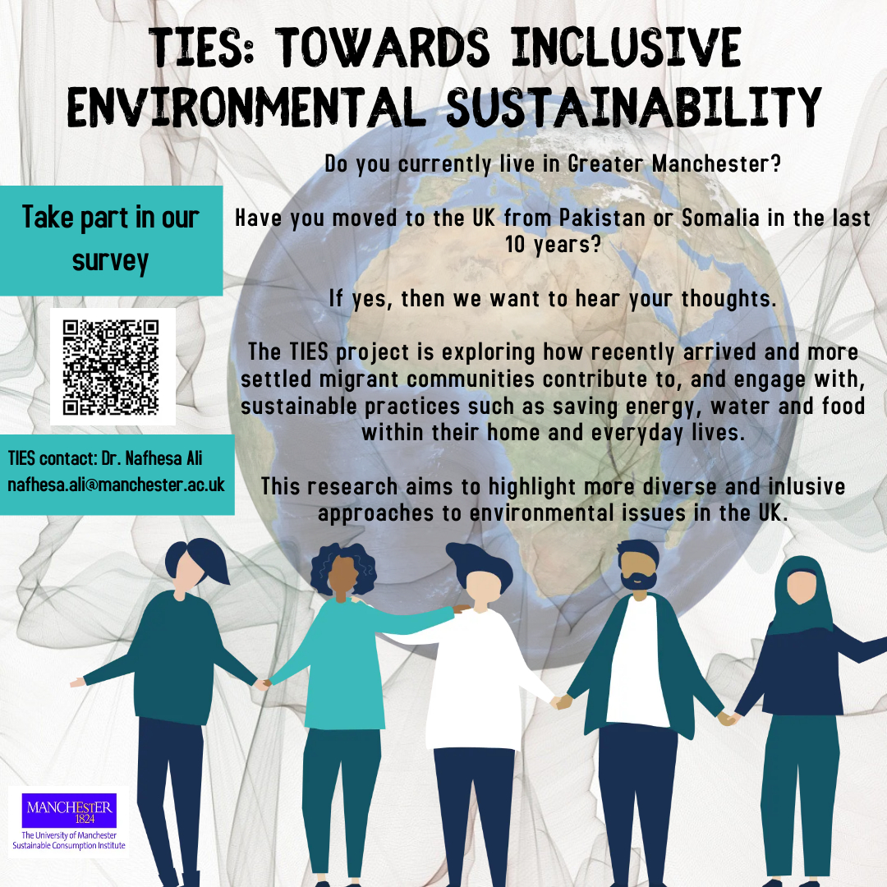

Here’s the link in case the QR doesn’t work (below).
-------------------------------------------------------------------------------------------------------
The Climate and Ecological Emergency (CEE) Bill

118 MPs are now supporting the CEE Bill, tabled by Caroline Lucas MP, across all nations of the UK

Parliament declared a Climate Emergency back in 2019 – but actions haven’t matched their words. An emergency requires strong, decisive action to reverse the climate and ecological crisis … Enter the CEE Bill.

The Bill requires the UK to take responsibility for its fair share of greenhouse gas emissions, to actively restore biodiverse habitats, and to stop damaging our natural world through the production, transportation and disposal of the goods we consume.

You can pledge your support for the CEE Bill as an individual here: https://www.ceebill.uk/sign-up
-------------------------------------------------------------------------------------------------------
The Co-operative Party’s Petition to Ban Bee-Killing Pesticides

Close the loophole on bee-killing pesticides

Earlier this year, when the Government announced it would use a loophole to temporarily allow the “emergency” use of banned bee-killing pesticides by sugar farmers, the Co-operative Party fought until the Government reversed its decision.

The Government has already said they “anticipate” that the emergency authorisations loophole – which allows bee-killing pesticides to be used – may be “needed” again in 2022 and 2023.

Please sign the Co-operative Party’s Petition here to protect our bees: https://party.coop/bees
-------------------------------------------------------------------------------------------------------
The 6R Sustainability Approach

- Follow the 6R protocol to manage plastics sustainably at home and on campus or in the labs

- These UoM videos and texts can answer all your questions about recycling (plastics and other items)
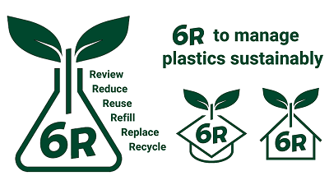
Best wishes
The UoM Climate Network
The CLIMATE-NETWORK list is archived at: http://listserv.manchester.ac.uk/cgi-bin/wa?A0=CLIMATE-NETWORK

