1. **Peaks and troughs in bookings throughout the year**

Between the launch of the Library’s study space bookings system on Monday 27th July 2020 and the closure of bookings on Friday 11th June 2021 at the end of semester two, over **16,800** people made over **508,000** bookings for a study space at one of our library spaces. There were predictable peaks in November and in a very busy May. The final week of the Christmas break and the final week of the Easter break saw high numbers of bookings.

*Figure 1* The number of bookings by day between 27th July 2020 and 11th June 2021

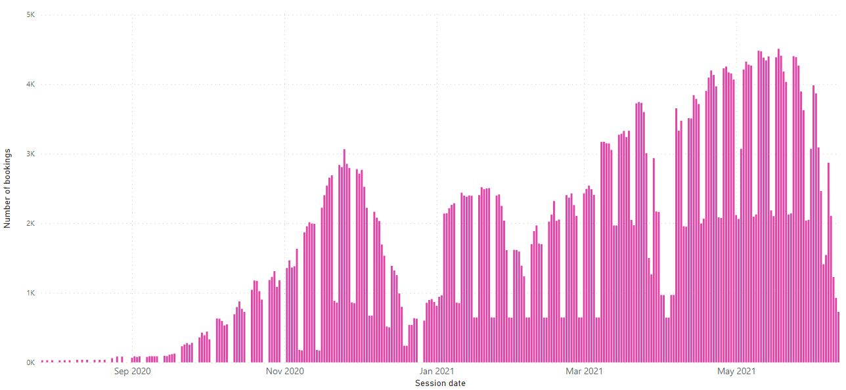

Semester 2 starts (8th Feb)

Most bookings in a day: Tues 18th May

Easter break (29th March to 11th April)

Christmas break (21st Dec to 10th Jan)

Wed 25th Nov (Nov peak)

**Data source and notes:** study space bookings data is from the *Study Space Bookings* Power BI report on the [Library Planning app](https://app.powerbi.com/Redirect?action=OpenApp&appId=0411bfda-ad88-43b0-a7e0-86b3cdf9bca3&ctid=c152cb07-614e-4abb-818a-f035cfa91a77) which takes data from the LibApps booking system. These numbers represent bookings rather than attendances – according to our attendance data many of these bookings were not used.

1. **Bookings by school and by academic level (year group)**

This tree map shows the number of bookings grouped largest to smallest by school and then, within each school, by academic level (year group). For instance, students from the School of Social Sciences made more bookings than any other school and, within that school, third year students made more bookings than any other group.

*Figure 2* Tree map of booking numbers by school and by academic level

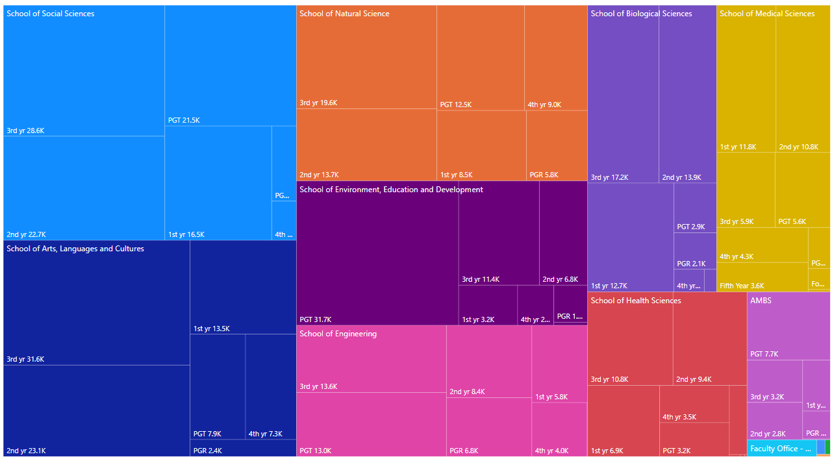

**Data source and notes:** study space bookings data is from the *Study Space Bookings* Power BI report on the [Library Planning app](https://app.powerbi.com/Redirect?action=OpenApp&appId=0411bfda-ad88-43b0-a7e0-86b3cdf9bca3&ctid=c152cb07-614e-4abb-818a-f035cfa91a77) which takes data from the LibApps booking system. These numbers represent bookings rather than attendances. To compare this data with the number of students in each school, visit the *Student Numbers by Organisation* report in the [Library Planning app](https://app.powerbi.com/Redirect?action=OpenApp&appId=0411bfda-ad88-43b0-a7e0-86b3cdf9bca3&ctid=c152cb07-614e-4abb-818a-f035cfa91a77).

1. **Bookings by school and by library**

There are some differences between schools in the booking patterns of students for sessions at our various libraries. For instance, students from the School of Engineering booked roughly the same number of sessions at AGLC as at Main Library, whereas students from SALC and SoSS booked far more sessions at Main Library than at AGLC.

*Figure 3* The number of bookings by school and by library

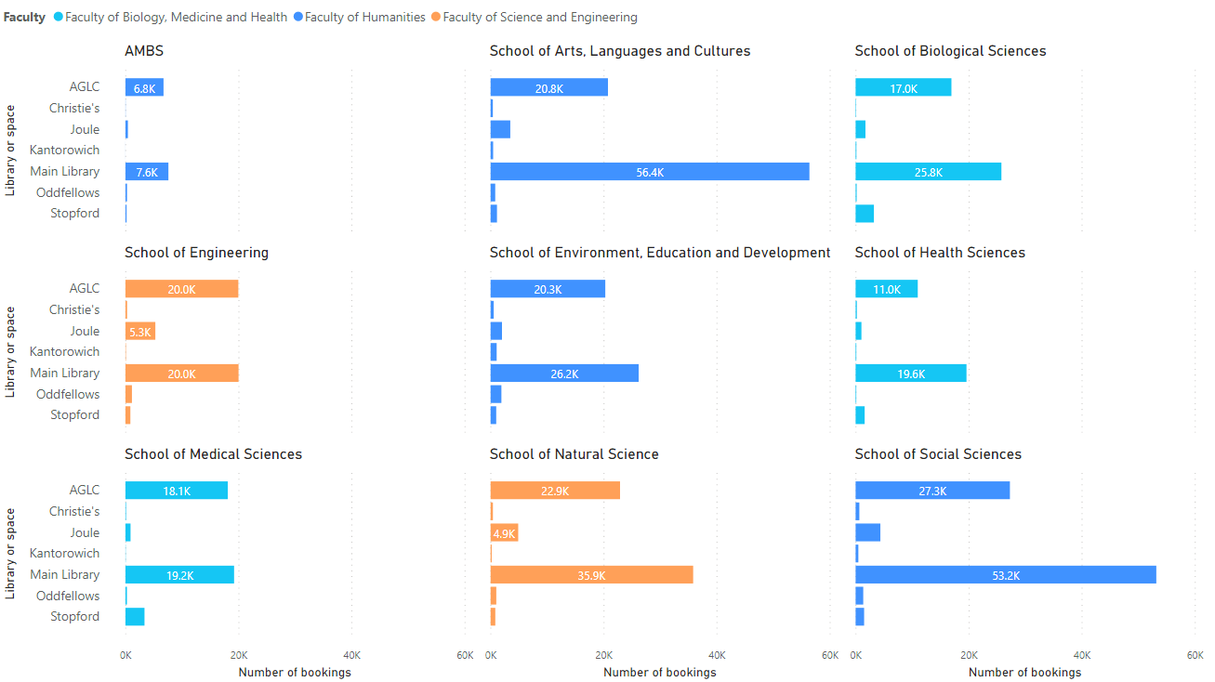

**Notes for figure 3:** (1) The charts exclude the following libraries because of their small numbers of bookings: Main Library Learning and AGLC Learning (the former group study rooms repurposed for individual use) and the online library study sessions. (2) The following schools or organisations were excluded because of their small numbers of bookings: the Directorate for the Student Experience, the Cancer Research UK Manchester Institute and the FSE Faculty Office.