**Self-certification and Mitigating Circumstances in light of COVID-19**

Contents

**1.** **Introduction** 1

**2.** **University key principles** 1

**3.** **What are we doing to check marks (including mitigating the impact of COVID-19 and Industrial Action)?** 2

**4.** **Self-Certification** 2

**5.** **Mitigating Circumstances** 3

**5.1.** **Ill health has prevented a student from engaging with assessment** 3

**5.1.1.** **Extensions** 3

**5.1.2.** **First sit opportunities** 4

**5.2.** **Students who have not been able to access learning materials** 4

**5.3.** **Evidence** 4

**Appendix 1: Applying Mitigation** 6

**Appendix 2: Student FAQs (from University of Manchester webpages)** 8

This document should be read alongside the

* [Humanities No Disadvantage Policy](https://www.staffnet.manchester.ac.uk/humanities/teaching-support/elearning/coronavirus/assessment-guidelines/)
* [Calculating your baseline mark](https://www.staffnet.manchester.ac.uk/humanities/teaching-support/elearning/coronavirus/assessment-guidelines/)
* [University of Manchester Mitigating Circumstances Policy](http://documents.manchester.ac.uk/display.aspx?DocID=4271)
* [University of Manchester Self Certification of Illness](https://www.staffnet.manchester.ac.uk/tlso/policy-guidance/assessment/reaching-decisions-from-assessment/self-certification/)
* [Mitigating Circumstances relating to COVID-19 March 2020](https://www.staffnet.manchester.ac.uk/tlso/policy-guidance/assessment/reaching-decisions-from-assessment/mitigating-circumstances/)

# **Introduction**

This document outlines the arrangements for implementing the ‘self-certification’ and ‘mitigating circumstances’ policies in Humanities during the COVID-19 outbreak. Like the other amendments to policies, we are mindful of the key principles of the University in light of the pandemic. This document is intended to provide some guidance to schools as to how they should implement the policies.

# **University key principles**

* We will allow as many students as possible to progress or graduate, subject to continued vigilance on quality and standards.
* We will act in the best interests of our students, ensuring their qualifications stand up to scrutiny in an unusual year, including by employers and accrediting bodies.
* We will conduct all, or virtually all, assessment online during the summer assessment period and resit period, where assessment is necessary at all. There will be no on-campus, closed-book examinations this summer.
* We will provide opportunities for continuing students to engage with online learning during the spring teaching and assessment periods, in order to support their confidence and success in the following year.

# **What are we doing to check marks (including mitigating the impact of COVID-19 and Industrial Action)?**

We have put in place a number of measures prior to the exam period in anticipation of mitigating circumstances applications. These measures are intended to address the mitigating circumstances related to COVID-19. The measures include:

* Open book exams with an extended period for completion
* Introduction of a ‘No Disadvantage’ policy that covers all of semester 2
* Further mitigation will be implemented at course unit/module level during moderation if required
* External Examiners will be asked to review performance for cohorts
* Review of performance in modules by Faculty Exam Boards/Faculty External Examiner
* University Exam Boards/University External Examiner will oversee Faculty Exam Boards

# **Self-Certification**

Students who are prevented from studying for up to and no more than seven calendar days should contact their school or programme administrator and submit a self-certification of illness form.

* Self-Certification of illness covers absence from teaching and learning but not exams or assessment.
* Students who are prevented from completing exams or assessment should complete a mitigating circumstances application.
* Self-certification of illness is a record of illness. The impact is covered by the no disadvantage policy so no further mitigation needs to be put in place.
* Schools should log periods of absence so that they can be followed up with immediate pastoral and/or academic support in 2020/21.

**Self-certification**

* Up to and including 7 days absence from learning and teaching activities
* No medical/supporting documentation required if the period of illness is since the closure of the campus
* Students should contact school via email on first day of absence (or as soon as possible after absence) and submit the self-certification form.

# **Mitigating Circumstances**

* The University defines mitigating circumstances as ‘unforeseeable or unpreventable circumstances that could have, or did have, a significant adverse effect on the academic performance of a student’.
* The adjustments to processes and policies that have been introduced for this academic year are intended to mitigate the impacts of COVID-19.
* Mitigating Circumstances applications are only required where the mitigation required goes significantly beyond that provided for through the No-Disadvantage policy.
* Students will not need mitigation if they have been absent from learning during the period since the outset of the epidemic unless:
  + Ill health prevents a student from engaging with assessment
  + Students have not been able to access learning materials for the whole period of the epidemic.
* Where students submit mitigating circumstances that include ‘multiple’ circumstances (including COVID-19), then schools should review the different elements of their application independently. It is expected that the circumstances related to COVID-19 will normally be mitigated by the No Disadvantage Policy.
* Students cannot submit mitigation for assessments that have already been completed without a credible and compelling explanation as to why the circumstances were not known before the beginning of the assessment period or why the student was unable to complete or submit an application prior to the published date.
* The options available to mitigating circumstances panels are available in Applying Mitigation.

# **Ill health has prevented a student from engaging with assessment**

* If a student has been unable to engage with assessment, then a mitigating circumstances panel may want to consider an Extension or a First sit opportunity.
* For first year students, where there is automatic progression to year 2, Mitigating circumstances panels do not need to offer an extension or a further opportunity to complete the assessment if students are prevented from engaging with assessments.
* Students who fail to engage with the formative assessment/learning in semester 2 or who receive a low mark in the formative assessment will be required to meet (face to face or online) with their Academic Advisor during the first semester of the new academic year to discuss their progress and to identify sources of support.

# **Extensions**

* Schools can extend deadline for whole cohorts or individual students.
* Extensions should only be given where:
  + it is in the interests of students
  + the extension will not impact upon the student’s ability to successfully complete future assessment tasks and preparation for open book exams
  + where the panel feel that the assessment task can be successfully completed by the revised deadline.
* Extensions must not impact upon colleagues ability to meet marking/exam board deadlines
* As far as possible, revised deadlines should be within the same assessment period.
* Revised deadlines must not impact upon the submission of future work or preparation for open book exams.
* If it is not possible to provide an appropriate extension within the same assessment period for final year students, students should be informed that their graduation may be delayed.
* The No Disadvantage policy applies to students who are given extensions but the majority of the work was expected to be undertaken before 20th September 2020.

# **First sit opportunities**

* Where a student cannot complete open book assessment tasks then they should be offered an opportunity for a ‘first sit’ in the next appropriate assessment period. In some cases, it may be possible to provide a first sit opportunity in the resit period or during the semester 1 exam period. In other cases, it may not be possible to provide a first sit opportunity until the summer examination period of 2020/21. Students should be provided with clear information as to the timing of assessment.
* Alternative opportunities for assessment do not have to take the same form as the original assessment (normally open book exam) so long as they assess the same Intended Learning Outcomes.
* There will be no exams on campus in the August resit period.
* The No Disadvantage Policy will only apply to students who have no further learning opportunities on a specific course unit in 2020/21. For example, the no disadvantage policy would be applied to first sit opportunities in the resit assessment period or early in semester 1 2020/21. The no disadvantage policy would not be applied to students who do a first sit in the summer examination period 2020/21 unless they were resitting without attendance (see [No Disadvantage Policy](https://www.staffnet.manchester.ac.uk/humanities/teaching-support/elearning/coronavirus/assessment-guidelines/)).

# **Students who have not been able to access learning materials**

* Where a student has not been able to access learning materials for some of the time since teaching began remotely, they are expected to ‘catch up’ on learning opportunities when they are able to access online learning materials. Mitigation for this is included in the No Disadvantage Policy.
* If students have not been able to access learning materials at all (for example because they do not have IT equipment or access to Broadband internet), then they can opt to either complete the assessments as required or interrupt their studies. The No Disadvantage Policy will not apply to students who interrupt their studies and complete in a subsequent year.

# **Evidence**

* There is no requirement for medical evidence to support any mitigating circumstances applications that cover the period since the University campus closed, due to the difficulty of obtaining medical appointments during the current pandemic; students may opt to include evidence where they have it. However, all other forms of evidence should be submitted as normal.
* Mitigating Circumstances Panels should be mindful that applications that are health related will have significant difficulties in acquiring a doctor’s note or appointment and this should not impact the panel’s view of the cases.
* Students should be asked to outline the impact of circumstances on their learning/assessment. Mitigating circumstances panels should review these impacts in evaluating each case.

# **Appendix 1: Applying Mitigation**

**Coursework (including dissertations), which can be subject to reassessment**

C1. Coursework to be submitted as a first attempt (deferral) in the next possible reassessment period appropriate to the programme. See First Sit opportunities.

C2. Coursework to be submitted as a reassessment (referral) in the next possible reassessment period appropriate to the programme.

C3. A reasonable extension to coursework to be granted within an assessment period (new deadline will need to be stated). This would include the removal of any late submission penalties imposed. See Extensions.

C4. Exclude the coursework assessment mark(s) from the calculation of the unit average if the coursework constitutes 30% or less of the unit assessment.

Regarding C1 to C3, if feedback for coursework has been provided to a programme cohort, Mitigating Circumstances Panels may request that the Programme Lead sets a new coursework question.

**Coursework (including dissertations), where reassessment is not practicable**

Students may be unable to access or undertake some assessments once the deadline for the assessment has passed (e.g., an eLearning assessment in Blackboard or carrying out some laboratory work). In such cases, where there is no opportunity to recommend codes C1 - C3 (above), Mitigating Circumstances Panels should consider recommendations C5 – C7 (below).

C5. Student to sit paper copy version of the eLearning assessment at a date set by the Mitigating Circumstances Panel normally during 2020/21 (unless cohort feedback has been given).

C6. Student to sit using an alternative assessment method, to be agreed with the unit coordinator, either as a referral or deferral, but the assessment must meet the same intended learning outcomes (ILOs) as the original.

C7. Exclude the coursework assessment mark(s) from the calculation of the unit average if the coursework constitutes 30% or less of the unit assessment.

**Assessments where resit opportunities exist (e.g. years 1 or 2 of a 3 year programme or programmes with PSRB requirements which allow final year resits)**

A1/A2/A3. If affected assessment(s) have been passed, the no disadvantage policy will apply.

A4. If assessment(s) have been failed or missed, they may be taken as a first attempt (deferral) in the next possible reassessment period.

A5. If reassessment(s) have been failed or missed, they may be taken as a reassessment (referral) in the next possible reassessment period. (When making this recommendation, the Mitigating Circumstances Panel/Exam Board should consider the required workload.)

A6. In exceptional circumstances, only if it is determined that more evidence (e.g., other assessment results) is required to conduct a result comparison, it could be recommended that the mitigation is carried forward to be evaluated in a future year/Examination Board.

**Assessments (including coursework) where resit opportunities cannot be offered as an option (e.g. in the final year of a programme)**

A7. Where there is sufficient evidence of attainment, exclude the assessment mark(s) from the calculation of the unit average if the assessment(s) for which mitigation applies does not exceed 50% of the unit assessment.

A8. If there is evidence of underperformance compared to unaffected units, disregard the affected unit(s) from the degree classification calculation (to a limit of 45 credits for the academic year).

A9. Extend the limit of the boundary zone for students falling between degree classifications at final classification stage by a maximum of 2%. The Mitigating Circumstances Panel will determine the extent of this depending on their assessment of evidence relating to severity, duration, timing and impact of the mitigating circumstances.

A10. In exceptional circumstances for scenarios not addressed in a recommendation above, a Mitigating Circumstances Panel may make an alternative recommendation considered to be reasonable; however, an explanation of the reasons must be fully documented.

# **Appendix 2: Student FAQs (from University of Manchester webpages)**

**Correct as 24/4/20**

**I’m not feeling well, what should I do with regards to my study?**

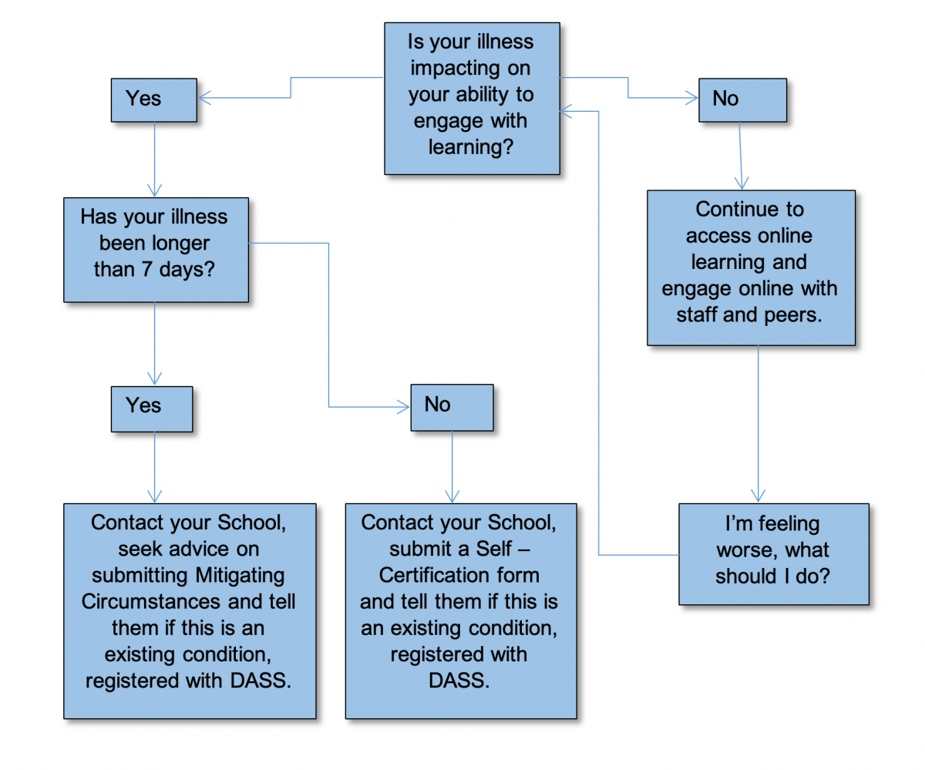

**Should I submit a request for mitigating circumstances to cover the impact of Coronavirus?**

No, you don’t need to do this, as steps will be taken for all students across all programmes to minimise the academic impact of the COVID-19 outbreak No, you don’t need to do this, as steps will be taken for all students across all programmes to minimise the academic impact of the COVID-19 outbreak.

You only need to submit a claim for Mitigating Circumstances if your illness or personal circumstances relating to COVID-19 is impacting on your ability to engage with the online learning resources resulting in you being unable to submit your assessment.

**There are issues with my health which are preventing me from engaging with online learning – what should I do?**

If you have been ill for seven days or less you can self-certificate using the [**self-certification procedure**](http://www.regulations.manchester.ac.uk/academic/self-certification-procedure/). If you have been ill for longer than seven days or you think you are not going to be better in time to complete your assessment, you should submit a claim for Mitigating Circumstances.

If you are too ill to engage with your studies online, you must [**contact your School office**](https://www.staffnet.manchester.ac.uk/tlso/policy-guidance/assessment/reaching-decisions-from-assessment/self-certification/school-contacts/). In your email please make sure to include your name, your university number and the programme you are studying on.  This will help us to keep an accurate record about who is affected and to give you further guidance.

**I’ve been ill for longer than seven days and this has impacted my ability to study and may impact my assessments – what should I do?**

You will need to submit a claim for mitigating circumstances to your School. You will not be required to submit any supporting evidence of your illness with your claim.

**I’ve been ill for longer than seven days and I have not been able to study – what should I do?**

If your period of illness will impact on you being able to complete your assessments or means that you will need to request an extension then you will need to submit a claim for mitigating circumstances to your School.  You will not be required to submit any supporting evidence of your illness with your claim.

**I submitted my assignment/dissertation/did my presentation in the last few weeks – can I make a claim?**

You will need to make a claim if you were ill at the time you completed the assignment or when you were making the presentation.  If this is the case you need to submit a claim for mitigating circumstances.

You should not base your claim on simply having to now make the presentation on line nor that a member of the group was self-isolating or that others were returning home due to the virus – claims on this basis would not be upheld.

**What evidence will I need to submit with my Mitigating Circumstances or Self Certification claim?**

If you are self-certifying you will not need to submit any evidence.

For claims for Mitigating Circumstances relating to illness where you would normally be required to provide a doctor’s certificate, the University has agreed to remove the requirement to provide this evidence for the academic session 2019/20.

**I’m self-isolating for 14 days, should I submit mitigating circumstances or self-certify?**

Providing you are well and working online you do not need to submit either. You only need to submit a claim for mitigating circumstances if you have been ill during your isolation and unable to work and this will impact on your ability to be able to submit any of your assessments.

**I’m worried about self-isolating, social distancing, and being able to access my online learning. What should I do?**

We will do all we can to support you and your learning during this time.  As far as possible all of your learning will be on-line and accessible, and relevant notes and materials will be uploaded into Blackboard.  Staff will reply as promptly as possible to any specific requests you make, through email or Blackboard, for academic support.

**Amendment history**

|  |  |  |
| --- | --- | --- |
| **Version** | **Date:** | **Reason for change:** |
| Final v1.1 280520 replaces Final v1 240429 | 28 May 2020 | Under section 5.3 replacement of paragraph `*There is no requirement for evidence to support any mitigating circumstances applications that cover the period since the University campus closed. Students may opt to include evidence where they have it.’*  with  *`There is no requirement for medical evidence to support any mitigating circumstances applications that cover the period since the University campus closed, due to the difficulty of obtaining medical appointments during the current pandemic; students may opt to include evidence where they have it. However, all other forms of evidence should be submitted as normal.’*  To replicate that which was published by the University. |