Humanities Word Template for PC

How to Use this Template

*Please read the first 3 pages of this guidance on how to format your online teaching materials before starting to add your content to this document. When you have finished adding your content into this template, don’t forget to delete these guidance pages!*

1. Save this file to your computer as a Word Template .dotx

* 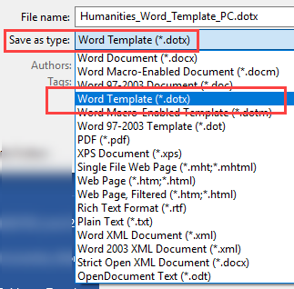Name the file " Humanities_Word_Template_PC" and choose **.dotx** from the file type options
* Ideally, you should save this template to the following location on your computer:   
   **C:\Users\username\AppData\Roaming\Microsoft\Templates**
* Alternatively, you can save this template anywhere on your computer and make a note of where you save it.

1. To create a new document based on the HUM template

**You can either**

* Open Word and select File > New, then from the Personal tab, select the Humanities_Word_Template_PC template  
    
  **or**
* Browse to the location where you saved this template, and double-click on the filename.

1. Format your materials following style guide

* **Built-in Font Styles**

There are 6 built-in ‘HUM’ styles available in this template:

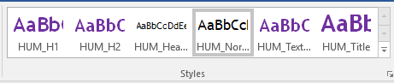To apply the styles, just highlight the relevant text in your document and then press the appropriate style from the Style Gallery.

* **Copying and Pasting from Another Document**

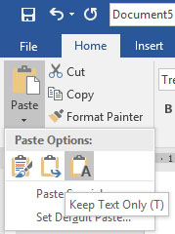If you are going to paste text from another Word document, you will need to use the ‘Keep Text Only’ option when pasting so as not to change the text formatting of this document.

* **Built-in Text Boxes with Icons**

Available text boxes:

* HUM_Bubbles
* HUM_Case_Studies
* HUM_Discussion
* HUM_Essential_Reading
* HUM_Learning_Outcomes
* HUM_Reading
* HUM_Summary
* HUM_Test_Quiz
* HUM_Video
* HUM_Writing

From the Insert menu, go to Text Box and click on whichever HUM text box you want. Each text box has a related icon.

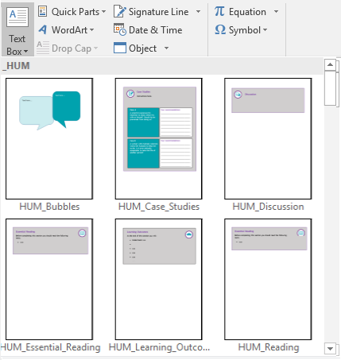

* **Boxes Spreading Over Two Pages**

If you are typing a lot of text into a text box, it may spill over onto the next page. If this is the case, type your text in the text box up until you reach the footer area of the page. When you reach the bottom of the page move your cursor to the next page and start a new text box: at the top of the next page, use Insert > Text Box and selecting the same text box style as in the previous page. Remove the redundant heading in the new text box, and continue typing the rest of your text.

* **Edit the Header**

From Page 2 of your document, you should edit the Header of the document to reflect the course title. Double-click in the Header area and amend the text. Press the Close Header and Footer button (red X).

1. Adding or changing icons

To change an icon in a text box:

* From the table below, copy the icon you want to insert
* Go back to the icon you want to get rid of, click on it and press the backspace key on your keyboard to remove it,
* Paste the icon you copied from the table below.

|  |  |  |  |  |
| --- | --- | --- | --- | --- |
|  |  |  |  |  |
| DL-Writing-Summative | DL-Discussion-Summative | DL-Test-Summative | DL-Assessment-Summative | DL-Learning-Outcomes |
|  |  |  |  |  |
| DL-Test | DL-Assessment | DL-Think | DL-Write | DL-Discussion |
|  |  |  |  |  |
| DL-Watch | DL-Listen | DL-Read | DL-Time | DL-Download |
|  |  |  |  |  |
| DL-Seminar | DL-Summary | DL-BlackBoard | DL-BlackBoard-V2 |  |

1. Print Your Document to PDF

With your Word document open, use File > Save As, and change the file type to PDF (.pdf) from the dropdown list. Then press the Save button.

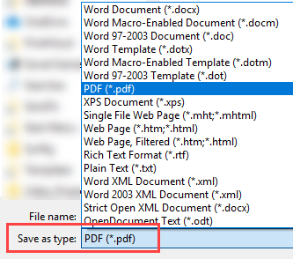

The following pages provide some examples of how to structure your materials with a mix of content and activities. If the activities included are not relevant simply remove them

DON’T FORGET TO

**DELETE THESE GUIDANCE PAGES**

FROM YOUR FINISHED DOCUMENT!

Unit 1:

Learning Outcomes



Learning Outcomes

At the end of this section you will:

* Understand
* xxx
* xxx
* xxx

Video

Watch the introductory video where XXXXX introduces this Section.

Insert a link to your video on <https://video.manchester.ac.uk>



* 1. Section 1: Introduction

This paragraph text should use the ‘HUM_Normal’ style.





Essential Reading

Before completing this section you should read the following texts.

* xxx
  1. **Add title here**
  2. Section 2: xxx

This paragraph text should use the ‘**HUM_Normal’** style.

* 1. Section 3: xxx

This paragraph text should use the ‘**HUM_Normal’** style.

* 1. Summary



Summary

Other Suggested Activities (delete if not required)



Discussion



Test / Quiz

Text here …

Text here …

**Case A**

A scientist expresses his intention to clone either his wife or himself. Should he be prevented from doing so?

Your recommendations __________________________________________________________________________________________________________________________________________________________________________________________________________________

Case B

A woman with multiple sclerosis wants her husband to help her to die. Is it ever ethically acceptable to take the life of another person?

Your recommendations __________________________________________________________________________________________________________________________________________________________________________________________________________________



Case Studies

Instructions here.

Writing Activity

Text here …

