Microsoft Credentials: Preparing For Your Exam using Learnkey online learning and practise tests in G-Metrix

- After setting up your G-metrix account, navigate to the Learn Key course of your chosen certification.
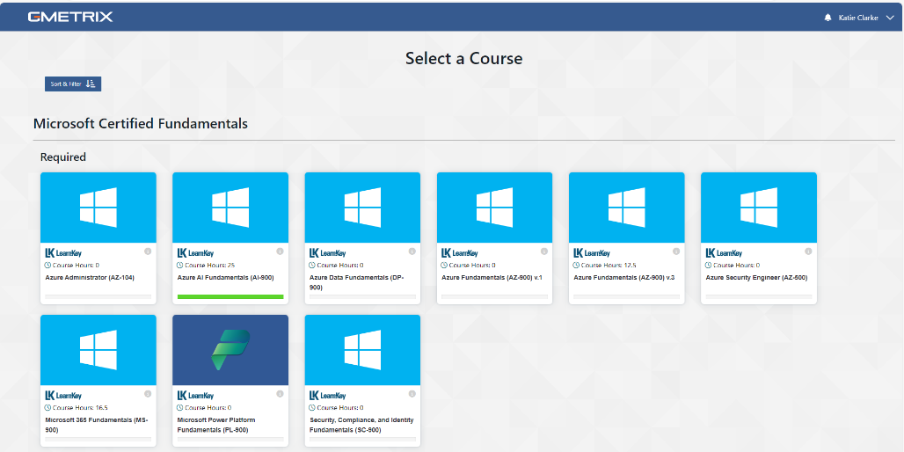

- Work through each domain, beginning with the pre assessment questions. Watch the videos, complete the exercise labs and post assessment questions. Each course has a slightly different layout in Learnkey. Watch this useful video on working through the course.
Most of the courses have around 25 hours of material to work through, including the practise tests.

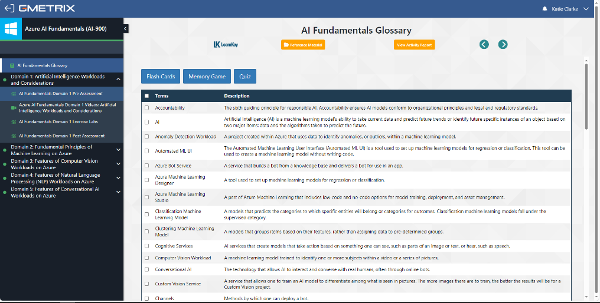
- Return to the G-metrix homepage and navigate to the study guide for your course of choice. Here you can see the objectives of the certification, take practise tests and monitor your progress.
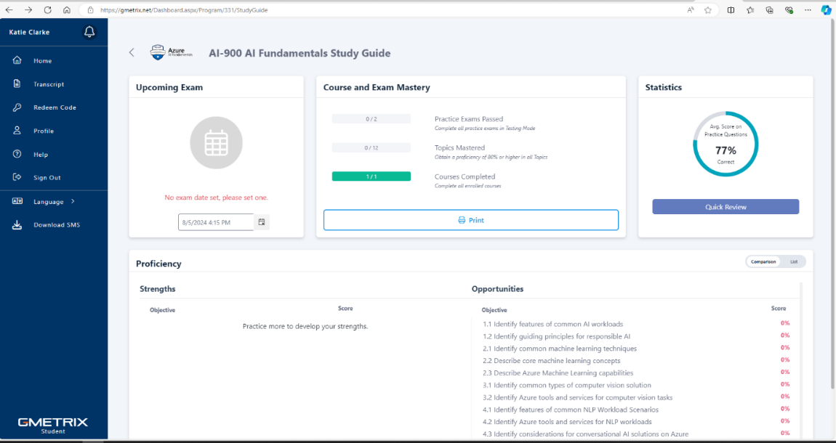

- Take a practise test by selecting training mode, set the question type to random. This will give you unlimited time to complete the test and will show you the correct answer to each question including an explanation.

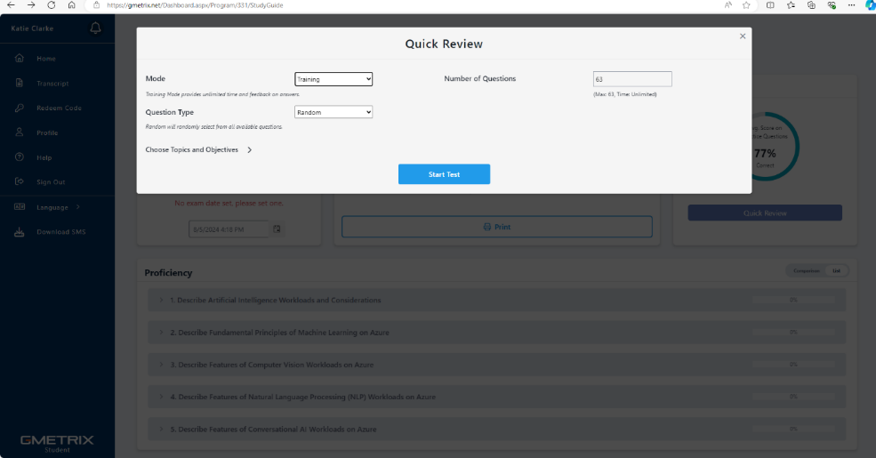

- Review your proficiency in each objective and continue to use the practise questions until you feel confident. You can also revisit the videos as needed.
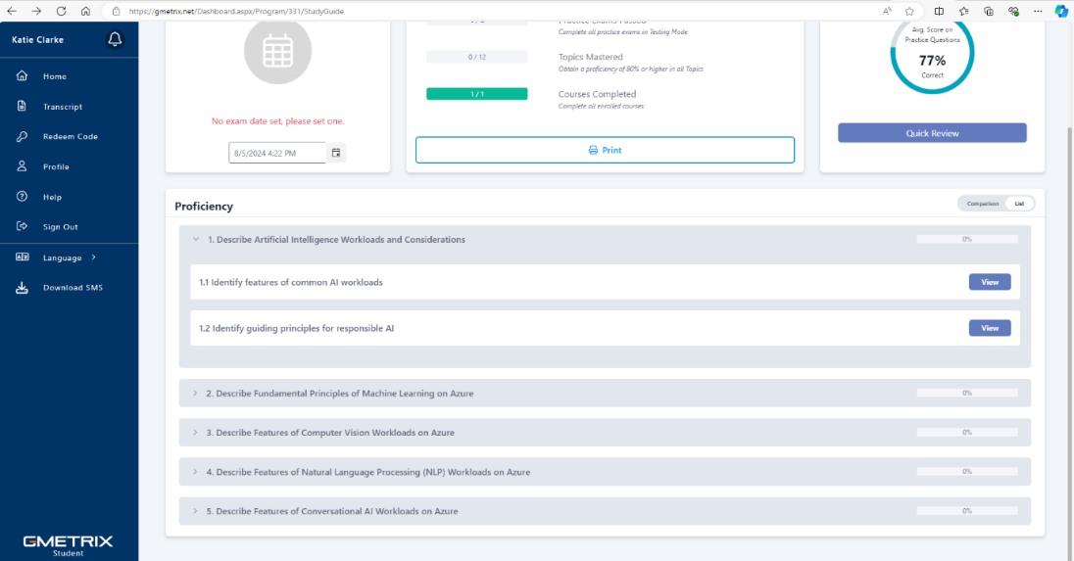

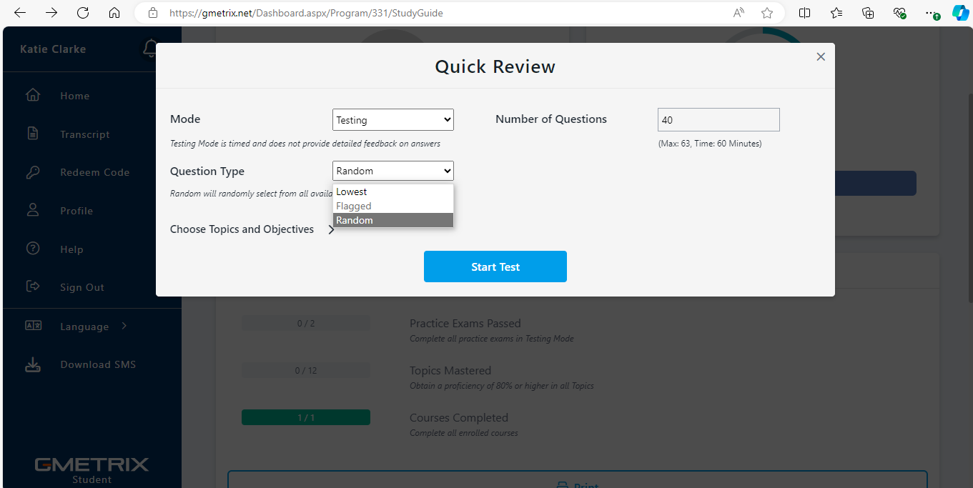
- Take the practise tests in testing mode, ensure you can score more than 70% before booking your exam. You can edit the number of questions and question type. If you want to focus only on objectives that you have scored a low proficiency on, selected ‘lowest’. The testing mode is a mock exam, you will have a fixed time to complete the test.

Further Guidance and Resources
FAQs
Note - the real exam will not contain questions that are identical to the practise test questions. Make sure you understand the concepts and are not just memorising the answers.

