**From:** Climate Network <climatenetwork@manchester.ac.uk>   
**Sent:** 15 November 2021 18:01  
**To:** CLIMATE-NETWORK@listserv.manchester.ac.uk  
**Subject:** [CLIMATE-NETWORK] Newsletter



**Hi everyone** J

**Whilst post-COP26 global temperature forecasts for the year 2100 (of 2.7oC above pre-industrial levels with current policies, or 2.4oC if 2030 targets are achieved) have fallen far short of the COP21 goal (of 1.5oC), we can remain hopeful that more countries are beginning to step up to the mark, even if many are still dragging their heels.  What is important is that we continue to look at ways to** [**mitigate the effects of climate change**](https://www.nhm.ac.uk/discover/does-climate-change-make-wildfires-worse.html)**,** [**develop climate resilience**](https://www.bbc.com/future/bespoke/follow-the-food/how-we-can-adapt-plants-to-save-our-planet.html)**, we collaborate through an** [**intersectional**](https://carbonliteracy.com/lgbtcommunity/) **and** [**representational**](https://www.ienearth.org/) **approach, and we continue to learn from one another, including** [**teaching the next generation**](https://www.studyexperiences.co.uk/destinations/manchester-earth-summit-2022/earth-summit-2022)

UoM Climate Network Meeting

We’ll soon be holding another event entitled “Post-COP26 Climate Politics” with Prof. Matthew Paterson, Professor of International Politics, as the speaker on **Thursday 25th November 2021 at 1pm-2pm**; everyone is welcome to join

(**please note:** we are planning to record this meeting, so please do ensure your camera is turned off when joining if you would prefer not to be recorded.  Thank you.)

Time: Nov 25, 2021 1:00 PM London

<https://zoom.us/j/93659329129>

Meeting ID: 936 5932 9129

Passcode: 160140

UoM Events

**From car to coronary: the cardiovascular effects of diesel exhaust particles**

Department of Earth and Environmental Sciences

17 Nov 2021 - 13:00 - 14:00

<https://events.manchester.ac.uk/event/event:tp9-kv9ob2uo-k8foux>

**The new EPSRC NNUF Radioactive Waste Management and Environmental Remediation (RADER) and Williamson Research Centre Laboratories - Research capabilities and opportunities**

Department of Earth and Environmental Sciences

24 Nov 2021 - 13:00 - 14:00

<https://events.manchester.ac.uk/event/event:opa-kv9ocpa8-zat47d>

**How can we bridge the gap between local and global knowledge in urban development research?**

Global Development Institute

24 Nov 2021 - 17:00 - 18:30

<https://events.manchester.ac.uk/event/event:nmu-kuo9gcfd-ktwwdv>

·       Harriet Bickley has created an [Easy Everyday Eco Actions booklet](http://documents.manchester.ac.uk/DocuInfo.aspx?DocID=44432) full of practical info to help UoM staff & students live, work & study in a more eco-friendly manner.

·       Pooja Kishinani and Marion Smith, students at The University of Manchester, have created a [Student Guide to the Climate Crisis](https://climateemergencymanchester.net/student-climate-handbook/) centred around three themes: the emotions, basic information, and activist advice of climate change.

·       [Want Not Waste](https://www.thezerowastenetwork.com/united-kingdom/manchester/zero-waste-shop/want-not-waste) have recorded their various environmental talks, which you can view on their [YouTube channel](https://www.youtube.com/channel/UCTpg3EG9LV9B14R1cXbHDig).

Greater Manchester Events

**The Winter Gardens at Platt Fields Market Garden**

Platt Fields Market Garden

13 Nov - 19 Dec 2021 (**market on Saturdays & Sundays 12pm-7pm**)

<https://www.manchesterfoe.org.uk/events/event/the-winter-gardens-at-platt-fields-market-garden/>

**Fire, food and forests – the Amazon rainforest in the 21st century**

MMU - Innospace

17 Nov 2021 - 18:00 - 20:00

<https://www.manchesterfoe.org.uk/events/event/fire-food-and-forests-the-amazon-rainforest-in-the-21st-century/>

**Bike Friday November 2021**

Manchester Friends of the Earth

26 Nov 2021 - 08:00 - 09:00

<http://www.manchesterfoe.org.uk/events/event/bike-friday/>

**NCHS: Wildlife Habitats with City of Trees**

City of Trees

27 Nov 2021 - 12:00 - 14:00

<https://www.manchesterfoe.org.uk/events/event/nchs-wildlife-habitats-with-city-of-trees/>

·       There are a number of ways that you can recycle single-use plastics both within Manchester and further afield:

       (1) [Recycling points for single-use face masks](https://www.staffnet.manchester.ac.uk/campus-management/news/display/?id=27153) across UoM campus are now available, and a [recycling point for single-use coffee cups](https://www.facebook.com/wantnotwastemcr/posts/808857489772186) in Piccadilly Train Station.

(2) [Co-op](https://www.coop.co.uk/) are currently running a [soft plastics recycling scheme](https://packagingeurope.com/co-op-launches-collection-scheme-for-soft-plastics/) for plastic bags and product wrapping (plastics that can be scrunched and that ‘ping’ back) at their stores.

(3) Stockport-based [Plastic Shed](https://www.plasticshed.org/) are taking donations of [specific types of plastic lids, soft stretchy plastic packaging, vinyl banners, straws, and plant pots](https://www.plasticshed.org/plastic-drop-off) which they creatively recycle and repurpose into useful items.  They also hold workshops and act as a community space; they share their [Merseyway Workshop](https://www.merseywayworkshop.com/) with a community-focussed design studio called [Easy Peel Studios](https://www.easypeelstudio.com/).

(4) An organisation called [ReWorked](https://www.reworked.com/) have now partnered with [Boots to offer beauty product recycling](https://www.reworked.com/2021/09/16/what-items-can-you-recycle-in-boots-stores-recycle-at-boots/) and [Wilko to offer single-use face mask recycling](https://www.reworked.com/2021/03/22/how-does-the-wilko-reclaimthemask-facemask-recycling-scheme-work/).  They also offer the ability to recycle lateral flow tests / face masks/ gloves / visors and many other household items but a recycling box must be purchased from their [online shop](https://www.reworked.com/shop/) (starting at £50 for each box, thus it is likely to be more cost-effective to share boxes in groups/organisations, although then more will likely need to be purchased).

·       [Cracking Good Food](https://crackinggoodfood.org/), a not-for-profit social enterprise, are looking for [volunteers](https://crackinggoodfood.org/about-us/volunteering/), mainly around the Stockport area, to help them in their goal to encourage and support more people to cook affordable, seasonal, and nutritious homemade food from scratch.

·       Season For Change are running a few more events that are climate change-related, including their [‘Season For Exchange 2’ talks](https://www.seasonforchange.org.uk/events/).

·       The ongoing [‘In Our Nature’ Campaign](https://zerocarbonmanchester.commonplace.is/), coordinated by a group of organisations around Manchester, aims to help everyone across the city live, work, and travel in ways that are good for us, our communities, and the environment.

·       Manchester Climate Change have released their own [15 actions to take to become a zero carbon city](https://www.manchesterclimate.com/15-actions)

Science Museum Group (SMG) Climate Talks

SMG’s climate talks will be happening throughout this year, 12 of which (as indicated in the below list) will be part of [Manchester Science Festival](https://www.scienceandindustrymuseum.org.uk/manchester-science-festival); this local festival has a climate change theme this year and will be mainly occurring between 12th – 21st February 2021.

·         [**Climate change: why should we care?**](https://www.youtube.com/watch?v=CnsGlk994cA)(occurred on 28 Jan 2021 – YouTube link provided ICYMI)

·         [**Transport: How can I be a good citizen of the world?**](https://www.youtube.com/watch?v=xl7mh0gnR1I) **- Manchester Science Festival** (occurred on 13 Feb 2021 – YouTube link provided ICYMI)

·         [**Equality: How can I be a good citizen of the world?**](https://www.youtube.com/watch?v=7pazufJoCA4) **- Manchester Science Festival** (occurred on 13 Feb 2021 – YouTube link provided ICYMI)

·         [**Earth, but not as we know it: Lovelock’s legacy and our future**](https://www.youtube.com/watch?v=7PiVnwKRpPE) **- Manchester Science Festival** (occurred on 13 Feb 2021 – YouTube link provided ICYMI)

·         [**Food: How can I be a good citizen of the world?**](https://www.youtube.com/watch?v=uXp-ApuK03A) **- Manchester Science Festival** (occurred on 14 Feb 2021 – YouTube link provided ICYMI)

·         [**The Road to Carbon Zero: In conversation with Professor Myles Allen**](https://www.youtube.com/watch?v=2ZTjeHUwXjo) **- Manchester Science Festival** (occurred on 14 Feb 2021 – YouTube link provided ICYMI)

·         [**Changing the system: Brian Eno and James Thornton in conversation**](https://www.bbc.co.uk/sounds/play/p09b6rbk) **- Manchester Science Festival** (occurred on 15 Feb 2021 – BBC Sounds link provided ICYMI)

·         [**You and the Planet: Air**](https://www.youtube.com/watch?v=4qggQz3MWCA) **- Manchester Science Festival** (occurred on 16 Feb 2021 – YouTube link provided ICYMI)

·         [**A Liveable Earth: Climate Change and the Faith Community**](https://www.youtube.com/watch?v=2Gsyaqa0WWM) **- Manchester Science Festival** (occurred on 20 Feb 2021 – YouTube link provided ICYMI)

·         [**Let’s Talk About Eco-Anxiety**](https://www.youtube.com/watch?v=8uiuU_kLCEI) **- Manchester Science Festival** (occurred on 20 Feb 2021 – YouTube link provided ICYMI)

·         [**Our Hydrogen Future: Delivering Net Zero**](https://www.youtube.com/watch?v=QnXD4thwQ4U) **- Manchester Science Festival** (occurred on 21 Feb 2021 – YouTube link provided ICYMI)

·         [**Is Capitalism compatible with Environmentalism?**](https://youtu.be/Qa_qWftGBYQ) (occurred on 26 Feb 2021 – YouTube link provided ICYMI)

·         [**Climate change: the view from space**](https://www.youtube.com/watch?v=B4TAwAZxd-k)(occurred on 16 Mar 2021 – YouTube link provided ICYMI)

·         [**Our future planet: global greenhouse gas removal**](https://www.youtube.com/watch?v=JTxLfMta98U)(occurred on 31 Mar 2021 – YouTube link provided ICYMI)

·         [**1.5 v 2 degrees Celsius: Why half a degree really counts**](https://www.youtube.com/watch?v=KfA7w3rs5I0)(occurred on 29 Apr 2021 – YouTube link provided ICYMI)

·         [**The Clean Energy Revolution**](https://www.youtube.com/watch?v=baIpPWlc3wA)(occurred on 13 May 2021 – YouTube link provided ICYMI)

·         [**The Future of Fuel**](https://www.youtube.com/watch?v=Ms-5ysPXJQ0) **- Manchester Science Festival [rescheduled from 12th Feb]** (occurred on 5 Jun 2021 – YouTube link provided ICYMI)

·         [**How are our oceans responding to climate change?**](https://www.youtube.com/watch?v=_7DcQuy7lH4)(occurred on 10 Jun 2021 – YouTube link provided ICYMI)

·         [**Tony Blair In Conversation with John Kerry**](https://youtu.be/HAujaspI5io)(occurred on 29 Jul 2021 – YouTube link provided ICYMI)

·         [**COP26: How can it achieve what the world needs?**](https://youtu.be/o85iHWWOfsU)(occurred on 5 Aug 2021 – YouTube link provided ICYMI)

·         [**How to feed the world without costing the Earth**](https://www.youtube.com/watch?v=H5BUBUt4n08) **-** (occurred on 8 Sep 2021 – YouTube link provided ICYMI)

·         [**Climate Change: How consumers and businesses can make a difference**](https://www.youtube.com/watch?v=Nr4gK5mi50A) **-** (occurred on 14 Oct 2021 – YouTube link provided ICYMI)

·         [**After COP26, what next?**](https://www.scienceandindustrymuseum.org.uk/whats-on/climate-talks/after-cop26) **-** (2 Dec 2021 - 19:30 - 21:00)

·         [**The Electricity Revolution: Our Zero Carbon Future**](https://www.scienceandindustrymuseum.org.uk/manchester-science-festival/whats-on/electricity-revolution) **- Manchester Science Festival** **[postponed until further notice]**

Other Events

**Highlighted Event: Festival of Social Science [contains a wide range of COP26-related events happening across the UK]**

Economic and Social Research Council (ESRC)

1 - 30 Nov 2021 (various times)

<https://festivalofsocialscience.com/>

**Being Human**

School of Advanced Study University of London

11 - 20 Nov 2021 (various times)

<https://beinghumanfestival.org/>

**Making an impact with climate research: insights, perspectives, and inspiration**

Taylor & Francis Group

16 Nov 2021 - 14:00 - 15:00

<https://register.gotowebinar.com/register/3486516605772421391>

**After COP: Keeping Momentum, Learning and Reflecting**

Friends of the Earth

23 Nov 2021 - 19:00 - 20:30

<https://www.manchesterfoe.org.uk/events/event/after-cop-keeping-momentum-learning-and-reflecting/>

**Institute of Cornish Studies: Citizens Assembly on the Climate**

University of Exeter (Green Futures)

1 Dec 2021 - 12:30 - 14:30

<https://greenfutures.exeter.ac.uk/latest-events/>

·       An interesting [explanation of Sustainability](https://www.treehugger.com/what-is-sustainability-and-why-is-it-important-5179651).

·       An interesting [explanation of Net Zero (and its related terms)](https://netzeroclimate.org/what-is-net-zero/).

·       A better future for our woodlands: [12 ideas to help British forests grow](https://www.youtube.com/watch?v=RX-LHyo_gJ4)

·       Downloading the [GreenLife](https://greenlife.cloud/) app on a smartphone provides you with daily tips to help you on your journey towards sustainable living and carbon neutrality; the website also provides a handy countdown to around 2028, seemingly the year by which they hope to achieve net zero emissions.

·       Downloading the [Buddlet](https://www.buddlet.com/) app on a smartphone allows you to improve the sustainability of your lifestyle by choosing from a range of eco-friendly swaps to your ordinary activities/purchases.  The app was scheduled to launch on 27 August 2021, currently only available via Apple devices.

·       Downloading the [Skoot](https://skootride.com/) app on a smartphone instantly plants 5 trees for free (and every friend referral also generates 5 additional planted trees for free), and then every journey, thereafter, that you make will be converted into 1 free planted tree.  It seems like they may change their model when they reach 1 million trees, due to the mention of the ‘1 million free tree challenge’ on their website, but for now it’s worth using.

·       Downloading the [Treekly](https://www.treekly.org/) app on a smartphone allows you to plant 1 tree each week for free (seemingly in Madagascar); by tracking your footsteps, using either your phone’s built-in pedometer or a fitness tracker/smartwatch, you can convert your 25,000 steps per week [5,000 each day for 5 days] into the planting of a tree.

·       Downloading the [TreeApp](https://www.thetreeapp.org/) app on a smartphone allows you to plant a tree for free, in an area that it’s needed e.g. often in the Global South, every single day (up to a daily limit of trees available – you’ll know when the limit has been reached as it prevents you from planting)

·       Whilst it still seems to be in the early stages of uptake, [AllotMe](https://www.allotme.co.uk/) – marketed as the ‘Airbnb for your Garden’ sounds like a great concept –  whereby individuals can rent spaces to grow food within major cities/urban environments, and garden owners can monetise their land.

·       Spare 3 minutes to fill in [Currensea’s Sustainability survey](https://www.surveymonkey.co.uk/r/P2GFFCV) and each completed survey removes 100 plastic bottles from the oceans (thanks to their [Plastic Bank](https://plasticbank.com/) partnership).

·       Changing your internet browser settings to use [Ecosia](https://www.ecosia.org/) as the default browser means that you’ll be planting trees whilst you’re searching (approx. 45 searches = 1 tree planted).

·       A [CO2 widget](https://co2widget.com/) created to communicate daily levels of CO2 by Matthew Shribman, his colleagues, and University of Cambridge / Cambridge Zero.  There is also the [Climate Action Tracker (CAT)](https://climateactiontracker.org/) that can be used to keep track of global climate action.

·       Some [suggested climate actions](https://itstime.earth/climate-actions) have been listed by Ecologi on their It’s Time website.

·       Really useful links to organisations who are promoting [circular economy initiatives](https://eeb.org/circular-future).

·    Please take a look at the [Students Organising for Sustainability UK (SOS-UK) website](https://sustainability.nus.org.uk/) as well as two current campaigns they are running:

1. [Invest for Change](https://www.investforchange.uk/)

2. [Carbon Targets](https://www.carbontargets.uk/)

Social Media

You can now connect to the Climate Network on:

1. [Facebook](https://www.facebook.com/groups/235576384126425/)

2. [Yammer](https://www.yammer.com/live.manchester.ac.uk/)

How To Subscribe To Us

Feel free to forward this newsletter on, but also please pay a visit to our website below (where you can subscribe to our mailing list, take look at our events calendar, and see a sample of the environmental groups affiliated with UoM):

<https://climatenetwork.uk/universityofmanchester/>

-------------------------------------------------------------------------------------------------------

Student Volunteering Opportunities

**Become an Eco-Team School Volunteer, as part of the Green Schools Project, a volunteering opportunity funded by** [**Wates**](https://www.wates.co.uk/) **– a construction company.**

Are you passionate about tackling the climate crisis and inspiring young people to join you?

Calling all Manchester University students! We require some enthusiastic volunteers to help deliver Green Schools Project and support a school Eco-Team in their mission to help them go green.

<https://find-volunteering.manchester.ac.uk/opportunity/result/36853>

Please get in touch if you have any questions - [beth.newman@greenschoolsproject.org.uk](mailto:beth.newman@greenschoolsproject.org.uk)

-------------------------------------------------------------------------------------------------------

Tackling climate breakdown at its core: subverting the super-rich

**Whilst capitalism as a concept may be trickier to combat, a redistribution of wealth, and thus power, to improve climate finance in areas of the world that need it most, could be the true answer to the climate crisis (as well as a host of other systemic issues).**

The richest 1% of the world’s people (those earning more than $172,000 a year) produce 15% of the world’s carbon emissions: twice the combined impact of the poorest 50%.

The wealthiest 1% generate roughly half the world’s aviation emissions; if everyone lived as they do, aviation would be the biggest of all the causes of climate breakdown.

The disparity in environmental impact mirrors a nation’s inequality. No wonder the prosperous people of the wealthy nations are so keen to seek to shift the blame to China, or on to other people’s birthrates: sometimes it seems they will try anything before attending to their own impacts.

Preventing systemic environmental collapse means driving extreme wealth to extinction. It is not humanity as a whole that the planet cannot afford. It’s the ultra-rich.

<https://www.theguardian.com/commentisfree/2021/nov/10/extreme-wealth-polluting-climate-breakdown-rich>

-------------------------------------------------------------------------------------------------------

100 Plant Science Questions Project

**The University of Bristol and New Phytologist Foundation need your help! They’re gathering the 100 most important questions in plant science, and are consulting everyone: from farmers to students, farmers and landworkers, industrial agriculturists to policy makers, expert academics to curious onlookers. They want to hear from as many people as possible, and no question is too big or small.**

You can submit your questions until the **31st December 2021** via this [link](https://forms.office.com/pages/responsepage.aspx?id=Ec2bnHqXnE6poLxzQJAWSikl4Q9XHnhHhoazR9xs7SZUM1U0RDc2WTIyNlpFSDNLUlk2S0JJN0tMVS4u). The submission form is available in French, Spanish, German, Portuguese (Brazil), Arabic, Chinese (Simplified) and Japanese.

They’d love to reach as many people as possible, so please share widely with your networks and email them at [bris-plant-sci@bristol.ac.uk](mailto:bris-plant-sci@bristol.ac.uk) if you have any questions.

They regularly sharing updates on [Twitter](https://twitter.com/PlantQuestions), [Instagram](https://www.instagram.com/100plantsciencequestions), and [Facebook](http://www.facebook.com/plantquestions) – join the conversation and their journey to find their #100PlantQuestions.

You can find their promo posters and slides [here, in their shared OneDrive](https://uob-my.sharepoint.com/:f:/g/personal/wp19435_bristol_ac_uk/Eo7KxotYEbJCljnGAXaHIHgBe4pc8laXMlsksQPcz5fJpg?e=sOgX7V) - please share these with anyone who might be interested!

The 100 Plant Science Questions Project is managed by Dr. Emily May Armstrong for The University of Bristol and The New Phytologist Foundation

The New Phytologist Foundation is an independent, not-for-profit organisation dedicated to the promotion of plant science. It owns and produces the international journals New Phytologist and Plants, People, Planet. Find out more about the Foundation’s work at [newphytologist.org](https://www.newphytologist.org/).

-------------------------------------------------------------------------------------------------------

The Fossil Fuel Non-Proliferation Treaty

**2,185 scientists and academics call for a Fossil Fuel Non-Proliferation Treaty**

On the eve of the United Nations General Assembly, thousands of academics have urged governments to negotiate an international treaty to tackle the climate crisis at its source: fossil fuels.

If you are a scientist, academic, or researcher, please sign the treaty here: <https://fossilfueltreaty.org/open-letter>

-------------------------------------------------------------------------------------------------------

Commission on the Conservation of Antarctic Marine Living Resources (CCAMLR) Petition

**Call On CCAMLR to protect Antarctica and secure the largest act of ocean protection in history**

Did you know Antarctica regulates our climate, and its waters feed the fish that feed the world? But who protects Antarctica and its ocean? One international organization does, called CCAMLR (Commission on the Conservation of Antarctic Marine Living Resources). This year it has the power to create three marine protected areas: the East Antarctic MPA proposal, the Weddell Sea MPA proposal, and the Antarctic Peninsula MPA proposal—**the largest act of ocean protection in history!**

Please sign [Only One](https://only.one/)’s Petition here and to find out more about the movement: <https://only.one/act/antarctica>

-------------------------------------------------------------------------------------------------------

The Co-operative Party’s Petition to Ban Bee-Killing Pesticides

**Close the loophole on bee-killing pesticides**

Earlier this year, when the Government announced it would use a loophole to temporarily allow the “emergency” use of banned bee-killing pesticides by sugar farmers, the Co-operative Party fought until the Government reversed its decision.

The Government has already said they “anticipate” that the emergency authorisations loophole – which allows bee-killing pesticides to be used – may be “needed” again in 2022 and 2023.

Please sign the [Co-operative Party](https://party.coop/)’s Petition here to protect our bees: <https://party.coop/bees>

-------------------------------------------------------------------------------------------------------

The pioneering 6R Protocol that is improving sustainability in labs and at home & on campus

**The 6R lab protocol, developed in 2019 by Maggy Foster & Ruth Grady, initially to reduce plastics in labs is now expanding university-wide.**

* Before COVID, the 6R protocol had been applied in the Faculty of Biology, Medicine, and Health (FBMH) to 12 practical lab classes, several taken by 650 students yearly, and saved 37,000 items of plastics/year and £3000/year.
* The 6R Home and Campus protocol was developed in 2020 with two graduate students, Natalie Clarke and Rea Georghiades.  Two undergraduate students, Calista Ow and Hector Mangas Afonso, developed our logos for both protocols below.
* The lab protocol will next be rolled out to all FBMH practical classes;  the Faculty of Science and Engineering (FSE) is beginning to adopt it too.  Plus, Lydia Wunderley will be heading a long-term project focussed around applying the protocol to FBMH research labs, specifically within the School of Biological Sciences (SBS).
* Maggy, Ruth and Chiamaka Anoliefo, a student intern, are integrating 6R within the University of Manchester-approved lab sustainability accreditation system called Lab Efficiency Assessment Framework (LEAF).
* 6R will soon be embedded in the curriculum. It will be advertised to Yr1 and Yr2 students as part of the Sustainability Challenge in September, and is part of 10,000 actions (student version to be released soon).

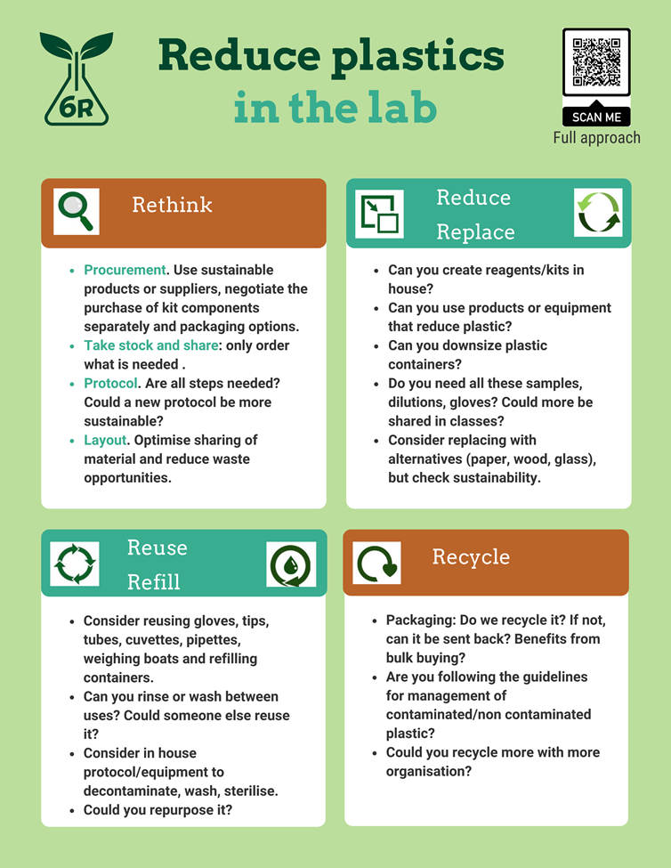            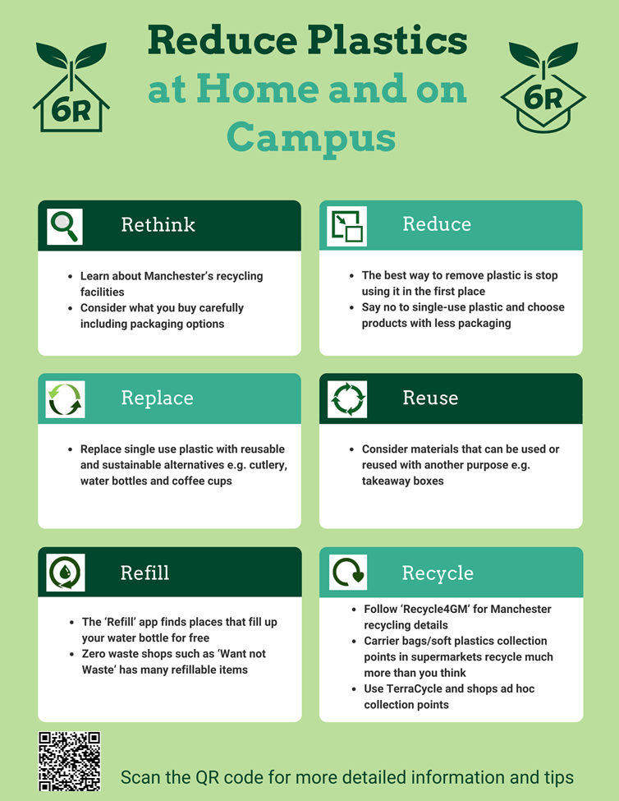

If you want more information or want to help, please contact: [maggy.fostier@manchester.ac.uk](mailto:maggy.fostier@manchester.ac.uk) for home, campus, practicals and [Lydia.Wunderley@manchester.ac.uk](mailto:Lydia.Wunderley@manchester.ac.uk) for research labs.

Best wishes

The UoM Climate Network

The CLIMATE-NETWORK list is archived at: <http://listserv.manchester.ac.uk/cgi-bin/wa?A0=CLIMATE-NETWORK>