TAB_col_white_background.eps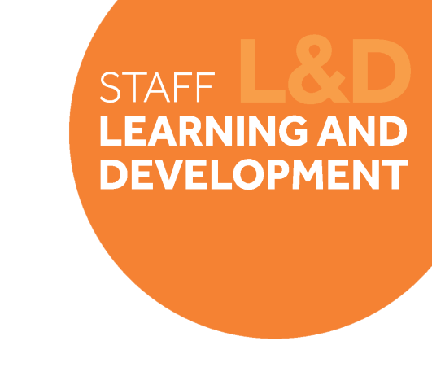

# Change Leadership Skills Framework: *Maintaining a Strategic Perspective*

## Definition

*Maintaining a strategic perspective* is about being able to take the long term and the broader perspective in your role as a change leader. It’s about being able to connect the overall strategic aims of the technical review to day-day tasks and activities, and keep in mind the overall needs and aims for the whole faculty/technical services as opposed to just your specific area.

Behavioural indicators

1. I think strategically, see new ways of doing things, and look for ways to improve our technical services.
2. When making decisions, I consider University/ Faculty benefit as well as local benefit.
3. 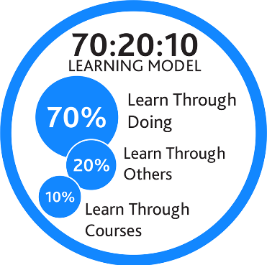I can understand and translate the strategic objectives of the Technical Review into specific local purpose and actions for my team.
4. I assess and link day-day tasks or short-term projects to the big picture / overall strategy.

## Example on-the-job development activities *(70)*

* Before making a major decision, write down the impact it will have on other areas of the Faculty/Technical Services, and how it will contribute to achieving the strategic aims of the Technical Review.
* Run a session with your team to consider what role your team needs to play in delivering the Technical Review, and understanding what the future will look like for the team.
* Write objectives for your team members which translates the overall strategy into meaningful contributions they can make to support the Technical Review.

|  |
| --- |
| *Capture your notes here:* |

## Suggested reflection / discussion questions *(20)*

Q: What will you do to connect the overall strategic aims of the technical review to the day-day tasks and activities, and ensure the overall purpose doesn’t get lost in the detail?

Q: How will you ensure colleagues engage with the Technical Review strategic aims and understand what it means for their role?

Q: What could prevent you from maintaining a strategic perspective? How will you manage this?

|  |
| --- |
| *Capture your notes here:* |

## Recommended learning resources *(10)*

|  |  |
| --- | --- |
| See the source image | Watch: [How to make strategic planning a habit](https://www.linkedin.com/learning/how-to-make-strategic-thinking-a-habit/making-time-for-strategic-thinking?u=74653818)  **LinkedIn Learning - 34mins** |
|  | Read: [Idon Model of Scenario Planning](https://app.goodpractice.net/#/manchester-tfl/s/20af728e)  **L&D Toolkit - 5mins** |
| See the source image | Guidance on taking a strategic approach  **Strategic Change Office – 10mins** |

|  |
| --- |
| *Capture your notes here:* |