

**MB ChB Programme**

**Year 3 Must Read**

**October 2018**

 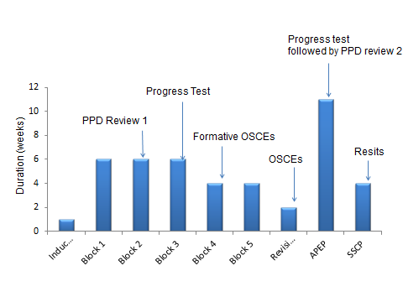

**Top Tips: Getting UPSAs signed off easily**

**What I should do beforehand**

•Be proactive

•Ask at the beginning of your shift/day what skills it might be possible to do on this day,

•Ask your assessor before you start your assessment if they don’t mind filling out the form straight away after you have done the skill so they are prepared to give feedback.

•Partially fill in the form with your assessor’s details as much as you can before handing your iPad to the tutor to complete their feedback

**What I should do immediately after an UPSA**

Use the ‘Submit’ button, not the ‘Draft’ button. Submit within 7 days of starting the assessment.

Remember: Over 7 days or if the assessor’s email is not known the assessor needs to validate the form. Over 14 days: your form will be rejected and you will need to retake the assessment.

If your dashboard is green then you can be assured that your UPSA is marked satisfactorily and has been validated.

**How many should I do per block?**

You should try to complete **at** **least 1 UPSA per block** so you don’t fall behind

**You are here**

**Dr Anu Trehan**

**Academic Lead Year 3**

**Consultant Acute Physician**

**Dear Students,**

You have almost completed your first placement and I am sure the time has flown by! There have been a lot of teaching and new learning experiences – I hope you have managed to capture them in your logbooks.

The first placement sign-off by your supervisor might seem daunting, but it is an opportunity to reflect on the highlights of your first clinical experiences, ask for advice on how to improve and create an action plan to help you organise your next steps. Be ready, help the supervisor by ensuring your logbook is up to date showing all the hard work you have done.

**UPSAs/Prescribing Skills**

One of the next steps I want you to think about is starting to get your UPSA and Prescribing Skills signed off. Some of the skills will need several attempts before you can be signed off as competent, in particular venepuncture and cannulation, so best to start early. If a Health Care Assistant (HCA) observes you doing an UPSA skill they must ask their supervising Nurse to sign you off as competent using their professional registration number. Your skills tutors and educational pharmacists, who you have met in your clinical skills or SCT teaching sessions, are available to provide support and advice where and how you can practise these. Information about UPSAs and Prescribing skills is available here.

<https://www.onemedinfo.manchester.ac.uk/blog/infoobjects/u-psa-guidance/?section=12482>

**Physical Examination Skills**

It is also important that you are practicing and learning about Physical Examination Skills in your clinical placement. The list of Year 3 Examinations is in your Skills iBook

(<https://s3-eu-west-1.amazonaws.com/mmsonemedlearn/wp-content/uploads/sites/3/2017/09/Y3_Clinical_Exam_2017-18.pdf>), Chapters 1-9.

Show the ibook to your placement tutors, create yourself a checklist if you need to track that you are covering all the skills. If you are struggling let us know earlier by contacting your Y3 Sector Lead. However, remember patients don’t fit textbooks!

We hope that you will also take the opportunity to learn other examination techniques as they arise within the placements.

With best wishes,

**Anu Trehan Alison Quinn Himanshu Singh***Academic Lead Year 3 Associate Lead Year 3 Associate Lead Year 3*

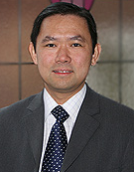**Sector Year 3 Lead**

**Professor Yeng Ang**

**Consultant Gastroenterologist**

**Sector Year 3 Lead**

**SRFT (Salford Campus)**

It was good to meet you during the induction week and hopefully you have had a good start. I am sure most of you have good induction to clinical placements. Even though the environments are new and could be challenging for some, as it comes with a different set of responsibilities and expectations, many have told me they really enjoyed their placements so far. Please ensure all eforms, UPSA and basic skills are signed off and up to date. Please advise Christina Newman of any cancellations in your teaching sessions and any problems within your clinical placement, if we are aware of problems we can help to sort them out.

You have ample opportunity to practice system examinations. We have an active clinical skills lab in the undergraduate department at SRFT and do visit it regularly. We have recruited a team of enthusiastic junior doctors specifically to assist your clinical examination teaching on top of the teachings provided by more senior clinicians.

**Your feedback**

Please ensure you pass on any feedback, questions or concerns to your year 3 representatives. I will also be available to see students on a ‘drop-in’ basis. I am free Wednesday morning from 11 am to 1 pm or Friday morning from 9 am to 11:30 am or please e-mail [yeng.ang@srft.nhs.uk](mailto:yeng.ang@srft.nhs.uk) if you wish to arrange an informal meeting.

Best wishes,

Prof Yeng Ang

[**Yeng.Ang@manchester.ac.uk**](mailto:Yeng.Ang@manchester.ac.uk)