**EDI Network Group Digest February 2021**

It’s time for February’s digest.

If you’d like anything featured in March’s digest, please message [equalityanddiversity@manchester.ac.uk](mailto:equalityanddiversity@manchester.ac.uk)

**International Women’s Day 2021**

The Faculty of Biology, Medicine and Health (FBMH) is delighted that [Dr Nicole Brown](https://www.nicole-brown.co.uk/dr-nicole-brown/), Director of Social Research & Practice and Education Ltd. and Lecturer in Education at the UCL Institute of Education, London will join us to mark [International Women’s Day](https://www.internationalwomensday.com/) (IWD) 2021.

Nicole's research focus over the past few years has focussed on the experience of disabled, chronically ill and/or neurodivergent members of higher education staff. She has presented extensively on cost-benefit analyses of disclosure as well as strategies and initiatives individuals and institutions may employ to bring about attitudinal changes regarding ableism.

In this keynote titled, **"It's all in your head": The experience of disabled women in higher education’**, Nicole will draw on her research with academics with fibromyalgia.   Nicole will be joined by Dr Hema Radhakrishnan, Associate Dean for Social Responsibility, and Vikki Goddard, University PS Lead for Equality, Diversity and Inclusion and Faculty Director of Operations, FBMH for a Q&A session.

**Event details:**

**When: Monday, 8 March, 12:30pm – 1:30pm      Venue: Live streamed on the**[**Faculty’s Facebook account**](https://www.facebook.com/bmhuom/)**– Facebook account not required     Register via**[**Eventbrite**](http://bit.ly/BMHIWD)

**If you have any queries about this event please contact**[**srbmh@manchester.ac.uk**](mailto:srbmh@manchester.ac.uk)

**EDI Blog**

Have you read our EDI blog lately?

We have a variety of pieces covering both general EDI plus a focus on Data

Read about how to be a an EDI Hero and the intersectionalities of the LGBQ+ community in the latest two submissions:

[Equality, Diversity and Inclusion Blog](https://uomequalityanddiversity.wordpress.com/data-stories/)

The blog has now a subscription box so you’ll never miss another post!

**British Sign Language and COVID vaccination**

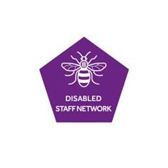

We have been made aware of a this video ref COVID-19 Vaccination as a BSL resource which we thought might be helpful for people:

[**https://www.gov.uk/government/publications/covid-19-vaccination-british-sign-language-resources/bsl-video-guide-on-covid-19-vaccination-for-eligible-adults**](https://www.gov.uk/government/publications/covid-19-vaccination-british-sign-language-resources/bsl-video-guide-on-covid-19-vaccination-for-eligible-adults)

**New Multifaith space in Manchester Museum- call out for young people aged 18-25 years**

My name is Anna Bunney and I’m part of the Learning and Engagement team at the Museum.  I’m co-ordinating this project and am really happy to answer any questions via email [anna.bunney@manchester.ac.uk](mailto:anna.bunney@manchester.ac.uk)  or on  07785 445 618

As part of the Manchester Museum’s hello future project, we are delighted to be creating the Museum’s first multifaith room.

This room will be created in part of the Museum that’s being transformed by building works.  As part of the Building design process, we need to write a brief which will outline the aims and purpose of a multifaith room, benchmark existing multifaith provision in public spaces and what features needed to be included in the room.

We are looking for young people 18-25, to help shape this important development for the Museum and participate in writing the brief.

There are three workshops on Wednesday 17, 24 February and 3 March from 5-5.45pm, where you’ll be joined by staff from the Museum, members of the [Our Shared Cultural Heritage](https://sharedculturalheritage.wordpress.com/blog-2/) young people’s Collective and University of Manchester project management team, to help shape the multifaith room brief.

**Living Wage**

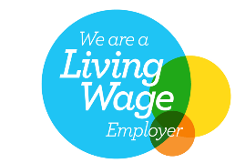The University has recently published an article on the increased Living Wage.

Full details can be seen in this piece:

* [Our University will be paying the increased Living Wage rate](https://www.staffnet.manchester.ac.uk/news/display/?id=25835)

**Calling all Caribbean Staff!**

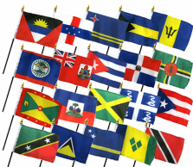April would like your feedback on an idea she has for bringing Caribbean staff together:

She’d like to set up a group that can provide opportunities through which members of staff at the University of Manchester with Caribbean background can meet each other in a friendly and safe environment to share experiences and support each other.

Would you like to be involved?  Or find out more?  Or contribute to the discussion?

If so, please contact April: [april.bryan@manchester.ac.uk](mailto:april.bryan@manchester.ac.uk)

**Message from University of Chester**

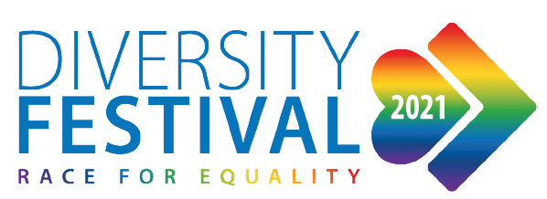The University of Chester Diversity festival events are taking place during the first two weeks in March and they have kindly opened them to us in Manchester!

You can view all their events on Eventbrite [here](https://www.eventbrite.co.uk/o/university-of-chester-7777072077?fbclid=IwAR0_ws9r8tqFBTi96yQKErN15v1oFZ4bfIv_HfJjboWEGNCnMNP8hR220nU) and their [Facebook page](https://www.facebook.com/Chester-Diversity-Festival-22404012546)

This year they have 45 events coving all aspects of diversity, with John Barnes, Amatey Doku, Laura Bates, CIPD CEO Peter Cheese and much much more.

**Research Participation**

You are invited to participate in a research project that investigates support for students with disabilities. The purpose of this study is to understand the role of academic and pastoral staff in supporting the wellbeing of students with disabilities, and to identify ways universities can better support students with disabilities.

The research team would like to speak to a range of student-facing staff who come into contact with students with disabilities. Participation involves taking part in an interview either by phone, zoom or email. Participants will be entered into a prize draw to receive a voucher.

If you are interested in taking part and/or finding out more information please contact: [Victoria.thomas-4@manchester.ac.uk](mailto:Victoria.thomas-4@manchester.ac.uk)

We hope you find something useful in this month’s digest and as mentioned, for inclusionin March’s digest, please contact [equalityanddiversity@manchester.ac.uk](mailto:equalityanddiversity@manchester.ac.uk)

Equality, Diversity & Inclusion | G.035 John Owens Building | The University of Manchester| Oxford Road | Manchester M13 9PL | T: 0161 306 5857

cid:image003.png@01D4AE64.2B362B80       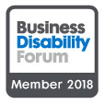

[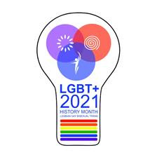](https://www.staffnet.manchester.ac.uk/equality-and-diversity/staff-network/lgbt-staff-network-group/lgbt-history-month-2021/)