**Tagging your Pure records to a University beacon**

Pure allows you to link relevant records held in Pure to any of the University’s Beacon areas.

Records could include publications, activities, datasets, prizes or press coverage.

By linking a record to the Centre, it will show on the Beacon’s page on Research Explorer. For example - <https://www.research.manchester.ac.uk/portal/en/browse.html?uri=ResearchInstitutes_Networks_Beacons%2F03%2F04&logicalname=ResearchInstitutes_Networks_Beacons>

**How to link records to a Beacon**

1. Log into Pure
2. Open the record you wish to link by clicking on it to open it.
3. Scroll down to the section titled **‘**RESEARCH NETWORKS AND BEACONS’
4. Click on the Add Research Networks and Beacons button.
5. Click the grey triangle to expand the list of Research Beacons.
6. Select the Beacon you wish to tag.
7. Save the record in the usual way, using the blue Save button.

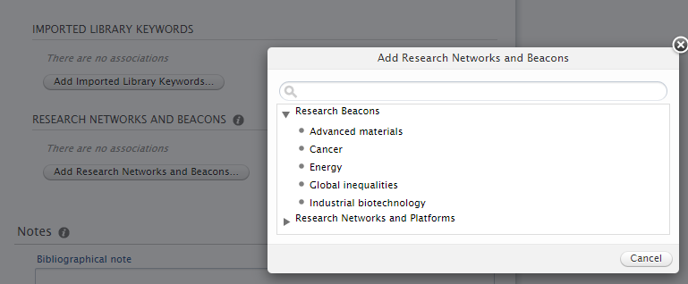

Providing the record has a visibility setting of Public, it will then automatically show on the corresponding Beacon page on Research Explorer.