**The New Boxmaker: The Mini Grand Pro**

**Mark Furness**

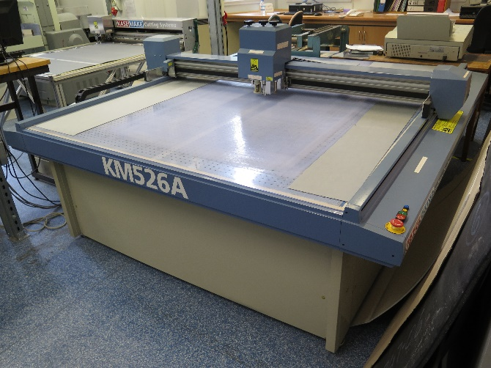

The old Kasemake 5 boxmaking machine

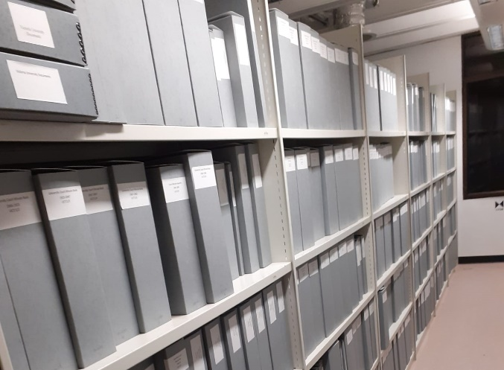 Examples of boxes made on the boxmaker

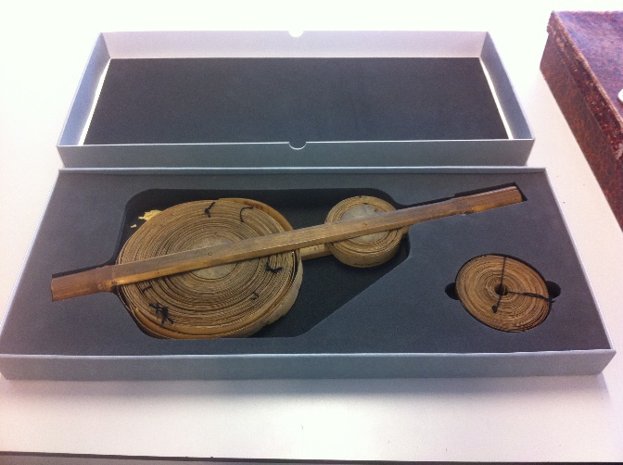

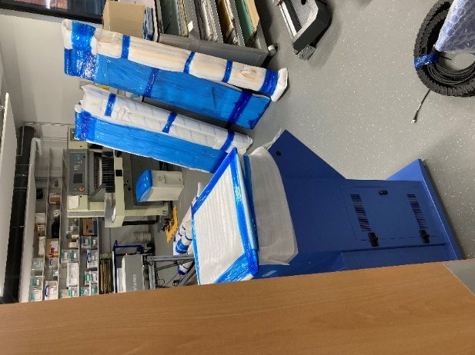

The new Kasemake Mini Grand Pro arrives in parts

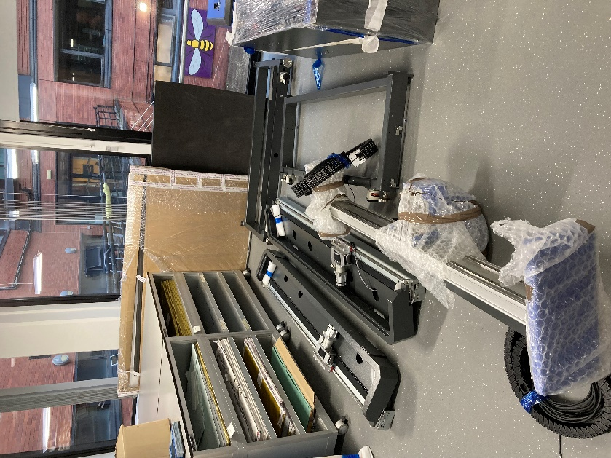

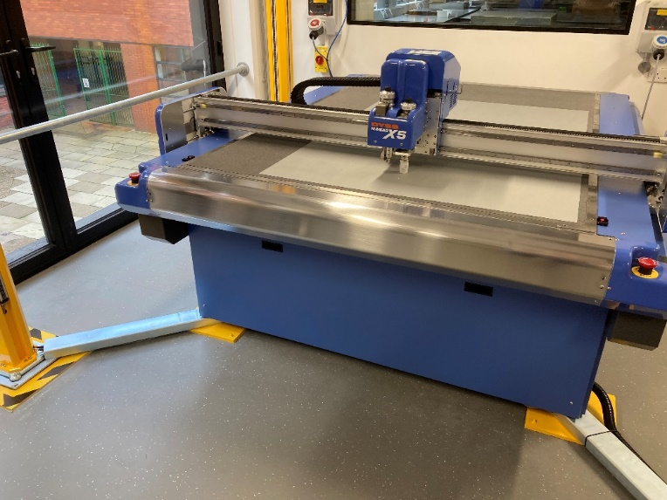

The new Kasemake Mini Grand Pro with safety plyons branching off the corners