1. **Loans of physical items by month and year (January 2018 to February 2021)**

Loans of all physical items are shown, including loans of equipment such as laptops. In-house loans are not included; renewals are not included. The data source is Alma Analytics and further details can be found on the [Library](https://app.powerbi.com/Redirect?action=OpenApp&appId=0411bfda-ad88-43b0-a7e0-86b3cdf9bca3&ctid=c152cb07-614e-4abb-818a-f035cfa91a77) [Planning app](https://app.powerbi.com/Redirect?action=OpenApp&appId=0411bfda-ad88-43b0-a7e0-86b3cdf9bca3&ctid=c152cb07-614e-4abb-818a-f035cfa91a77). Data are as at the end of February 2021.

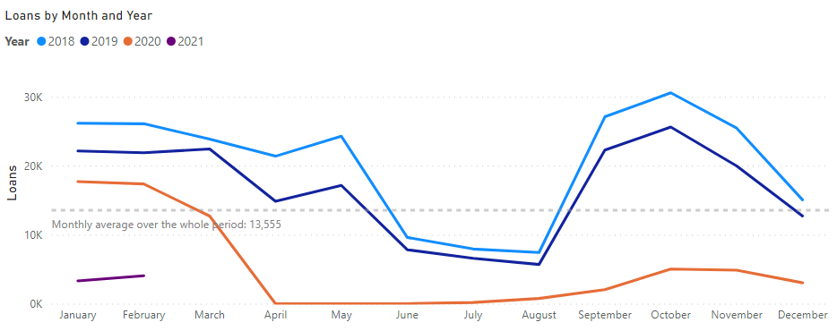 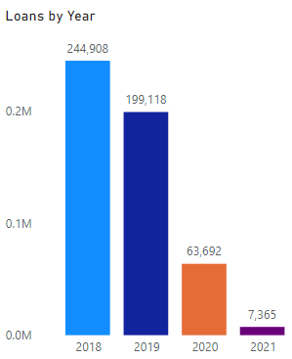

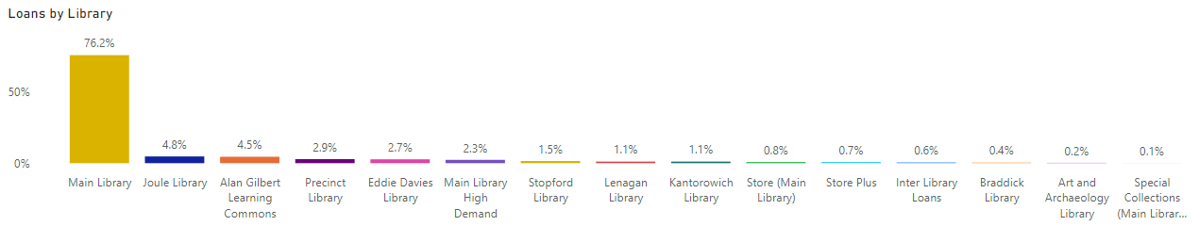

1. **Loans of physical items by year and by library (excluding Main Library)**

Loans of all physical items between 2018 and 2020 are shown, including loans of equipment such as laptops. In-house loans are not included; renewals are not included. Loans from Main Library are excluded to allow the number of loans from other libraries to be seen in more detail.

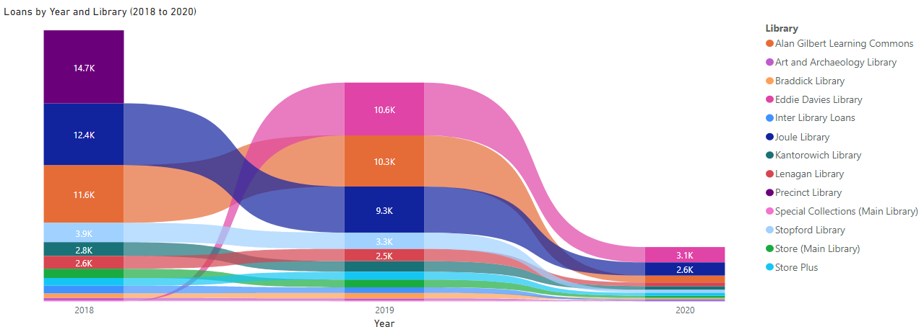

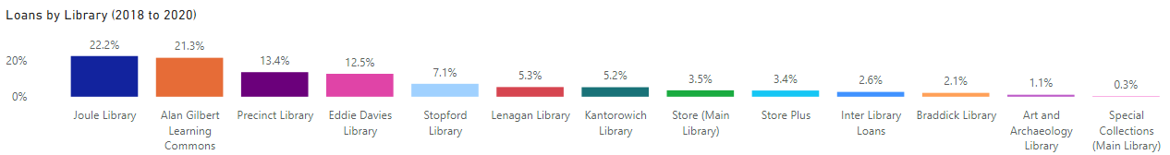

1. **Loans of physical items by month and by library (excluding Main Library)**

Loans of all physical items are shown, including loans of equipment such as laptops and laptop chargers. In-house loans are not included; renewals are not included. Loans from Main Library are excluded to allow the number of loans from other libraries to be seen in more detail. Data are shown for 2019 only (since 2020 was atypical for loans).

