Centre for Digital Trust and Security
Seedcorn Final Report 22/23

Project Title:
Defining the acceptability of ‘safe’ data linkage to identify women at risk of postnatal complication in Greater Manchester
Project Investigators:
Dr Victoria Palin (Principal)
Prof Niels Peek
Prof Jenny Myers
Dr Anthony Wilson
Bradley Quinn

Change: Dr Siobhán O'Connor, a senior lecturer in the School of Health Sciences replaced co-I Dr Stephanie Steels during this project. SS was no longer available due to unforeseen circumstances and on extended leave.
SO’s research focuses on the co-designing, testing, and implementing technologies in healthcare, with a particular interest in software, hardware, and computing systems that can support patient self-management. SO has helped to plan and co-facilitate workshops, as well as the analysis and write up of our recommendations.
Project overview:

This project will formed two working groups.
- a diverse Patient and Public Involvement and Engagement (PPIE) group of expectant and/or parents that lived within Greater Manchester.
- a representative stakeholder group of general practitioners (GPs) and midwives working in Greater Manchester.
Facilitator-led workshops or one-to-one interviews with some clinical representatives were conducted from March – June 2023 to explore the acceptability of:
- linking EHRs between maternity services for research to identify mothers in the postpartum period.
- using de-identified versions of this data (secondary use) in a secure environment to develop mathematical algorithms that predict individual risk for developing postnatal disease.
- developing a dashboard to notify primary care doctors of their patients that recently delivered, requiring medical review.
- prioritising GP review by risk using the mathematical algorithms.
A formal evaluation of each workshop was performed using thematic analysis. This evaluation informs both the acceptability and trustworthiness of secondary use of data in maternity research and provides some recommendations to incorporate into the design and implementation of a digital intervention that can improve postnatal care of mothers across Greater Manchester.

Key findings:

The reality of postnatal examinations with a GP six weeks after delivery were very different to patient expectations, with many public contributors describing them as a “tick-box” exercise that lacked comprehensiveness or personalisation. Whilst clinical staff also reported system constraints and ineffective systems or processes that prevented detailed and thorough examinations.
Contributors were supportive of safe data linkage to identify women at risk of postnatal complications seeing real benefit of research to better healthcare delivery and long-term postnatal health. There were some concerns of data safety and disrespectful use of data, however all contributors favoured the approach suggesting better education of women and their families about the benefits of sharing health data to tackle some of the misconceptions that exist on how and why health data is collected and used. Suggesting tailored educational campaigns to specific communities to maximise inclusivity. All contributors saw the potential benefit of digital risk predictions tools, streamlining and automating processes, and the ability to highlight women at risk of postnatal complications with a digital tool that could devise an individualised care plan based on individual risk factors and patient facing lifestyle recommendations. Contributors also highlighted important design considerations, challenges with systems integration and community-based communication needs.
[Please note – this is lifted out of the manuscript – so would need paraphrasing if being published in a blog/shared. Thank you.]
Outputs to date:
Ethical approval was obtained (UoM Full ethical approval, awarded Jan 2023).

March to June 2023:
Completed 3 PPIE workshop (face-to-face) with 27 contributors of mixed ethnicity.
Completed 4 Clinical stakeholder interviews or focus group discussions (all virtually) with 7 stakeholders, ranging from GPs, midwives and health psychologists.
https://twitter.com/v1kki_p/status/1657072671983534086
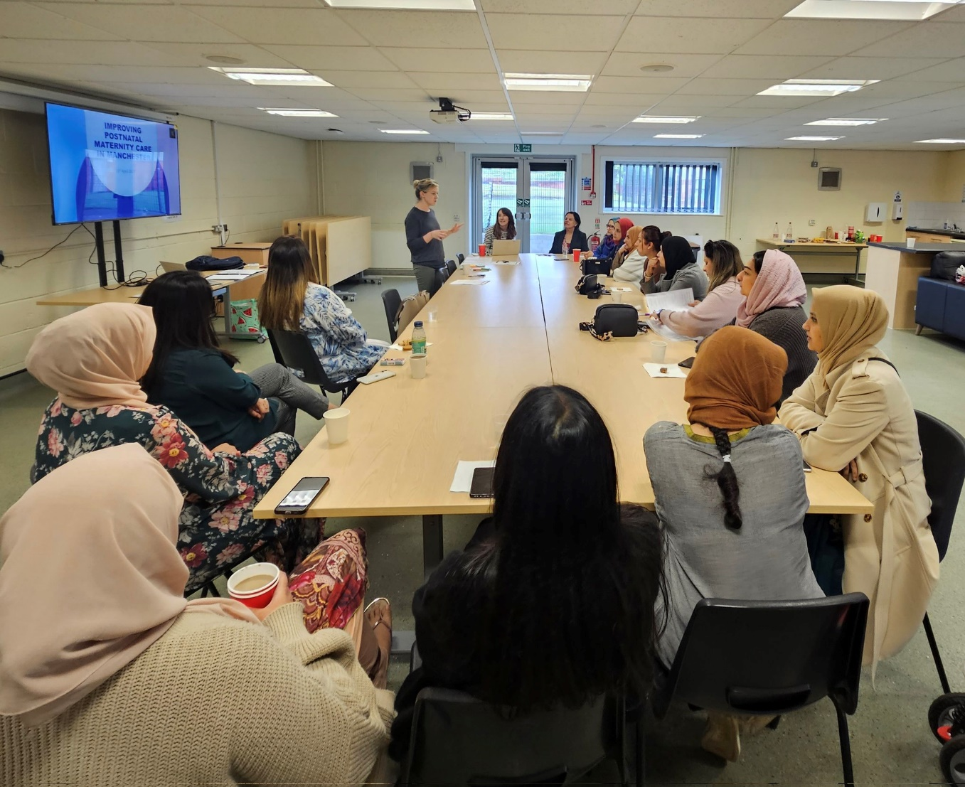

Maintained communication with the PPIe representatives and involving interested parties in future research studies.

13th September 2023: Spoke at a public engagement event hosted by UCLAN medical school and Professor Romesh Gupta, chairman for the National Forum for Health & Wellbing. Summarising the work conducted as part of this funding. https://twitter.com/v1kki_p/status/1706643415545376992

Manuscript written to report of the key findings and recommendations, will be submitted for peer-review this October.

Were all planned outcomes achieved?
If not, how did you mitigate non-achievement?

All planned activities have been achieved including:
Ethical approval,
Recruitment of PPIE and clinical stakeholders
Conducting workshops,
Analysis of content gathered from PPIE and clinical workshops,
A written report of the key findings and recommendations – which will be submitted as a manuscript for peer-review this October.

Planned activities post-project:
Continue to communicate with PPIE members as work develops. Some have acted as a collaborator on a recent grant application. This grant application has been submitted featuring - some of the initial findings from this work in the background and evidence support section - with the ambition of achieving funds to develop an automated way to identify women postnatally using routinel collected EHRs in local and national datasets.
I have the plan to submit an additional, more substantial grant, early in 2024. This will feature exploring the technical infrastructure and developing methods to interrogate secondary care patient data with primary care records within GMCR (Greater Manchester Care Record). The overall aim to improve antenatal and postnatal care of mothers who experiences high risk in pregnancy, and or poor outcomes. This will also feature model development for identifying those at higher risk, as well as dashboard development to display findings to clinical teams and working with clinicians to map out treatment plans for those at higher risk.

