# Welcome Week

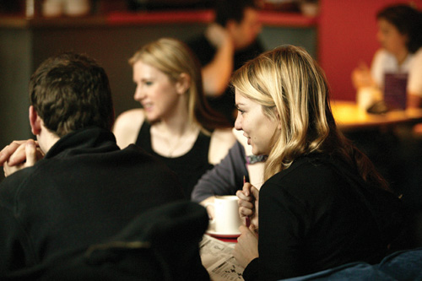

*Details of events organised for you during*

*Welcome Week!*

**Welcome Week Fair**

From Monday 17 September to Wednesday 19 September there will be a School of Arts, Languages & Cultures Welcome Week Fair in the North and South Foyers of the Samuel Alexander Building (see link to campus map below). There will be lots of information available about University services and facilities (eg. library, careers, sport) as well as more specific information relating to the School (eg. peer mentoring, societies). There will also be School Helpdesks so you can ask for help and advice.

**CLASSICS AND ANCIENT HISTORY - SCHEDULE FOR WELCOME WEEK SEPTEMBER 2012**

**MONDAY 17 SEPTEMBER**

**11.00– 12.00 Welcome meeting with Peer Mentors: Ellen Wilkinson Building, C5.1**

With Dr Peter Liddel (Peer Mentor Co-ordinator)

**12.00-13.00 Welcome the School of Arts, Languages and Cultures: Theatre 1, Stopford Building**

**TUESDAY 18 SEPTEMBER**

**10.30-11.30 Welcome to CLAH Meeting: All Level 1 students must attend. Samuel Alexander Lecture Theatre.** With Dr Polly Low (Head of Depart) and Dr Andy Fear (UG Programme Director).

**12.00-12.30 Introduction to the Library: Samuel Alexander Lecture Theatre.** With Stephen Pearson (The University of Manchester Library) - A brief summary of the facilities available at the John Rylands University Library

**12.30-13.00 Prospects for Study Abroad: Samuel Alexander Lecture Theatre.** With Paula Kolata - A short talk on the study abroad possibilities for your second year

**13.00 School Barbecue:** Lime Café (Lower Ground, Samuel Alexander Building)

**14.00-15.00 Options Clinic: Samuel Alexander A113.** With Dr Andy Fear – A help session for advice and guidance on choosing your courses

**WEDNESDAY 19 SEPTEMBER**

**14.00-15.00 Students invited to meet with their personal tutors. Venues will be announced.**

**15.30-17.00 ClAH Peer Mentor Meeting Party: North Foyer, Samuel Alexander Bldg.**

**THURSDAY 20 SEPTEMBER**

**9.30–17.00 An Introduction to the Ancient Languages:** This **compulsory** all day session will introduce students to the study of Greece and Rome at university. Please see the separate enclosed letter from Dr Fear for more details.

**17.00-18.00 Welcome Party! North Foyer, Samuel Alexander Bldg.**

**FRIDAY 21 SEPTEMBER**

**11.30-14.00 Exhibition tour: ‘Faces and Voices’**: Identity, Culture, and Artefacts from Roman to Contemporary Egypt, **at the John Rylands Library, Deansgate.** Meet at North Foyer, Samuel Alexander Bldg., 11.30