TAB_col_white_background.eps

# Change Leadership Skills Framework: *Inclusive Leadership*

## Definition

*Inclusive Leadership* is about ensuring all staff have equal opportunities for development and to voice their views, as well as ensuring working arrangements and procedures account for different needs. It is also about personal behaviour, ensuring all words and actions show commitment to equality and diversity.

Behavioural indicators

1. I ensure equal access to development opportunities for all.
2. I enable and encourage people to express their views and ask questions
3. 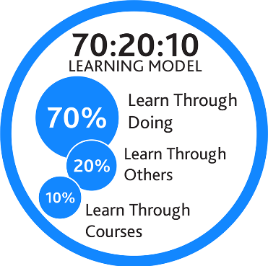I ensure that working arrangements, resources and processes respond to different needs, abilities, values and ways of working
4. I ensure my own behaviour, words and actions support a commitment to equality of opportunity and diversity.

## Example on-the-job development activities *(70)*

* Facilitate a discussion with your team about how to make the most of peoples’ strengths and motivations, to help raise of differences and the opportunities for the team.
* Review how the Technical Review may affect people differently in your team including speaking to individuals for their input. Put a plan in place to ensure every person’s needs are accounted for.
* Analyse the diversity of the technical teams, and encourage a discussion with the rest of the leadership team about your role in building the diversity and representation across all levels of technical staff.

|  |
| --- |
| *Capture your notes here:* |

## Suggested reflection / discussion questions *(20)*

Q: Every person has biases which are formed through life from our experiences. What are yours, and how can you manage them to ensure they don’t play out in your behaviour/leadership?

Q: Consider how you provide people opportunities to share their views and provide feedback on the Technical Review. Do you provide varied opportunities for your team, and do they feel that their feedback has been heard/acted on when they provide it?

Q: How might individuals in your team require development during and after the Technical Review? How can you ensure every person gets the opportunity, not just those who ask for it the loudest?

|  |
| --- |
| *Capture your notes here:* |

## Recommended learning resources *(10)*

|  |  |
| --- | --- |
| Image result for ARTICLE ICON | Read: [Why Inclusive Leaders Are Good for Organisations, and How to Become One](https://hbr.org/2019/03/why-inclusive-leaders-are-good-for-organizations-and-how-to-become-one)  **Harvard Business Review – 15mins** |
|  | Watch: [Unconscious Bias: A Spotter’s Guide](https://app.goodpractice.net/#/manchester-tfl/s/709236e4)  **L&D Toolkit - 4mins** |
| See the source image | Listen: [Key Traits of Inclusive Leaders](https://www.linkedin.com/learning/inclusive-leadership/welcome?u=74653818)  **LinkedIn Learning – 45mins** |

|  |
| --- |
| *Capture your notes here:* |