What’s this programme all about?

# The big picture

Flexible Learning aims to create the right conditions and support structures to allow us to explore new ways of teaching and learning.

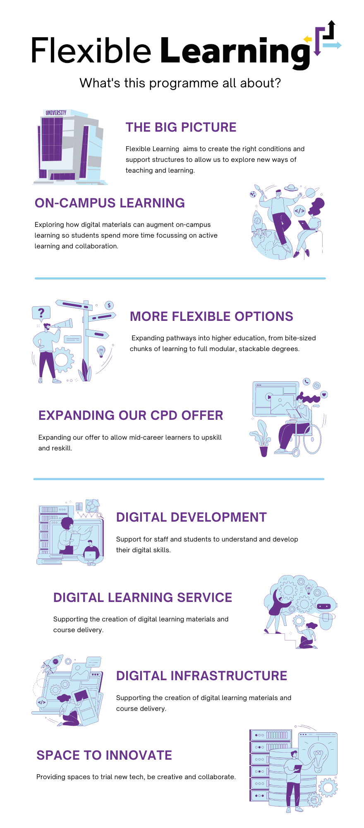

# ON Campus Learning

Exploring how digital materials can augment on-campus learning so students spend more time focussing on active learning and collaboration.

# More Flexible Options

Expanding pathways into higher education, from bite-sized chunks of learning to full modular, stackable degrees.

# Expanding our CPD offer

Expanding our offer to allow mid-career learners to upskill and reskill.

# Digital Development

Support for staff and students to understand and develop their digital skills.

# Digital Learning Service

Supporting the creation of digital learning materials and course delivery.

# Digital Infrastructure

Reviewing applications and tools for teaching and learning, ensuring these are easy to use and accessible.

# Space to Innovate

Providing spaces to trial new tech, be creative and collaborate.