MA (Oxon) FCIPD - Biography

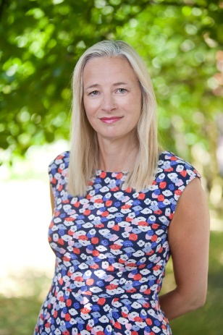
Anna is an experienced and highly effective consultant, executive coach and facilitator with a proven track record of coaching and running leadership development programmes in blue chip organisations. She has experience of working in the health care, pharmaceutical, manufacturing and sales sectors and has delivered coaching, leadership and team development in Europe, the US, Asia and Australia. She has worked with leaders and teams at all levels, including Executive Team and Board members.

Anna has extensive organisational development experience gained through a number of senior HR and OD roles at AstraZeneca plc and through the direct line management of global teams. She is a Fellow of the Chartered Institute of Personnel and Development and is qualified in MBTI Step 1, OPQ and EQi 2.0 (including the 360 tool). Anna also has extensive experience of Belbin’s Team Types and the Thomas-Kilmann Conflict Mode Instrument. Anna is a qualified ILM Level 7 Executive Coach and a member of the European Mentoring and Coaching Council.

In her role as a consultant, Anna has worked with a wide range of clients, including BAe Systems, Trelleborg Group, Bentley Motors, Hallmark Cards, AstraZeneca, Blackpool Teaching Hospitals, Tameside Hospital NHS Trust, Bolton GP Federation, MacMillan Cancer Support, The General Medical Council, Manchester, Nottingham Trent and Newcastle Universities, Blackpool and the Fylde College and LOROS Hospice, Leicester.

Anna has a warm and engaging style. She is passionate about what she does and invests energy and enthusiasm to ensure that she meets her clients’ needs.



