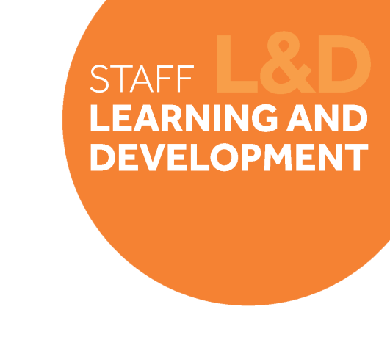TAB_col_white_background.eps

# Change Leadership Skills Framework: *Personal Resilience*

## Definition

*Personal Resilience* centres on self-awareness; having a good understanding of personal levels of resilience and when to access support, as well as being proactive with good everyday habits to promote resilience levels. It is also about the ability to recover from setbacks, and have an overall positive outlook towards the technical review and the direction for the service.

Behavioural indicators

1. I acknowledge when I’m struggling and access support when I need it.
2. **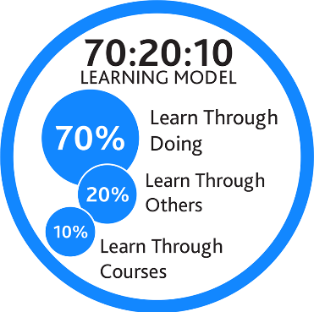**I have good every day habits to support my personal resilience
3. I feel able to bounce back from setbacks and challenges
4. I am optimistic and feel positive about the outcomes of the Technical Review.

## Example on-the-job development activities *(70)*

* Complete an assessment of where you get your resilience from (suggested tool below) and think about the implications of this for you in your role. Are there any risks or gaps that you need to fill?
* Map out the things that top-up your resilience, and the things that drain on your resilience levels. Talk to a trusted colleague about steps you can take to manage your ‘drains’ so they don’t have a negative impact.
* Encourage open conversations in your team about resilience and wellbeing, in both team meetings and in 1:1s. Encourage colleagues to share their tips to keep their resilience high and discuss habits and behaviours that the team can adopt to support each other’s’ resilience.

|  |
| --- |
| *Capture your notes here:* |

## Suggested reflection / discussion questions *(20)*

Q: What network do you have around you in your role that you can access when you feel you need support?

Q: Rate you level of optimism for the outcomes of the Technical Review on a scale of 1-10. Consider 1) where you need it to be and how you could get it there, and 2) how your level of optimism will be affecting your team.

Q: Reflect on your personal levels of adaptability, and how this may be impacting your resilience during periods of change.

|  |
| --- |
| *Capture your notes here:* |

## Recommended learning resources *(10)*

|  |  |
| --- | --- |
| SL&D white block.png | Attend: [Developing Personal Resilience for Change](https://app.manchester.ac.uk/training/profile.aspx?unitid=7916&parentId=183&returnId=183&returntxt=Return+To+Search&returnQs=%3fterm%3ddeveloping+personal%26org%3d0%26typeId%3d2)  **Learning for All Course – 2.5hours** |
| See the source image | Watch: [Building Resilience](https://www.linkedin.com/learning/building-resilience/become-resilient?u=74653818)  **LinkedIn Learning – 34mins** |
|  | Complete: [Self-Coaching Modules](http://documents.manchester.ac.uk/DocuInfo.aspx?DocID=48740)  **Mindset – (various)** |

|  |
| --- |
| *Capture your notes here:* |