Library Environmental Sustainability (ES) Working Group: Terms of Reference

Purpose:
- To facilitate, support and advocate engagement and contribution from colleagues across the Library in driving forwards the ES agenda ​through on the ground action and activities
- To mobilise and empower staff across the Library to engage in activity to support environmental sustainability as agreed with the ES Steering Group.
- To develop the Working Group as a hub to engage with and share ES activity across the Library and drive action
- Drive action within the ES space by advocating for change with the Library ES Steering Group and senior Library colleagues
- To lead on agreed action and projects (as directed by the Library ES Steering Group) in partnership with colleagues from across the Library and wider University, for example with the University 'Sustainability Squad'.
- To ensure equity of opportunity to lead on and participate in ES activity across the Library ​
- To develop and embed best practice, encouraging both Library staff and the whole Library community to take positive steps towards a greener future when using our buildings and engaging with our services.
- To implement ES initiatives that don’t sit under a particular Library Directorate
- To highlight, explore and publicise the Library's potential role in University led ES initiatives and events

Expressions of Interest

- Megan Johnston (CSD)
- Naomi Brook (EESI)
- Nikki Tomlinson (EESI)
- Laura Briggs (CSD)
- Lyndsay Wilson (EESI)
- Phoebe Hall (EESI)
- Jonathan Owen (CSD)
- Dana Barringham (EESI)
- Alex Hill (CSD)

Membership, roles and responsibilities:

Person | Representing | Responsibilities
Helen Foster |  | Co-Chair  Link to ES Steering Group
Laura Snow | Rylands | Co-Chair
Eloise Anderson | Teaching, Learning & Student intern | Student voice

To be a success, the ES Working Group requires the full engagement of all its members.

Expectations of members include the following:

- That they will proactively contribute and lead on agreed activities and projects
- That they will be the 2-way link between the wider Library community and the Library ES Steering group
- That they will take a proactive lead on engaging the whole cohort of Library staff to take positive action on ES
- That they will take a proactive lead on determining how we engage our end users and customer groups in ES and ensures they take positive action to improve ES when engaging in Library services
- That they will ensure positive changes and good practice are communicated, celebrated and shared with Library colleagues and the wider Library community
- That they will participate in the administration, organisation and development of the group
- That they will be proactive in their use of the Teams space to share issues and learn from each other, both inside and outside of any formal meetings.

Governance:
- The Library Environmental Sustainability Working Group will support the Library's ES Steering Group in mobilising ES within the Library
- The Working Group will be co-chaired by members of DMT, including representation for Rylands
- Working Group membership will be drawn from across the Library at all levels and should be broadly representative of the divisional structure of the Library.
- Other members may be coopted from time to time to provide advice, support and leadership in defined areas of expertise as necessary.

The Working Group is responsible for:

- Developing, maintaining and updating a local Library level action plan to embed ES into our day-to-day activities and working practices
- Encouraging and supporting grass roots action by engaging all Library staff with ES activities
- Working Group meetings will normally be monthly and last no more than 1 hour
- If a member is unable attend, they can nominate an alternate to attend in their place
- Meetings will consist of a mix of online and face to face according to the agenda items and activity required

Governance structure and relationships
Indicative diagram showing the links between current ES groups at UoM and the Library.
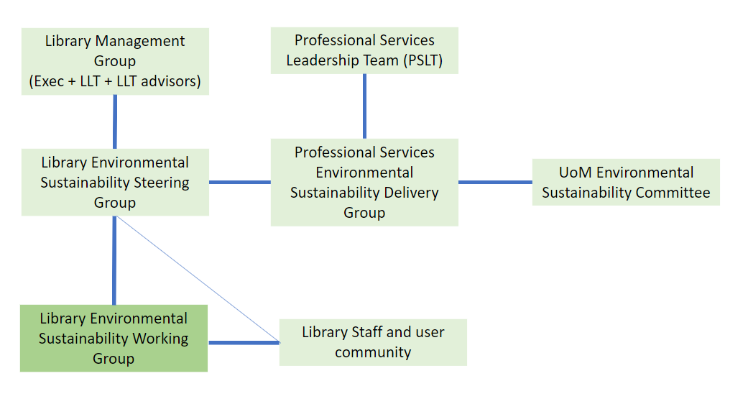
Link: Library ES Steering Group - links to nodes in Library and UoM.pptx

Agreed by ES working group and approved by ES Steering Group Dec 2024

