**Key Dates 2025-2026**

**PAD Review meeting dates**: These are formal PAD review meetings that take place in service between the trainee PWP and PAD sign off person. This meeting could also include the clinical skills supervisor and case manager if these people are not the overall PAD sign off person.   The PAD review meetings are an opportunity for self-assessment and for the trainee to assess progress throughout the programme. Supervisors/PAD sign off person will complete a brief report commenting on the trainee’s progress towards programme learning outcomes.   These meetings should be scheduled to take place over the course of training. There are 5 suggested dates. Review meetings enable a discussion to make sure trainees are making the right sort of progression towards completion.  The end point review is about finalising and signing off the completed document. Please make sure that both the trainee PWP and the PAD sign off person completes the PAD review meeting forms on the PARE system – pages 8-12

Recommended schedule

|  |  |
| --- | --- |
| **PAD Review Meetings** | **Dates** |
| Meeting 1 (Initial meeting) | September/October 2025 |
| Meeting 2 (Interim Review) | November/December 2025 |
| Meeting 3 (Interim Review) | March 2026 |
| Meeting 4 (Interim Review) | May 2026 |
| Meeting 5 (End-point Review) | Before 20th July 2026 (Submission Date) |

**PAD Timeline**

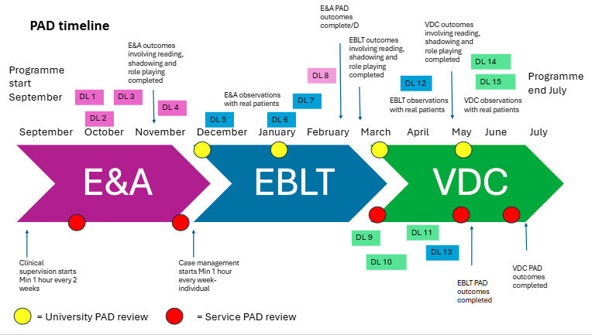

**Academic Advisor tutorials with students:** Throughout the programme, Academic Advisors meet regularly with trainees to ensure they are progressing well and to offer support. AA’s will review trainees PAD’s to ensure they are progressing with practice based outcomes. You will find the scheduled dates for AA meetings within the programme timetable, but for ease please see the table below. Academic Advisors will make themselves available for additional tutorials with students if required.

|  |  |
| --- | --- |
| **AA Tutorials** | **Dates** |
| Meeting 1 (initial meeting) | 15th September 2025 |
| Meeting 2 (Interim Review) | 8th December 2025 |
| Meeting 3 (Interim Review) | 19th January 2026 |
| Meeting 4 (Interim Review) | 9th March 2026 |
| Meeting 5 (final meeting) | 18th May 2026 |

**Assessment dates:** You will find assessment dates in the Trainee PWP Supervisor Handbook. For ease please see the key assessment dates below:

|  |  |
| --- | --- |
| **Assessment** | **Dates** |
| Formative Problem Focused Assessment | 3rd and 4th November 2025 |
| Summative Problem Focused Assessment | 17th and 18th November 2025 |
| Formative Assessment and Engagement unit essay | 5th January 2026 |
| Summative Assessment and Engagement unit essay | 10th February 2026 |
| Formative treatment session | 2nd and 3rd March 2026 |
| Summative real life recording | 18th May 2026 |
| Formative Evidence based treatment unit essay | 11th May 2026 |
| Summative Evidence based treatment unit essay | 16th June 2026 |
| Formative VDC Presentation | 3rd June 2026 |
| Summative VDC presentation | 8th July 2026 |
| Formative VDC Supervision essay | 8th June 2026 |
| Summative VDC Supervision essay | 13th July 2026 |
| Practice Assessment Document (PAD) | 20th July 2026 |

**Programme and service webinar dates:** The programme delivers a pre-programme webinar to services supporting a University of Manchester trainee PWP. This webinar will give you an overview of the programme as well as any key updates or changes. The programme also offers a recruitment webinar to discuss planning for the upcoming cohorts.

|  |  |
| --- | --- |
| **Webinar** | **Dates** |
| Pre-programme webinar | 1st September 2025 |
| Update Webinar | Date TBC |
| Recruitment webinar | Date TBC |

**Clinical placement review audit**: To ensure services are offering trainee PWP’s a learning experience that confirms to the IAPT guidance, HEI’s will carry out clinical placement review audits with services twice per academic year. Once in person and once online. The dates for Sept 24-25 are listed below.

|  |  |
| --- | --- |
| **Webinar** | **Dates** |
| Clinical placement review audit 1 | 21st October 2025 |
| Clinical placement review audit 2 | 23rd March 2026 |