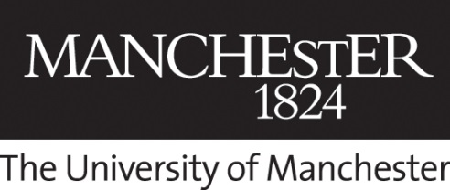 | University Heritage Tours Booking Form
The University of Manchester History and Heritage is pleased to offer bespoke and private Heritage Tours for the University’s faculties, schools and units.
Available for a maximum of twenty people, all University Heritage Tours are subject to availability. The maximum tour length is one hour.
If you would like to make an enquiry about a bespoke/private tour for your faculty, school, unit or event, please fill out the form below.

Organiser Contact Details
Title
First Name
Last Name
Phone Number
Email address
Faculty/School/Unit
Job Title

Tour Group Details
Number of attendees
Proposed date/time
Proposed length of tour (max 1 hour)
Please tell us who the tour is for…

Please email your completed form to
heritage-events@manchester.ac.uk

