From: Climate Network <climatenetwork@manchester.ac.uk>
Sent: 14 October 2024 17:47
To: CLIMATE-NETWORK@listserv.manchester.ac.uk
Subject: [CLIMATE-NETWORK] Newsletter

Hi everyone J

UoM Climate Network

Our recorded talks are now available on our YouTube channel.

UoM Events

Individuals involved in UoM Research Only: Team Research Microcatalyst Funding Launch
Faculty of Biology, Medicine and Health
15 Oct 2024 – 10:00 - 13:15
https://events.manchester.ac.uk/event/event:wkb-m056whez-codz42

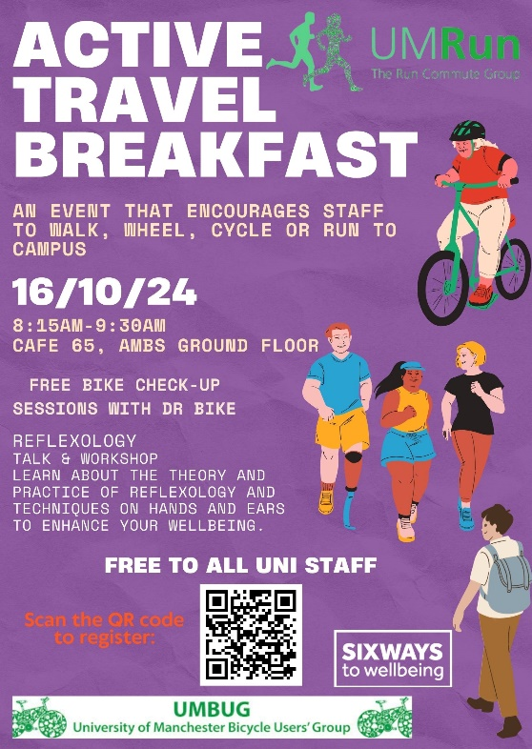
UoM Staff Only (sign up via form): Active Travel Breakfast Event
UMRun / UMBUG
16 Oct 2024 – 08:15 - 09:30
https://forms.office.com/e/JaNQrazcaU

Irene Manton Lecture 2024 (10th anniversary)
Faculty of Biology, Medicine and Health
16 Oct 2024 – 17:30 - 19:00
https://events.manchester.ac.uk/event/event:kqx-m1915v03-l6wxwf

Global Marxism - Simin Fadaee in conversation with Kevin Gillan
Manchester University Press
16 Oct 2024 – 18:30 - 20:00
https://events.manchester.ac.uk/event/event:qua-m1qjb94w-wkftt2

Modern Manchester Unveiled: Exploring the Cultural Tapestry
Manchester University Press
18 Oct 2024 – 18:30 - 20:00
https://events.manchester.ac.uk/event/event:oub-m1qjig8w-ehvgt3

Festival of Social Science
Economic and Social Research Council (ESRC)
19 Oct - 9 Nov 2024 @ Various Times
https://festivalofsocialscience.com/

Measuring resilience and vulnerability
Alliance Manchester Business School
21 Oct 2024 – 10:00 - 11:30
https://events.manchester.ac.uk/event/event:ivp-m2098y3t-8dtatw

‘Connecting Through Culture as We Age’: Digital Creative Citizenship
Manchester Urban Ageing Research Group
21 Oct 2024 – 12:00 - 13:30
https://events.manchester.ac.uk/event/event:ur8-m19c1stk-7s2spj

Atmospheric Violence: Disaster and Repair in Kashmir (book launch)
Faculty of Humanities
23 Oct 2024 – 16:00 - 17:30
https://events.manchester.ac.uk/event/event:ekn-m0c9q5hr-cptz64

Gathering of Strangers: Why Museums Matter
Creative Manchester
24 Oct 2024 – 18:00 - 20:00
https://events.manchester.ac.uk/event/event:sos-m10qyimq-he6ufj

Meet The Changemakers: Black History Month
Manchester Museum
26 Oct 2024 – 12:00 - 16:00
https://www.eventbrite.com/e/meet-the-changemakers-black-history-month-tickets-1024920864897

AI and the City: Urbanistic perspectives on artificial intelligence
Manchester Urban Institute
28 Oct 2024 – 13:30 - 15:30
https://events.manchester.ac.uk/event/event:gw2-m20gytbq-ale8p7

Digital Futures & Sustainable Futures PhD Workshop
Digital Futures & Sustainable Futures
30 Oct 2024 – 13:00 - 15:30
https://www.eventbrite.co.uk/e/digital-futures-sustainable-futures-phd-workshop-tickets-993588930237
🗣 Interested in presenting?
PhD students are invited to present their research. This is a unique chance to share your insights with an interdisciplinary audience and spark innovative conversations.
🌟 If your research has a digital or sustainable component, please contact kitty.lo@manchester.ac.uk by 21st October 2024, 5 PM. Spaces are limited, so reach out early to secure your spot!

PAID EVENT: Climate Cafés
Manchester Museum
In-person events running every 2 months from 6 Nov 2024 onwards – 17:30 - 19:00
https://www.eventbrite.com/e/climate-cafes-tickets-520550379197

Wild Walks with Manchester Museum: Treescapes sensory walk with Trees
Manchester Museum
9 Nov 2024 – 13:00 - 14:30
https://www.eventbrite.com/e/wild-walks-with-manchester-museum-treescapes-sensory-walk-with-trees-tickets-993019517107

Sustainable Futures Seminar: Sustainable Aviation Fuel & Garment Designing (+ networking session exclusively for Early Career Researchers)
Sustainable Futures
20 Nov 2024 – 14:00 - 16:00
https://events.manchester.ac.uk/event/event:tw9-m21nkkez-tdlwb3

Designing new treescapes in the city
Manchester Museum
30 Nov 2024 – 13:00 - 14:30
https://www.eventbrite.com/e/designing-new-treescapes-in-the-city-tickets-993303787367

Sustainable Futures Annual Conference: Celebrating Interdisciplinary Sustainability Research
Sustainable Futures
12 Dec 2024 – 10:00 - 16:30
https://events.manchester.ac.uk/event/event:bw4-m21mejz7-cc2g0d

The Albatross Lecture 2025: Dr Jared Margulies
Sustainable Futures
23 Jan 2025 – 11:00 - 15:00
https://events.manchester.ac.uk/event/event:hx7-m24mqyp6-tkb2g5

• An episode of UoM’s Talk 200 podcast series focuses upon energy and climate change, with talks from Prof. Alice Larkin, Dr. Aneeqa Khan, and Aidan Rhode.

• UoM Library’s Libby App can now be downloaded on a smartphone or accessed via a browser (UoM login required); there are a number of e-books that were made available for Sustainability Action Month.

• UoM Earth and Environmental Science PhD student Kaydee Barker and environmentalist Cody Sanford have co-created the Livable Future Podcast focussed around current global challenges and how we can work together to create a more liveable future.

• UoM’s Environmental Sustainability Team launched their latest environmental sustainability strategy (2023-2028); the update is provided here.

• Harriet Bickley has created an Easy Everyday Eco Actions booklet full of practical info to help UoM staff & students live, work & study in a more eco-friendly manner.

• Pooja Kishinani and Marion Smith, students at The University of Manchester, have created a Student Guide to the Climate Crisis centred around three themes: the emotions, basic information, and activist advice of climate change.

• Want Not Waste have recorded their various environmental talks, which you can view on their YouTube channel.

Greater Manchester Events

Fossil Free Greater Manchester campaign meeting
Fossil Free Greater Manchester
Online meeting on 2nd and 4th Monday of every month – 18:30 - 20:00
https://www.manchesterfoe.org.uk/events/event/fossil-free-greater-manchester-campaign-meeting-39/

Manchester Extinction Rebellion Groups meeting
XR Manchester
In-person meeting on 2nd Monday of every month – 19:00 - 20:30
https://www.manchesterfoe.org.uk/events/event/manchester-extinction-rebellion-groups-meeting/

Olinda Community Garden volunteering morning
Olinda Community Gardens
Every Tuesday (for the foreseeable future) – 10:00 - 12:30
http://www.manchesterfoe.org.uk/events/event/olinda-community-garden-volunteering-morning/

Soup Night- Manchester
Just Stop Oil
In-person meeting on 3rd Tuesday of every month – 18:30 - 20:30
https://www.manchesterfoe.org.uk/events/event/just-stop-oil-soup-night-manchester-monthly/

Manchester Monthly Meet
Just Stop Oil
In-person meeting on 1st Thursday of every month – 18:30 - 20:30
https://www.manchesterfoe.org.uk/events/event/manchester-monthly-meet-just-stop-oil/

EcoHome Lab: Monthly meetup and skill share
EcoHome Lab
Online meeting on 2nd Thursday of every month – 18:00 - 19:30
https://www.manchesterfoe.org.uk/events/event/ecohome-lab-monthly-meetup-and-skill-share-13/

Bike Friday
Manchester Friends of the Earth
Last Friday of every month (for the foreseeable future) – 08:00 - 08:45
https://www.manchesterfoe.org.uk/events/event/bike-friday-various-locations-2/

Levenshulme Repair Café
Levenshulme Repair Café
Third Saturday of every month (for the foreseeable future) starting 20 Jan 2024 – 10:00 - 12:00
https://www.manchesterfoe.org.uk/events/event/levenshulme-repair-cafe-6/

Plant Swaps @ Manchester Craft & Design Centre
Manchester Craft & Design Centre
Third Saturday of every month (for the foreseeable future) starting 18 May 2024 – 12:00 - 13:00
https://www.manchesterfoe.org.uk/events/event/plant-swaps-manchester-craft-design-centre-2/

Gardening and Clean Up
Olinda Community Gardens
First Sunday of every month (for the foreseeable future) starting 1 Jan 2023 – 10:30 - 13:30
https://www.manchesterfoe.org.uk/events/event/gardening-and-clean-up-2/

Peer Support Group
Climate Conversations
In-person meeting every fortnight from 4 May 2023 onwards – 19:00 - 21:00
https://www.manchesterfoe.org.uk/events/event/climate-conversations-peer-support-group/

Birchfield Park Forest Garden work session
Birchfields Park Wildlife and Biodiversity Group
Various Days @ Various Times
https://www.manchesterfoe.org.uk/events/event/birchfield-park-forest-garden-work-session/

PAID EVENT: How should we pay for driving?
The Manchester Literary and Philosophical Society
14 Oct 2024 – 18:30 - 20:00
https://www.manlitphil.ac.uk/events/how-should-we-pay-for-driving/

Green Social Prescribing Taster Session for Link Workers & Professionals
RHS Garden Bridgewater
15 Oct 2024 – 10:30 - 15:00
https://www.manchesterfoe.org.uk/events/event/green-social-prescribing-taster-session-for-link-workers-professionals-rhs-bridgewater/

How to Save Windermere – A conversation with Matt Staniek & Prof. Jamie Woodward about the campaign to protect Lake Windermere and our waterways from sewage
Save Windermere campaign and Patagonia
24 Oct 2024 – 18:30 - 21:00
https://www.manchesterfoe.org.uk/events/event/how-to-save-windermere-a-conversation-with-matt-staniek-prof-jamie-woodward-about-the-campaign-to-protect-lake-windermere-and-our-waterways-from-sewage/

Repair Café
Boilerhouse
26 Oct 2024 - 10:00 - 12:00
https://www.manchesterfoe.org.uk/events/event/repair-cafe-boilerhouse/

Apple & Pumpkin Day
Hulme Community Garden Centre
27 Oct 2024 - 11:00 - 16:00
https://www.manchesterfoe.org.uk/events/event/apple-pumpkin-day-hulme-community-garden-centre/

Ending the fossil fuel era: how we win a just transition
Global Justice Now and Manchester Climate Justice Coalition
27 Oct 2024 - 14:00 - 17:00
https://www.manchesterfoe.org.uk/events/event/ending-the-fossil-fuel-era-how-we-win-a-just-transition-manchester-event-global-justice-now-manchester-climate-justice-coalition/

Manchester - People, Planet, Pint: Sustainability Meetup
Small99
31 Oct 2024 – 18:00 - 21:00
https://www.eventbrite.co.uk/e/manchester-small99s-people-planet-pinttm-sustainability-meetup-tickets-781655150597

• There are a number of ways that you can recycle single-use plastics both within Manchester and further afield:

(1) Co-op have been running a soft plastics recycling scheme for plastic bags and product wrapping (plastics that can be scrunched and that ‘ping’ back) at their stores. As an aside, yet still very much relevant to sustainability, Co-op are also helping to expand Hubbub’s Community Fridge Network, a programme that can potentially tackle a number of societal ills, including: food waste, food poverty, and social isolation.

(2) Stockport-based Plastic Shed have reignited their collections of specific types of plastic lids, soft stretchy plastic packaging, vinyl banners, straws, and plant pots to creatively recycle and repurpose them into useful items; they particularly need your plastic donations between Oct 2023 – Feb 2024 in order to build a sculpture after receiving funding via UK SPF. They also hold workshops and act as a community space; they share their Merseyway Workshop with a community-focussed design studio called Easy Peel Studios, who also run their own events too.

(3) An organisation called ReFactory (previously ReWorked) have partnered with a number of organisations, including Boots, to promote better recycling practices in the UK. A number of recycled household products can be purchased from their online shop, as well as a wide range of recycling boxes for a variety of plastic waste, such as for lateral flow tests, face masks, disposable gloves, visors etc. (starting at £72 per box).

• Manchester Climate Change Agency recommend 15 actions to take to become a zero carbon city

Other Events

Heading for Extinction (and what to do about it)
Extinction Rebellion
Online meeting on 2nd Wednesday of every month – 19:00 - 20:30
https://www.manchesterfoe.org.uk/events/event/heading-for-extinction-and-what-to-do-about-it-extinction-rebellion-2/

The state of EU right to repair: missing pieces to a thriving repair economy in Europe – Webinar
Repair EU
15 Oct 2024 – 12:30 - 14:00
https://www.manchesterfoe.org.uk/events/event/the-state-of-eu-right-to-repair-missing-pieces-to-a-thriving-repair-economy-in-europe-webinar-right-to-repair/

An introduction to Active Hope – a resilience and well-being practice
Friends of the Earth
16 Oct 2024 – 18:00 - 20:15
https://www.manchesterfoe.org.uk/events/event/an-introduction-to-active-hope-a-resilience-and-well-being-practice-friends-of-the-earth/

• Dr. Emily Heath of Scientists for Global Responsibility has shared 9 tips to encourage a culture of climate activism in universities.

• In Spring 2022, the Department for Education (DfE) released a new policy paper entitled ‘Sustainability and climate change: a strategy for the education and children’s services systems’, setting out key goals such as the introduction of a Natural History GCSE, a National Education Nature Park (NENP), a Climate Leaders Award (CLA), and a National Climate Education Action Plan (NCEAP). MMU are champions of the NENP and CLA, whereas The University of Reading will lead the implementation of the NCEAP.

• UCL’s Generation One collective have created their own Climate Podcast.

• The new Sustainable Futures careers course, aimed at providing teaching professionals with content suitable for a teenage audience (14-18y.o.), has been developed by WWF-UK in an attempt to bolster the next generation with a greater awareness of sustainability as they decide upon their future careers.

• Kudos, an online tool for improving research impact, created a climate change knowledge cooperative to aid the sharing of the latest climate change research in a non-technical / comprehensible format.

• A better future for our woodlands: 12 ideas to help British forests grow

• The Lemu app can be downloaded on smartphones. The organisation’s mission relies on the idea of leveraging technology to learn, explore, and protect nature, as well as improving conservation measures and outputs. They are looking to prove that financing conservation projects is not about charity but an investment into the future of our Planet

• The WeAre8 app can be downloaded on smartphones – launched in 2020, it became the world's first B corp-certified social media ecosystem, built to transform the digital advertising sector and address the broken and divisive state of the social media industry. The app’s purpose is to make a big impact through small daily actions; you can earn rewards for watching videos that support social and environmental causes.

• Skoot is no longer the app it used to be (which allowed you to plant free trees for every car journey), its model changed after it succeeded in its ‘1 million free tree challenge’, it is now an award-winning climate change platform dedicated to helping its subscribers – both businesses and individuals – to reducing their carbon footprints through a variety of off-setting methods.

• Downloading the Treekly app on a smartphone allows you to plant 1 tree each week for free (seemingly in Madagascar); by tracking your footsteps, using either your phone’s built-in pedometer or a fitness tracker/smartwatch, you can convert your 25,000 steps per week [5,000 each day for 5 days] into the planting of a tree.

• Downloading the TreeApp app on a smartphone allows you to plant a tree for free, in an area that it’s needed e.g. often in the Global South but now also in the UK, every single day (and now there’s no daily limit). Also, if you own land (or know of potentially suitable land) for tree planting? Fill in this form and let the people behind TreeApp know.

• AllotMe – originally marketed as the ‘Airbnb for your Garden’ sounds like a great concept – whereby individuals can rent green spaces to grow food within major cities/urban environments, and garden owners can monetise their land (although many garden spaces appear to be free to use).

• Spare 3 minutes to fill in Currensea’s Sustainability survey and each completed survey removes 100 plastic bottles from the oceans (thanks to their Plastic Bank partnership).

• A CO2 widget created to communicate daily levels of CO2 by Matthew Shribman, his colleagues, and University of Cambridge / Cambridge Zero. There is also the Climate Action Tracker (CAT) that can be used to keep track of global climate action.

• Some suggested climate actions have been listed by Ecologi on their It’s Time website.

• Really useful links to organisations who are promoting circular economy initiatives; besides many organisations will now offer their own in-house recycling schemes, as is the case for Google Devices; yet there are many other organisations, like Music Magpie and Mazuma Mobile, that will pay you for items that you trade in.

• Please take a look at the Students Organising for Sustainability UK (SOS-UK) website as well as two current campaigns they are running:
1. Invest for Change
2. Carbon Targets

Social Media

You can now connect to the Climate Network on:
1. Facebook
2. Yammer

How To Subscribe To Us

Feel free to forward this newsletter on, but also please pay a visit to our website below (where you can subscribe to our mailing list and see a sample of the environmental groups affiliated with UoM):
https://climatenetwork.uk/universityofmanchester/
-------------------------------------------------------------------------------------------------------
Manchester Museum Wild exhibition – community noticeboard

Manchester Museum’s exhibition Wild includes an action-focused space called Wild futures, inviting visitors to think about the futures they want to see and create. The last part of this is an action wall, which highlights some groups and projects across Greater Manchester working to improve spaces for people and nature. There is a ‘community noticeboard’ on this wall where we are sharing a selection of content under 3 headings:
- Actions you can take at home
- Events and groups you can get involved with
- Stay informed and use your voice
Content in this display will be updated over the course of the exhibition. If you have a relevant flyer you wish to be included, please email wild@manchester.ac.uk. Flyers should be A5. We can take digital submissions or drop off paper copies at the Welcome Desk.

Thanks so much!
Hannah

Hannah Hartley (she/her)
Environmental Action Manager
Mobile: 07436 855 206
Manchester Museum | The University of Manchester | Oxford Road | M13 9PL | www.museum.manchester.ac.uk

-------------------------------------------------------------------------------------------------------
Help to improve Manchester and the climate crisis via a survey by Global Shapers Manchester

Born out of the World Economic Forum, the Global Shapers Community is a network of inspiring young people under the age of 30 working together to address local, regional, and global challenges. The Manchester Hub started in January 2020 with the aim to create a community that is focused on making a positive social impact and supporting one another.

The results of this survey will be used to design a climate action project that addresses the climate crisis and makes local people’s lives better.

The survey can be completed here: https://www.surveymonkey.com/r/climateconversationsmcr

Also, if you meet the below criteria, you can also become a member of Global Shapers Manchester yourself by applying here
- You are between 18 and 27 years old at the time of this application
- You can commit at least 2 hours per week to the Manchester Hub and participate in at least 2 meetings per month
- You are a resident of or live close to Greater Manchester (GM), have a connection to GM, and plan to continue living in GM for at least 2 years
-------------------------------------------------------------------------------------------------------
Can you help to shape/organise community events and would you like to help improve climate change education and upskilling?

Envirolution are looking for volunteers to help their organisation and take their initiatives further over the coming years. If interested, please contact Bob Walley at bwalley1@uclan.ac.uk

Envirolution Cooperative is a Manchester-based community benefit society that has been running annual large-scale, climate change education and community engagement festivals since 2010. These are free to attend, positive, and solution-focused events, which aim to be as inclusive as possible by appealing to the wide and diverse demographic of communities who get involved. Envirolution creates an atmosphere where attendees can learn new skills, meet new people, and explore pro-active responses to the climate emergency which are relevant and appropriate to them.

Everyone is welcome at Envirolution, though the target audience are people who do not currently engage with the challenges of climate change, or are not sure which actions are of the most value. The event has a fun non-judgemental atmosphere, with world music playing from its solar-powered stages, vegan food stalls, games and creative activities for children, talks and interactive workshops, provided by organisations and groups making real and positive change in communities. Attendees can then join groups, volunteer, receive training. This increases employability for local people in the sustainability and green jobs sector and decreases social isolation and loneliness. Around 5,000 people attend the event each year, creating a unique opportunity for workshop providers, speakers, and others to engage audiences they may otherwise find it difficult to access. Envirolution is a colourful, vibrant, fun, inclusive, positive, and safe space for people to learn together how they can respond positively and proactively to the challenges faced by the climate and ecological emergency. The value and impact of Envirolution and the groups events can be seen on their website.
-------------------------------------------------------------------------------------------------------
Would you, or a student you know of, like to help solve the climate issues of today and tomorrow?

The University Living Lab (ULL) provides opportunities for students to undertake sustainability-focussed projects that aim to provide tangible benefits to local and wider society by creating solutions for issues that businesses and other organisations may encounter.

With it being estimated that a quarter of all students at UoM (approx. 10,000) are already studying subjects that are directly related to sustainability, if each of those students dedicated half of their study hours (approx. 750 hours) to a ULL project it would equate to approx. 7,500,000 hours of research towards sustainable solutions to real-life problems. Yet, there are many more areas of study that aren’t directly related to sustainability that could potentially also contribute!

Please take a look at the ULL website to see how you could get involved: https://www.universitylivinglab.org/
-------------------------------------------------------------------------------------------------------

Job Opportunities

- 1 x Environmental Sustainability Officer [Permanent but Part-time 21 hours/week, approx. £16k-£19k DOE], Flexible UK location so presumably remote (application deadline = 17 Oct 2024 @ 23:59) with British Red Cross.

- 1 x Energy Specialist [Permanent, approx. £24k], Manchester-based [application deadline unknown] with Octopus Energy.

- 1 x Waste and Environmental Management Graduate Programme [Fixed-Term 2 Year Programme? Minimum £32k but potentially more DOE], can be Warrington-based (application deadline = 17 Dec 2024 @ 23:59) with Babcock.
-------------------------------------------------------------------------------------------------------
Volunteering Opportunities

Depending upon what you would like to get involved in, there’s plenty of choice when it comes to eco-volunteering:

• UoM People & Planet are looking for committed students to assist with its campaigning activities, a successful example of which has been its Fossil Free Campaign. They can be contacted via email peopleandplanetmcr@gmail.com and have a Facebook community.

• UoM’s Students’ Union offers a range of options for students to support the local community, including via various sustainability projects (such as those listed by the ‘Student Action’ group): https://manchesterstudentsunion.com/volunteering-and-fundraising

• Plastic Shed in Stockport are looking for marketing assistants, graphic & website designers, photography & filmmaking content creators, business advisors, social & environmental impact analysts, fundraising advisors, volunteer coordinators, shop volunteers, workshop volunteers, and plastic recycling volunteers. If interested, get in touch with Caitlin (Co-Director): caitlin@plasticshed.org. One of their biggest projects to date has involved the creation of the UK’s largest recycled plastic bottle cap mural in March 2024.

• Cracking Good Food, a not-for-profit social enterprise, are looking for volunteers, mainly around the Stockport area, to help them in their goal to encourage and support more people to cook affordable, seasonal, and nutritious homemade food from scratch.

• The Kindling Trust offers regular hands-on agricultural volunteering at both its Woodbank Community Food Hub (Offerton) and Agroforestry Tree Nursery (Glazebury): https://kindling.org.uk/Calendar?field_event_type_target_id=7

• Manchester Friends of the Earth Manchester can be supported in a number of ways, from campaigning to officer roles – you could join the Young FOE Manchester or help the communications team: https://www.manchesterfoe.org.uk/current-volunteering-opportunities/

• Manchester Greenpeace support Greenpeace campaigns in the local area; there are wide range of activities that they get involved in as a local Greenpeace group.

• City of Trees want to hear from everyone – whether you’re a green guru, an eager novice, or just fancy helping out occasionally at some tree planting or orchard creation: https://www.cityoftrees.org.uk/volunteer

• Sow The City are in regular need of help in a variety of ways, including: constructing or maintaining community gardens and planting fruit and vegetables: https://www.sowthecity.org/jobs%20and%20volunteering.htm
-------------------------------------------------------------------------------------------------------
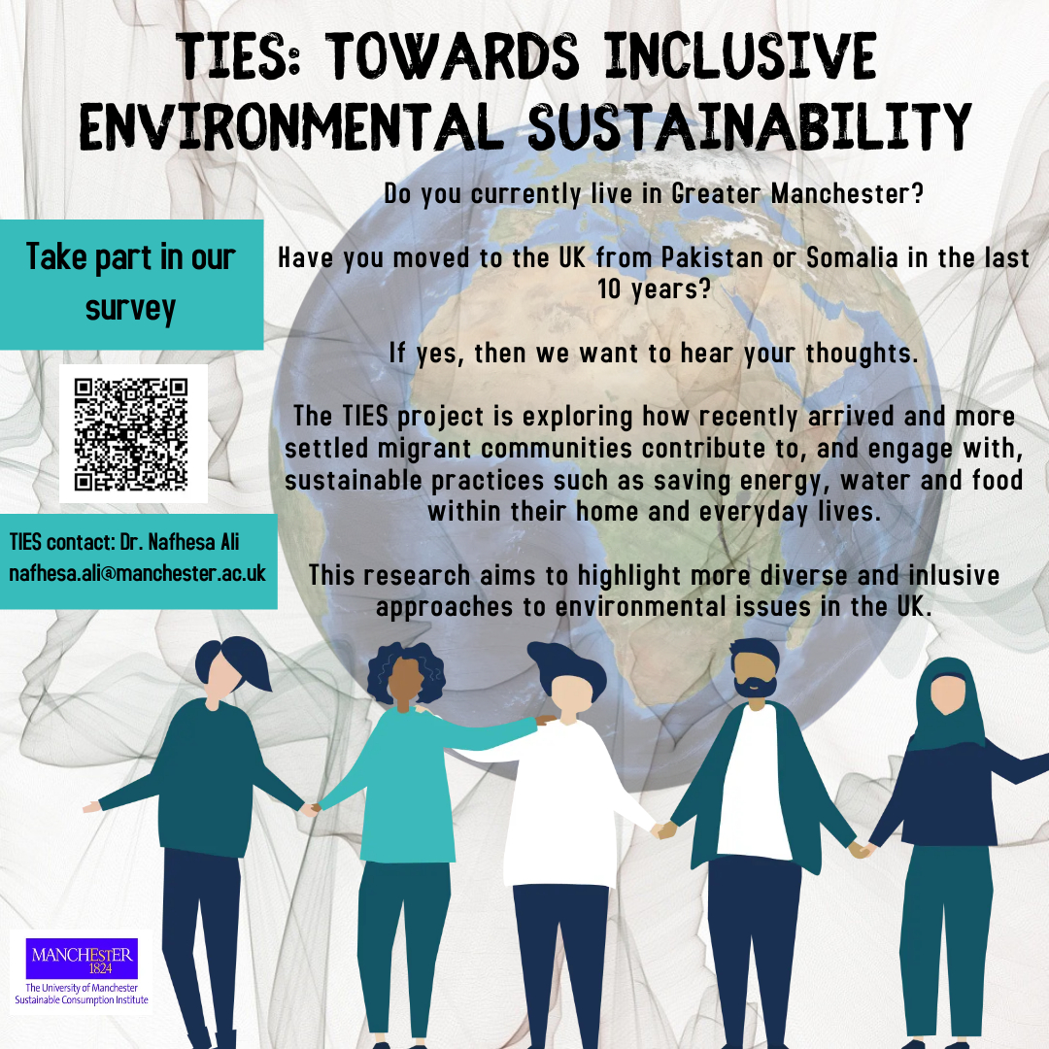

Here’s the link in case the QR doesn’t work (below).
-------------------------------------------------------------------------------------------------------
The Climate and Ecological Emergency (CEE) Bill

118 MPs are now supporting the CEE Bill, tabled by Caroline Lucas MP, across all nations of the UK

Parliament declared a Climate Emergency back in 2019 – but actions haven’t matched their words. An emergency requires strong, decisive action to reverse the climate and ecological crisis … Enter the CEE Bill.

The Bill requires the UK to take responsibility for its fair share of greenhouse gas emissions, to actively restore biodiverse habitats, and to stop damaging our natural world through the production, transportation and disposal of the goods we consume.

You can pledge your support for the CEE Bill as an individual here: https://www.ceebill.uk/sign-up
-------------------------------------------------------------------------------------------------------
The Co-operative Party’s Petition to Ban Bee-Killing Pesticides

Close the loophole on bee-killing pesticides

Earlier this year, when the Government announced it would use a loophole to temporarily allow the “emergency” use of banned bee-killing pesticides by sugar farmers, the Co-operative Party fought until the Government reversed its decision.

The Government has already said they “anticipate” that the emergency authorisations loophole – which allows bee-killing pesticides to be used – may be “needed” again in 2022 and 2023.

Please sign the Co-operative Party’s Petition here to protect our bees: https://party.coop/bees
-------------------------------------------------------------------------------------------------------
The 6R Sustainability Approach

- Follow the 6R protocol to manage plastics sustainably at home and on campus or in the labs

- These UoM videos and texts can answer all your questions about recycling (plastics and other items)

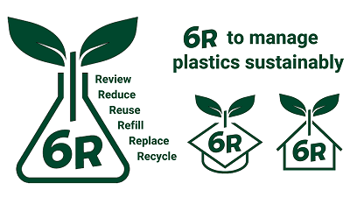

Best wishes

The UoM Climate Network
The CLIMATE-NETWORK list is archived at: http://listserv.manchester.ac.uk/cgi-bin/wa?A0=CLIMATE-NETWORK

