**From:** Climate Network <climatenetwork@manchester.ac.uk>   
**Sent:** 06 September 2021 15:24  
**To:** CLIMATE-NETWORK@listserv.manchester.ac.uk  
**Subject:** [CLIMATE-NETWORK] Newsletter



**Hi everyone** ☺

UoM Climate Network Meeting

We’re still planning to hold another event (Title TBC) possibly in September, however, depending upon speaker availability this may be moved to October, everyone is welcome to join.

Time: Sep **(??)**, 2021 1:00 PM London

<https://zoom.us/j/93259170908>

Meeting ID: 932 5917 0908

Passcode: 411011

UoM Events

**Workshop on Energy Poverty: Why is it important and how can municipalities fight it?**

School of Environment, Education and Development

9 Sep 2021 - 13:00 - 14:30

<https://events.manchester.ac.uk/event/event:xbj-ks5xs16l-88pkqn/>

**Sustainable Futures External Launch**

Sustainable Futures

20 Oct 2021 - 10:00 - 12:00

<https://events.manchester.ac.uk/event/event:z1s-kngfzx4i-vl1orf/>

•       Harriet Bickley has created a booklet full of practical info to help UoM staff & students live, work & study in a more eco-friendly manner. Download from <http://documents.manchester.ac.uk/DocuInfo.aspx?DocID=44432>

•       Pooja Kishinani and Marion Smith, students at University of Manchester, have created a guide for students around three themes: the emotions, basic information, and activist advice of climate change. Download it at: <https://climateemergencymanchester.net/student-climate-handbook/>

•       Want Not Waste have recorded their various environmental talks on their YouTube channel, please take a look here: <https://www.youtube.com/channel/UCTpg3EG9LV9B14R1cXbHDig>

Greater Manchester Events

**Greater Manchester Friends of the Earth and Climate Action network meeting**

Manchester Friends of the Earth

6 Sep 2021 - 20:15 - 21:30

<https://www.manchesterfoe.org.uk/events/event/greater-manchester-friends-of-the-earth-and-climate-action-network-meeting-online/>

**Trafford’s Green Recovery Challenge**

City of Trees

7 Sep 2021 - 10:00 - 15:00

<https://www.manchesterfoe.org.uk/events/event/traffords-green-recovery-challenge-city-of-trees/>

**Volunteer at Wellacre Country Park**

City of Trees

8 Sep 2021 - 10:00 - 14:00

<https://www.manchesterfoe.org.uk/events/event/volunteer-at-wellacre-country-park-city-of-trees/>

**Bury’s Green Recovery Challenge**

City of Trees

9 Sep 2021 - 10:00 - 15:00

<https://www.manchesterfoe.org.uk/events/event/burys-green-recovery-challenge-city-of-trees/>

•       There are a number of ways that you can recycle single-use plastics both within Manchester and further afield:

(1) Recycling point for single-use coffee cups in Piccadilly Train Station: <https://www.facebook.com/wantnotwastemcr/posts/808857489772186>

(2) Recycling point for face masks outside Morrisons on Grafton Street: <https://www.facebook.com/wantnotwastemcr/posts/820812448576690>

(3) [Co-op](https://www.coop.co.uk/) are currently running a soft plastics recycling scheme for plastic bags and product wrapping (plastics that can be scrunched and that ‘ping’ back) at their stores: <https://packagingeurope.com/co-op-launches-collection-scheme-for-soft-plastics/>

(4) Stockport-based [Plastic Shed](https://www.plasticshed.org/) are taking donations of [specific types of plastic lids, soft stretchy plastic packaging, vinyl banners, straws, and plant pots](https://www.plasticshed.org/plastic-drop-off) which they creatively recycle and repurpose into useful items.  They also hold workshops and act as a community space; they share their [Merseyway Workshop](https://www.merseywayworkshop.com/) with a community-focussed design studio called [Easy Peel Studios](https://www.easypeelstudio.com/).

(5) An organisation called [ReWorked](https://www.reworked.com/) are able to recycle lateral flow tests / facemasks / gloves / visors that would otherwise be sent to landfill (although this might not be free of charge): <https://www.mygreenpod.com/articles/recycling-rapid-tests/>

•       [Cracking Good Food](https://crackinggoodfood.org/), a not-for-profit social enterprise, are looking for volunteers, mainly around the Stockport area, to help them in their goal to encourage and support more people to cook affordable, seasonal, and nutritious homemade food from scratch: <https://crackinggoodfood.org/about-us/volunteering/>

•       Season For Change are running a few more events that are climate change-related, including their ‘Season For Exchange 2’ talks: <https://www.seasonforchange.org.uk/events/>

•       The ongoing ‘In Our Nature’ Campaign, coordinated by a group of organisations in Manchester, aims to help everyone across the city live, work, and travel in ways that are good for us, our communities, and the environment: <https://zerocarbonmanchester.commonplace.is/>

•       Season For Change are running a few more events that are climate change-related, including their ‘Season For Exchange 2’ talks: <https://www.seasonforchange.org.uk/events/>

•       Manchester Climate Change have released their own 15 actions to take to become a zero carbon city: <https://www.manchesterclimate.com/15-actions>

Science Museum Group (SMG) Climate Talks

SMG’s climate talks will be happening throughout this year, 12 of which (as indicated in the below list) will be part of [Manchester Science Festival](https://www.scienceandindustrymuseum.org.uk/manchester-science-festival); this local festival has a climate change theme this year and will be mainly occurring between 12th – 21st February 2021.

•         [**Climate change: why should we care?**](https://www.youtube.com/watch?v=CnsGlk994cA)(occurred on 28 Jan 2021 – YouTube link provided ICYMI)

•         [**Transport: How can I be a good citizen of the world?**](https://www.youtube.com/watch?v=xl7mh0gnR1I) **- Manchester Science Festival** (occurred on 13 Feb 2021 – YouTube link provided ICYMI)

•         [**Equality: How can I be a good citizen of the world?**](https://www.youtube.com/watch?v=7pazufJoCA4) **- Manchester Science Festival** (occurred on 13 Feb 2021 – YouTube link provided ICYMI)

•         [**Earth, but not as we know it: Lovelock’s legacy and our future**](https://www.youtube.com/watch?v=7PiVnwKRpPE) **- Manchester Science Festival** (occurred on 13 Feb 2021 – YouTube link provided ICYMI)

•         [**Food: How can I be a good citizen of the world?**](https://www.youtube.com/watch?v=uXp-ApuK03A) **- Manchester Science Festival** (occurred on 14 Feb 2021 – YouTube link provided ICYMI)

•         [**The Road to Carbon Zero: In conversation with Professor Myles Allen**](https://www.youtube.com/watch?v=2ZTjeHUwXjo) **- Manchester Science Festival** (occurred on 14 Feb 2021 – YouTube link provided ICYMI)

•         [**Changing the system: Brian Eno and James Thornton in conversation**](https://www.bbc.co.uk/sounds/play/p09b6rbk) **- Manchester Science Festival** (occurred on 15 Feb 2021 – BBC Sounds link provided ICYMI)

•         [**You and the Planet: Air**](https://www.youtube.com/watch?v=4qggQz3MWCA) **- Manchester Science Festival** (occurred on 16 Feb 2021 – YouTube link provided ICYMI)

•         [**A Liveable Earth: Climate Change and the Faith Community**](https://www.youtube.com/watch?v=2Gsyaqa0WWM) **- Manchester Science Festival** (occurred on 20 Feb 2021 – YouTube link provided ICYMI)

•         [**Let’s Talk About Eco-Anxiety**](https://www.youtube.com/watch?v=8uiuU_kLCEI) **- Manchester Science Festival** (occurred on 20 Feb 2021 – YouTube link provided ICYMI)

•         [**Our Hydrogen Future: Delivering Net Zero**](https://www.youtube.com/watch?v=QnXD4thwQ4U) **- Manchester Science Festival** (occurred on 21 Feb 2021 – YouTube link provided ICYMI)

•         [**Is Capitalism compatible with Environmentalism?**](https://youtu.be/Qa_qWftGBYQ) (occurred on 26 Feb 2021 – YouTube link provided ICYMI)

•         [**Climate change: the view from space**](https://www.youtube.com/watch?v=B4TAwAZxd-k)(occurred on 16 Mar 2021 – YouTube link provided ICYMI)

•         [**Our future planet: global greenhouse gas removal**](https://www.youtube.com/watch?v=JTxLfMta98U)(occurred on 31 Mar 2021 – YouTube link provided ICYMI)

•         [**1.5 v 2 degrees Celsius: Why half a degree really counts**](https://www.youtube.com/watch?v=KfA7w3rs5I0)(occurred on 29 Apr 2021 – YouTube link provided ICYMI)

•         [**The Clean Energy Revolution**](https://www.youtube.com/watch?v=baIpPWlc3wA)(occurred on 13 May 2021 – YouTube link provided ICYMI)

•         [**The Future of Fuel**](https://www.youtube.com/watch?v=Ms-5ysPXJQ0) **- Manchester Science Festival [rescheduled from 12th Feb]** (occurred on 5 Jun 2021 – YouTube link provided ICYMI)

•         [**How are our oceans responding to climate change?**](https://www.youtube.com/watch?v=_7DcQuy7lH4)(occurred on 10 Jun 2021 – YouTube link provided ICYMI)

•         [**Tony Blair In Conversation with John Kerry**](https://youtu.be/HAujaspI5io)(occurred on 29 Jul 2021 – YouTube link provided ICYMI)

•         [**COP26: How can it achieve what the world needs?**](https://youtu.be/o85iHWWOfsU)(occurred on 5 Aug 2021 – YouTube link provided ICYMI)

•         [**How to feed the world without costing the Earth**](https://www.scienceandindustrymuseum.org.uk/whats-on/how-to-feed-the-world) **-** (8 Sep 2021 - 19:30 - 20:45)

•         [**The Electricity Revolution: Our Zero Carbon Future**](https://www.scienceandindustrymuseum.org.uk/manchester-science-festival/whats-on/electricity-revolution) **- Manchester Science Festival** **[postponed until further notice]**

Other Events

**Using Social Media for COP and the Global Day of Action**

Friends of the Earth

7 Sep 2021 - 17:30 - 19:00

<https://www.manchesterfoe.org.uk/events/event/using-social-media-for-cop-and-the-global-day-of-action/>

**Climate disinformation – what is it and how can you tackle it?**

Friends of the Earth

9 Sep 2021 - 13:00 - 14:00

<https://www.manchesterfoe.org.uk/events/event/climate-disinformation-what-is-it-and-how-can-you-tackle-it/>

**Climate Action Welcome webinar**

Friends of the Earth

9 Sep 2021 - 19:30 - 20:45

<https://www.manchesterfoe.org.uk/events/event/climate-action-welcome-webinar-2/>

**Climate Action Plans for councils – explained**

Friends of the Earth

Beginning 13 Sep 2021 (various dates & times)

<https://www.manchesterfoe.org.uk/events/event/climate-action-plans-for-councils-explained/>

**Forests, climate and the Great Big Green Week: engaging with your MP**

Biofuelwatch and Cut Carbon Not Forests

16 Sep 2021 - 18:00 - 19:30

<https://www.manchesterfoe.org.uk/events/event/forests-climate-and-the-great-big-green-week-engaging-with-your-mp/>

**Ripples of Hope Festival**

Robert F. Kennedy Human Rights UK

15 - 19 Sep 2021 (various times)

<https://www.ripplesofhopefestival.org/>

**The Great Big Green Week**

The Climate Coalition

18 - 26 Sep 2021 (various times)

<https://greatbiggreenweek.com/>

**How to accelerate eco-action at work**

Pawprint

30 Sep 2021 - 16:00 - 17:00

<https://www.eventbrite.co.uk/e/how-to-accelerate-eco-action-at-work-tickets-166508135315>

•       An interesting explanation of Sustainability: <https://www.treehugger.com/what-is-sustainability-and-why-is-it-important-5179651>

•       An interesting explanation of Net Zero (and its related terms): <https://netzeroclimate.org/what-is-net-zero/>

•       Downloading the [Buddlet](https://www.buddlet.com/) app on a smartphone allows you to improve the sustainability of your lifestyle by choosing from a range of eco-friendly swaps to your ordinary activities/purchases.  The app is scheduled to launch on 27 August 2021.

•       Downloading the [Skoot](https://skootride.com/) app on a smartphone instantly plants 5 trees for free (and every friend referral also generates 5 additional planted trees for free), and then every journey, thereafter, that you make will be converted into 1 free planted tree.  It seems like they may change their model when they reach 1 million trees, due to the mention of the ‘1 million free tree challenge’ on their website, but for now it’s worth using.

•       Downloading the [Treekly](https://www.treekly.org/) app on a smartphone allows you to plant 1 tree each week for free (seemingly in Madagascar); by tracking your footsteps, using either your phone’s built-in pedometer or a fitness tracker/smartwatch, you can convert your 25,000 steps per week [5,000 each day for 5 days] into the planting of a tree.

•       Downloading the [TreeApp](https://www.thetreeapp.org/) app on a smartphone allows you to plant a tree for free, in an area that it’s needed e.g. often in the Global South, every single day (up to a daily limit of trees available – you’ll know when the limit has been reached as it prevents you from planting)

•       Whilst it still seems to be in the early stages of uptake, [AllotMe](https://www.allotme.co.uk/) – marketed as the ‘Airbnb for your Garden’ sounds like a great concept –  whereby individuals can rent spaces to grow food within major cities/urban environments, and garden owners can monetise their land.

•       Spare 3 minutes to fill in Currensea’s Sustainability survey and each completed survey removes 100 plastic bottles from the oceans (thanks to their [Plastic Bank](https://plasticbank.com/) partnership): <https://www.surveymonkey.co.uk/r/P2GFFCV>

•       Changing your internet browser settings to use [Ecosia](https://www.ecosia.org/) as the default browser means that you’ll be planting trees whilst you’re searching (approx. 45 searches = 1 tree planted).

•       A CO2 widget created to communicate daily levels of CO2 by Matthew Shribman, his colleagues, and University of Cambridge / Cambridge Zero: <https://co2widget.com/>

•       Some suggested climate actions have been listed by Ecologi on their It’s Time website: <https://itstime.earth/climate-actions>

•       Really useful links to organisations who are promoting circular economy initiatives: <https://eeb.org/circular-future>

•    Please take a look at the [Students Organising for Sustainability UK (SOS-UK) website](https://sustainability.nus.org.uk/) as well as two current campaigns they are running:

1. [Invest for Change](https://www.investforchange.uk/)

2. [Carbon Targets](https://www.carbontargets.uk/)

Social Media

You can now connect to the Climate Network on:

1. [Facebook](https://www.facebook.com/groups/235576384126425/)

2. [Yammer](https://www.yammer.com/live.manchester.ac.uk/)

How To Subscribe To Us

Feel free to forward this newsletter on, but also please pay a visit to our website below (where you can subscribe to our mailing list, take look at our events calendar, and see a sample of the environmental groups affiliated with UoM):

<https://climatenetwork.uk/universityofmanchester/>

-------------------------------------------------------------------------------------------------------

Student Volunteering Opportunities

**Become an Eco-Team School Volunteer, as part of the Green Schools Project, a volunteering opportunity funded by** [**Wates**](https://www.wates.co.uk/) **– a construction company.**

Are you passionate about tackling the climate crisis and inspiring young people to join you?

Calling all Manchester University students! We require some enthusiastic volunteers to help deliver Green Schools Project and support a school Eco-Team in their mission to help them go green.

<https://find-volunteering.manchester.ac.uk/opportunity/result/36853>

Please get in touch if you have any questions - [beth.newman@greenschoolsproject.org.uk](mailto:beth.newman@greenschoolsproject.org.uk)

-------------------------------------------------------------------------------------------------------

Job opportunities with the University of Manchester

**Digital Futures & Sustainable Futures Administrator (deadline = midnight on Thursday 9th September)**

This is a varied and interesting role , you will provide support across both Digital Futures & Sustainable Futures platforms, working closely with the Strategy and Operations Manager, and the academic theme/challenge area leads to support the development of the Platforms’ programmes at The University of Manchester, providing administrative, communications and finance support.

For more information, job description, and to apply please visit: <https://www.jobs.manchester.ac.uk/internal/displayjob.aspx?jobid=20648>

>>

**Digital Futures & Sustainable Futures Communications and Engagement Coordinator (deadline = midnight on Wednesday 22nd September)**

This varied and interesting role will see you design, plan and manage successful large virtual and physical events with internal and external attendees, and develop and deliver communications strategies with responsibilities including creating and delivering compelling, engaging content, copy-writing, creating videos and other digital content, as well as maintaining websites. The role will also support the Strategy and Operations Manager (Digital Futures and Sustainable Futures) in building and maintaining communities of researchers within and across the Digital Futures themes and the Sustainable Futures challenge areas.

For more information, job description, and to apply please visit: <https://www.jobs.manchester.ac.uk/internal/displayjob.aspx?jobid=20754>

-------------------------------------------------------------------------------------------------------

Commission on the Conservation of Antarctic Marine Living Resources (CCAMLR) Petition

**Call On CCAMLR to protect Antarctica and secure the largest act of ocean protection in history**

Did you know Antarctica regulates our climate, and its waters feed the fish that feed the world? But who protects Antarctica and its ocean? One international organization does, called CCAMLR (Commission on the Conservation of Antarctic Marine Living Resources). This year it has the power to create three marine protected areas: the East Antarctic MPA proposal, the Weddell Sea MPA proposal, and the Antarctic Peninsula MPA proposal—**the largest act of ocean protection in history!**

Please sign [Only One](https://only.one/)’s Petition here and to find out more about the movement: <https://only.one/act/antarctica>

-------------------------------------------------------------------------------------------------------

Chester Zoo is running a sustainability spectacular called ‘Love It For Longer’

**This event, which is all about waste, marks the zoo’s 90th anniversary as a leading wildlife charity**

The [Love it for Longer exhibition](https://www.chesterzoo.org/whats-here/love-it-for-longer/) begins on 11th June and will run until mid-October.

A range of thought-provoking art pieces have been created for the event, including a 20-foot-long chameleon made from recycled shampoo bottles, a sculpture that turns rainwater into music, and a maze made from unwanted fabric.

Additionally, a programme of events, talks, and classes focussed around waste, recycling, repurposing, and reducing consumption and waste will occur throughout the summer.

<https://www.manchestereveningnews.co.uk/whats-on/family-kids-news/rubbish-day-out-chester-zoo-20786482>

-------------------------------------------------------------------------------------------------------

The pioneering 6R Protocol that is improving sustainability in labs and at home & on campus

**The 6R lab protocol, developed in 2019 by Maggy Foster & Ruth Grady, initially to reduce plastics in labs is now expanding university-wide.**

* Before COVID, the 6R protocol had been applied in the Faculty of Biology, Medicine, and Health (FBMH) to 12 practical lab classes, several taken by 650 students yearly, and saved 37,000 items of plastics/year and £3000/year.
* The 6R Home and Campus protocol was developed in 2020 with two graduate students, Natalie Clarke and Rea Georghiades.  Two undergraduate students, Calista Ow and Hector Mangas Afonso, developed our logos for both protocols below.
* The lab protocol will next be rolled out to all FBMH practical classes;  the Faculty of Science and Engineering (FSE) is beginning to adopt it too.  Plus, Lydia Wunderley will be heading a long-term project focussed around applying the protocol to FBMH research labs, specifically within the School of Biological Sciences (SBS).
* Maggy, Ruth and Chiamaka Anoliefo, a student intern, are integrating 6R within the University of Manchester-approved lab sustainability accreditation system called Lab Efficiency Assessment Framework (LEAF).
* 6R will soon be embedded in the curriculum. It will be advertised to Yr1 and Yr2 students as part of the Sustainability Challenge in September, and is part of 10,000 actions (student version to be released soon).

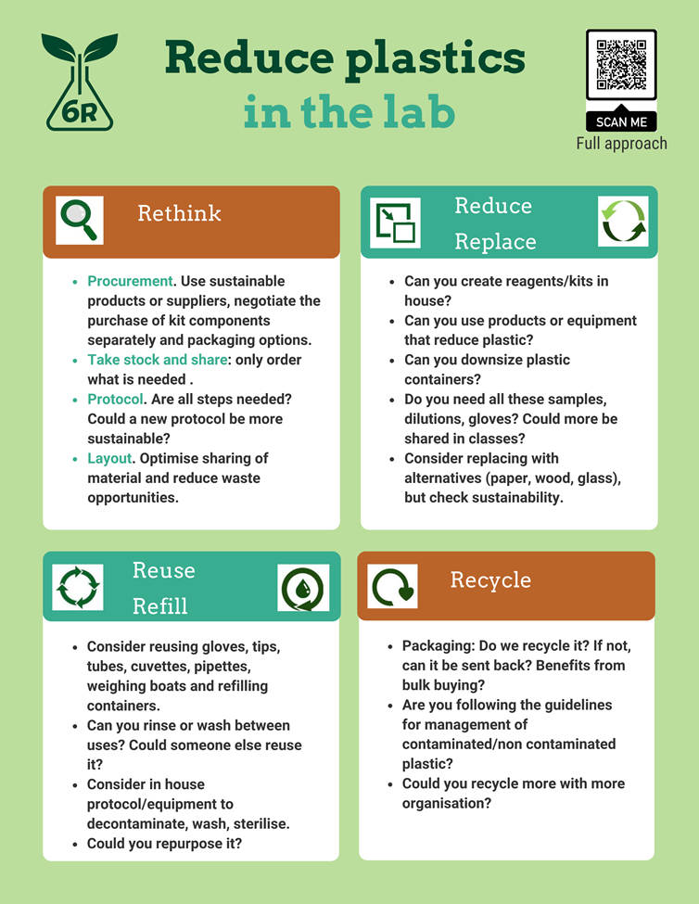            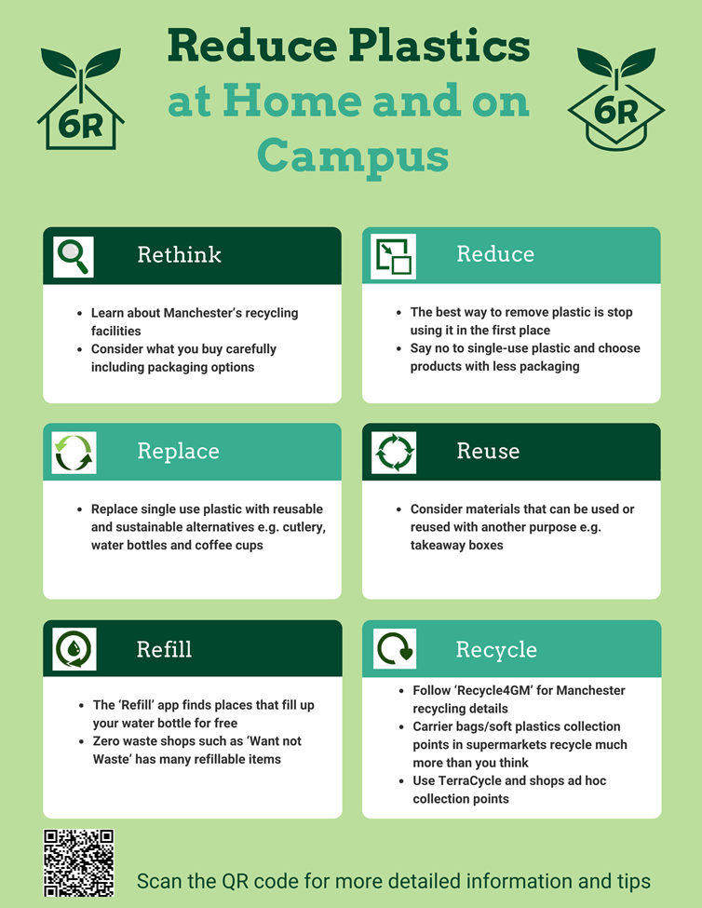

If you want more information or want to help, please contact: [maggy.fostier@manchester.ac.uk](mailto:maggy.fostier@manchester.ac.uk) for home, campus, practicals and [Lydia.Wunderley@manchester.ac.uk](mailto:Lydia.Wunderley@manchester.ac.uk) for research labs.

Best wishes

The UoM Climate Network

The CLIMATE-NETWORK list is archived at: <http://listserv.manchester.ac.uk/cgi-bin/wa?A0=CLIMATE-NETWORK>