**Nature Positive Universities Pledge**

**Update November 2024**

1. **Baseline**

Between July and September 2022 ecologists undertook Biodiversity Baseline Surveys and Baseline Biodiversity Net Gain Assessments (BNGA) across the University estate.  An evaluation and assessment of the ecological value of the various sites using biodiversity metric calculations was completed and recommendations for further biodiversity enhancements included.

**Methodology**

Surveyed areas include Main Campus, Residential Campus’ Whitworth Park, Fallowfield and Victoria Park, Broomcroft Hall and Jodrell Bank.

Biodiversity Baseline Surveys comprised ecological desk studies and ecological walkover surveys, including  UKHabitat  surveys, to inform an assessment of the ecological value of the sites and their potential to support, or be used by, habitats and species protected under either UK or European nature conservation legislation.

The initial BNGA was to identify sites’ biodiversity baseline with regards to habitat value specifically using the Biodiversity Metric 3.1 and identify opportunities for enhancements that will result in biodiversity net gain.  The Biodiversity Metric determines a proxy biodiversity value by measuring habitat type, its condition and the size of the area. The metric is designed to assess changes in biodiversity value.

**Results**

Sites have potential to support common amphibians (e.g. common frog), various bat, bird and invertebrate species, badgers, reptiles (e.g. slow worms), hedgehogs and great crested newts (Jodrell Bank).

The estate baseline area habitats have produced a biodiversity value of 370 habitat units (HU) and baseline linear habitats a value of 9.67 HU.  Habitat condition and ecological value varies between sites (**Figure 1**). There is very little habitat in ‘good’ condition.

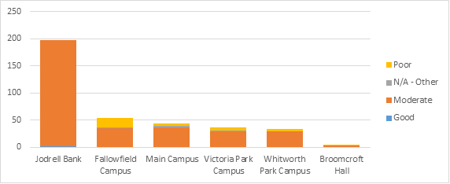**Figure 1: Habitat condition by site**

|  |
| --- |
| Condition is a measure of the habitat quality in relation to the ecological optimum of the habitat type and allows for direct comparisons of habitat quality to be made for the same habitat type. Habitat condition is defined as either good, moderate or poor by assessment against a suite of condition criteria which are specific to the habitat type.  It should be stressed that condition in biodiversity terms is not to be confused with traditional perceptions of condition or maintenance. A grassland that might be perceived to be well maintained (e.g. regularly mown) is very likely to be in poor condition. |

Almost half (**Figure 2**) of the habitat value across the estate (not including Jodrell Bank) comes from our urban trees highlighting their importance and the need to protect and manage them carefully. Modified grassland, or amenity grass, has a very low ecological score but because there is a significant amount across the estate it contributes a third of the habitat value (**Figure 2**). There is opportunity to replace amenity grass with more species rich options and improve the condition of habitats.

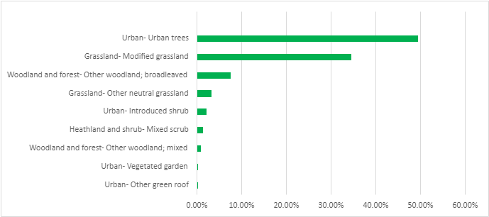

**Figure 2: Percentage of habitat value by type across estate** (not including Jodrell Bank)

|  |  |
| --- | --- |
| **Habitat Type** | **UK Habitat Definition** |
| Urban trees | Trees within constructed, industrial and other artificial habitats. |
| Modified grassland | Vegetation dominated by a few fast-growing grasses. Frequently characterised by abundance of rye-grass e.g. amenity grass. |
| Woodland - broadleaved | Land with more than 25% cover of trees more than 5m in height. Broadleaved mixed and yew woodland. |
| Other neutral grassland | Rye-grass likely to be present at <30% with between 9and 15 further species also present e.g. wildflowers. |
| Urban introduced shrub | Non-native shrubs planted within constructed, industrial and other artificial habitats. |
| Mixed scrub | Dense scrub comprising a mixture of species without a single species dominant. |
| Woodland - mixed | A mixture of broadleaved and coniferous trees in which neither make up more than 80% of tree cover. |
| Urban vegetated garden | Garden that is principally vegetated, for example with large areas of grass and flower beds within constructed, industrial and other artificial habitats. |
| Urban green roof | A roof or deck onto which vegetation is intentionally grown or habitats for wildlife are established in constructed, industrial and other artificial habitats. |

**Recommendations**

Key ecological management objectives following the mitigation hierarchy:

* Retain existing key habitat areas for use by foraging/commuting bats and birds, and potential wildlife corridor links for invertebrates and small mammals.
* Enhance existing habitat features, where appropriate, with native species to enhance the existing flora with appropriate management measures.
* Create new habitats to benefit bats, birds, amphibians, invertebrates and small mammals through the provision of foraging and sheltering opportunities.  This includes replacing areas of modified grassland with more distinctive grassland and scrub.
* Pond creation and associated sensitive landscaping
* Incorporate features to support specific species e.g. log and brash piles, hibernacula, etc.
* Green roofs and walls
* Signage and promotion to increase awareness
* Involve staff/students/local community in enhancement/maintenance work and specific species survey work.

1. **Targets**

[Our Sustainable Future, the University’s Environmental Sustainability Strategy](https://documents.manchester.ac.uk/display.aspx?DocID=33155), sets out our “Valuing Nature” objective and commitments.

Objective: Our campus is an environment where people and wildlife thrive together.

Commitments:

* Work with our academics, staff and students to develop biodiversity priorities to enhance wildlife and public spaces on campus.
* Identify opportunities to increase green, cooling and absorbent spaces as an adaptation response to climate change.
* Integrate biodiversity themes into current and future Estates strategy, with nature and green spaces an integral part of planning.
* Eliminate the use of peat-based compost by 2023.
* Continually seek to reduce the use of synthetic chemical herbicides on campus.
* Increase the quality and quantity of existing green space, achieving a 10% increase in urban green space by 2028, from 2018 levels.
* Calculate a baseline and set a target to provide a measurable improvement in biodiversity by 2030.
* Continue our work with academics to measure wellbeing outcomes and improve the staff and student wellbeing scores associated with campus green space by 25% by 2028 from a 2018/19 baseline.
* Maximise opportunities to integrate learning and teaching with our estate’s biodiversity.
* Zero reportable pollution incidents to air, land and water across the University estate.
* Achieve 20% biodiversity net gain on all major construction and refurbishment projects.

1. **Actions**

Our Valuing Nature Action plan has been drafted with stakeholders from across the university which takes the commitments outlined in the ES Strategy and proposes key actions and metrics to measure performance. The Nature Action Group, comprising PS and academic staff, has written an action plan to deliver the “Valuing Nature” commitments set out in the ES Strategy. Key actions, metrics to measure performance and baselines have been calculated to improve biodiversity.

Live projects in development to increase the quantity of green space on campus like the Ellen Wilkinson space. As part of our bicentenary celebrations the Old Quad has been regenerated from a car park to create a new, biodiverse green space for both people and wildlife to enjoy. A biodiversity net gain of 80% has been achieved by planting new trees and plants and introducing bird and bat boxes, log piles and shallow pools to provide habitats and water sources for wildlife. New planting has also been incorporated as part of the Martin Harris Centre expansion.

The Landscaping Team have eliminated the use of peat-based compost, increased the number of wildflower areas on campus. No-Mow May was expanded to more locations than ever before, allowing selected lawns across campus to grow freely for a month to provide a much-needed boost for wild plants and wildlife. It is hoped these areas can be expanded. Bug hotel have also been constructed by using recycled wood and brown vegetation from our university grounds

In November 2022 the Landscaping Team planted trees and wildlife hedges with saplings provided by the late Queen’s Green Canopy project, a unique tree planting initiative created to mark Her Majesty’s Platinum Jubilee. Species planted include hawthorn, silver birch, rowan, wild cherry, sessile oak, blackthorn and hazel. There are nine wildflower areas on Main Campus and species-rich turf outside Nancy Rothwell. Eight green roofs continue to be maintained, and 40,000 litres of peat-free compost was used. All machinery is now battery-operated avoiding pollution and emissions from fuel use.

We have improved our engagement with students and has establish the Student Sustainability Champion programme. Forty-three student volunteers deliver different projects around themes of Nature and Biodiversity, Energy and carbon, Food, Travel and Reduce Reuse Recycle. Each themed group has delivered engagement projects at the Student Union on the topic of reducing unnecessary digital data and teaching students how to utilise vegetable and fruit peel to reduce waste. Each group will deliver another project next year. We encourage our Champions to take the Nature Positive Pledge and to commit to addressing the impact that they and the university have on nature.

Three societies, UomSust, Mcr. Botanists and Tree Musketeers offer volunteering opportunities like restoring peatland and hedgerows, as well as community events like talks and nature focused socials, to encourage students to reflect, improve and preserve nature around campus.

The Firs Botanical Garden and Jodrell Bank are two green spaces that offer students local volunteering opportunities and the chance to learn about the biodiversity that surrounds them.

Framed around the United Nation's sustainable Development Goals, our students work in partnership with organisations to deliver positive change. For example, the collaboration with Ardwick Climate Action to illustrate the risks of air pollution and to create the 'Green Routes' initiative. This allowed for walking routes that avoid some of the highly polluted areas, minimising pedestrian's exposure to air pollution and dangerous traffic.

The University also offers a new MSc which allow students to pursue an interest in nature positive approaches, developed in collaboration with industry experts in nature recovery, restoration and rewilding.

<https://www.manchester.ac.uk/study/masters/courses/list/21491/msc-nature-recovery-restoration-and-rewilding/#:~:text=Course%20overview&text=Engage%20in%20a%20solutions%2Doriented,by%20all%20sectors%20of%20society>.