TAB_col_white_background.eps

# Change Leadership Skills Framework: *Inspire and Motivate*

## Definition

*Inspire and motivate* is about being an authentic leader, inspiring others and understanding individual motivators to encourage people to engage in the change process. It’s about acknowledging and recognising others’ contributions, and communicating in a way that makes people excited for the future of technical services.

Behavioural indicators

1. I am an authentic advocate for the Technical Review in all circumstances.
2. I inspire and motive others to engage as a team member in identifying and implementing change
3. 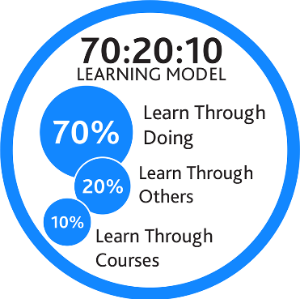I communicate change in a positive manner through influencing and persuasion.
4. I make an effort to acknowledge and praise contributions from individuals and the team as a whole.

## Example on-the-job development activities *(70)*

* Discuss and capture motivations of people in your area and what help people to deliver at their best. Share your findings with your team or peers and develop a plan to encourage this environment.
* Make a point of noticing when a colleague does something well or delivers a positive outcomes and keep a note. Use this record to share their successes with the rest of the team and ensure credit is given to others.

|  |
| --- |
| *Capture your notes here:* |

## Suggested reflection / discussion questions *(20)*

Q: Do I truly understand what motivates individuals in my team? How do I tap into this to support their commitment to the technical review?

Q: Who in my work network who is a good influencer, and is able to gain buy-in without necessarily having positional power? What they do to enable them to have the influence, and how can I replicate in my role?

Q: How can I constructively address negativity in my team so people feel more motivated?

|  |
| --- |
| *Capture your notes here:* |

## Recommended learning resources *(10)*

|  |  |
| --- | --- |
| See the source image | Watch: [Situational Leadership](https://youtu.be/bAuwgjmF5xc)  **YouTube - 10mins** |
|  | Read: [How to motivate your team](https://app.goodpractice.net/#/manchester-tfl/s/daa6bb3a)  **L&D Toolkit - 6mins** |
| See the source image | Watch: [Cultivating a Growth Mindset](https://www.linkedin.com/learning/cultivating-a-growth-mindset?u=74653818)  **LinkedIn Learning – 58mins** |
| See the source image | Attend: [Influencing for Results](https://app.manchester.ac.uk/training/profile.aspx?unitid=8133&parentId=4)  **SL&D ‘Learning for All’ Course – 3hours** |

|  |
| --- |
| *Capture your notes here:* |