PPMS Registration
PPMS is the University’s research facility management system which supports researchers and facility managers with the booking of instruments and services and the process of cost recovery.
To use the system you must first be registered with the system. This involves:
- Logging into the system with your University username and password
- Completing the registration form with your phone number, your default finance code and your lab group
- Approval of you registration form by the Facility Manager

Login
PPMS uses the University’s single sign-on system.  If you are currently logged into this system then clicking on the link below will take you directly to the registration, or account creation, page.  If you are not currently logged on then the following link will present a standard University login page where you will enter your University username and password. On successful login you will be presented with the registration page.  https://corefacilities.manchester.ac.uk/areq/ | 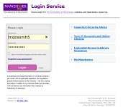

Registration Form
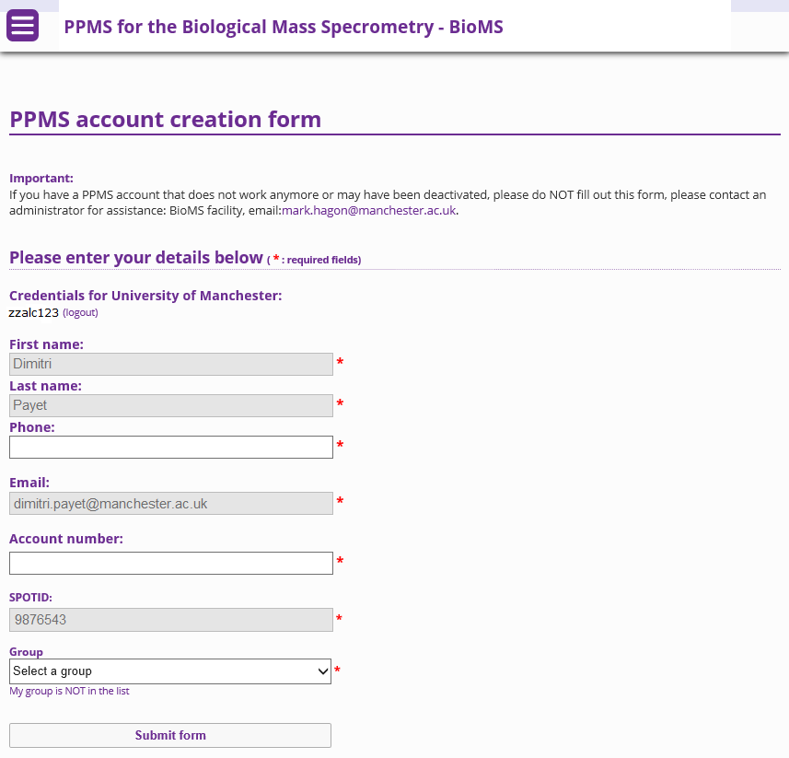 | The registration page will already have your first name, last name, email address and SPOTID completed. This information was automatically provided at the end of the login process.  The registration form requires you to enter:  - Phone number – You must provide a contact phone number. This information is not passed to any other system.  - Account number – This is the default University finance code that will be charged for your use of a facility. Please note that it is your responsibility to ensure that you have approval from the PI or budget holder to use this finance code. When you use a project finance code (i.e. beginning with the letter R or P) you must also specify the task code and use a colon (:) to separate the two codes. For example R012345:A07  - Group – This will typically be your lab group with the name of your PI. Group names are organised by school. If you PI is not listed in the groups then you can create a new group which will be verified as part of the registration approval process.

Approval
Once you submit a completed registration form the registration must be approved by a facility manager. You should receive a confirmation email once your PPMS account has been approved and then you will be able to access any facility in PPMS. Permission to book specific instruments or services is controlled by Facility Managers independently of overall system access.

