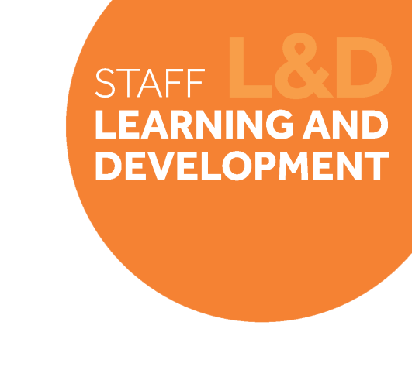TAB_col_white_background.eps

# Change Leadership Skills Framework: *Empowerment & Mobilising Others*

## Definition

*Empowering and Mobilising Others* is about giving team members freedom to use their own initiative and find their own solutions. It is also about providing opportunities for challenge and development, as well as adopting coaching and mentoring techniques to get the best from people.

Behavioural indicators

1. I allow my teams to use their own initiative, and allow them sufficient authority and autonomy to work effectively.
2. I delegate work and responsibility to challenge and develop my team.
3. I use coaching and mentoring techniques to get the best performance from individuals and to help others develop.
4. I support others to find their own solutions, rather than giving all the answers. **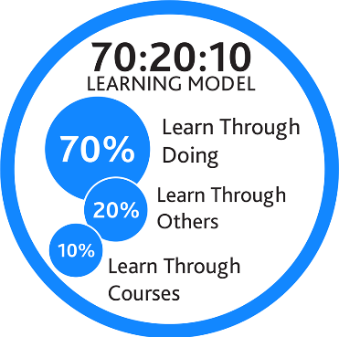**

## Example on-the-job development activities *(70)*

* Find an opportunity where you can allow someone else from your team to take the lead on a project or activity you normally would do and provide them with your full support.
* Spend some time with each member of your immediate team to find out what they are interested in, and what skills and knowledge they want to develop. Look for opportunities to give each person assignments that will exercise those skills when they are ready for them.
* Assign an inexperienced employee to work with an individual who excels at something the employee needs to learn.

|  |
| --- |
| *Capture your notes here:* |

## Suggested reflection / discussion questions *(20)*

Q: Think about the last time one of your team members came to you with a problem. How could a coaching-based approach have improved the outcome of that conversation?

Q: What considerations do you need to make when delegating a piece of work for the person’s level of skill and will?

Q: How do you provide mentoring as part of your role as a line manager? What opportunities are there for you to do this more?

|  |
| --- |
| *Capture your notes here:* |

## Recommended learning resources *(10)*

|  |  |
| --- | --- |
| SL&D white block.png | Complete: [Coaching Lessons for Non-Coaches](https://app.manchester.ac.uk/TSLD53E)  **E-learning course – 1hour** |
|  | Watch: [Leaders and Managers as Coaches](https://app.goodpractice.net/#/manchester-tfl/s/ae22e962)  **L&D Toolkit – 5mins** |
| See the source image | Watch: [Five Ways to Lead in an Era of Constant Change](https://www.ted.com/talks/jim_hemerling_5_ways_to_lead_in_an_era_of_constant_change#t-12582)  **Ted Talks – 13mins** |

|  |
| --- |
| *Capture your notes here:* |