**Business Case**



|  |  |
| --- | --- |
| Prepared by: |  |
| Proposed Project title: |  |

|  |
| --- |
| Why is the project needed? |
|  |
| What other options were considered? |
|  |
| What are its objectives? |
|  |
| What are the benefits? |
|  |
| How will success be measured? (success criteria) |
|  |
| What are the boundaries or scope of the project? |
|  |
| What are the constraints – consider time, quality, cost |
|  |
| How much will it cost and how long will it take? Is this realistic? |
|  |
| What are the risks associated with this and can they be managed? |
|  |
| Who needs to be involved and how? |
|  |
| Conclusion – should the project proceed? |
|  |



|  |  |
| --- | --- |
| **Title** | Project Success Criteria Planning |
| **Project** |  |
| **Date of plan** |  |
| **Project**  **Manager** |  |

**Purpose**

The purpose is to determine the success criteria at the planning stage of the project. This should be identified in the business case and developed in the definition stage.

**Expected benefits as outlined in Business Case & PID?**

**Product description (outcome, service, deliverable)?**

**Time, cost and quality criteria (including any tolerances agreed)?**

**Users agreed acceptance criteria and quality expectations (do not include user perceived criteria)?**

**Any other criteria?**

|  |  |  |  |  |
| --- | --- | --- | --- | --- |
| **Project Charter**  These are commonly used headers but you can rearrange the headers to suit your own project  **Project Sponsor** – write the name of the person here | | | | |
| **Project Background and Timescales** |  | **Assumptions** |  | **Milestones** |
| Write a little about the context and how this project  came about.  Start Date: Completion Date: |  | Write down any assumptions you have when writing  this document. |  | How will you know you are on track to succeed?  Write down your measurable steps along the way. |
| **Objectives** |  | **Scope** |  |
| Write down the overall objectives of the Project. |  | What is included in the project and what is not  included? |  |
| **Team** |  | **Risks** |  | **Constraints/Drivers** |
| Write down the name of the project leader and  team members and if relevant, their department or specialism that they bring or represent. |  | Write down what the key risks are here. |  | What elements of this project are fixed no matter  what – cost, quality, time, skills, people? |
| **Stakeholders** |  | **Resources** |  | **Benefits/Deliverables** |
| Write down the names and positions of anyone  who is affected by the project or the outcomes of it. |  | This may be the budget or it may be the amount of  person hours, full time equivalents or people the project has assigned to it. |  | What are you expecting to gain as a business from  the project completion? What will you actually deliver at the end? |

**Kick-Start Meeting Agenda**

|  |  |
| --- | --- |
| Project title: | Meeting date, time and duration: |
| Attendees: | Venue: |



|  |  |
| --- | --- |
| **No.** | **Agenda Item** |
| **1.** | Clarify roles and responsibilities – agree team contract |
| **2.** | Review Business Case |
| **3.** | Complete Project Charter / PID – discuss and confirm  • Assumptions  • Risks  • Resources  • Milestones / deliverables  • Constraints  • Benefits |
| **4.** | Outline Communications Plan |
| **5.** | Next steps |
| **6.** | Any other items |
| **7.** | Date of next meeting |



|  |  |
| --- | --- |
| **Title** | Project Risk Register |
| **Project** |  |
| **Date** |  |
| **Project**  **Manager** |  |

|  |  |  |  |  |  |
| --- | --- | --- | --- | --- | --- |
| Date | Description of Risk | Likelihood | Impact | Risk  Rating | Action  (Avoid, reduce, fallback, transfer, share, accept etc.) |
|  |  |  |  |  |  |
|  |  |  |  |  |  |
|  |  |  |  |  |  |
|  |  |  |  |  |  |



|  |  |
| --- | --- |
| **Title** | Communication Plan |
| **Project** |  |
| **Date** |  |
| **Circulation** |  |
| **Author** |  |

|  |  |  |  |  |
| --- | --- | --- | --- | --- |
| **Stakeholders** | **Info required** | **Info provider** | **Frequency** | **Method** |
| E.g. Project Board,  Users | E.g. highlight reports,  progress report | E.g. Project  Manager, Team  Manager | E.g. weekly,  monthly, when needed etc | E.g. meeting, phone,  email, presentation, report etc |
|  |  |  |  |  |
|  |  |  |  |  |
|  |  |  |  |  |
|  |  |  |  |  |
|  |  |  |  |  |
|  |  |  |  |  |
|  |  |  |  |  |
|  |  |  |  |  |

**Change Control Log**



|  |  |  |
| --- | --- | --- |
|  | **Project Title:** |  |
|  | **Project**  **Manager:** |  |

|  |  |  |  |  |
| --- | --- | --- | --- | --- |
| Description of change | Date received | Date evaluated | Date approved | Date completed |
|  |  |  |  |  |
|  |  |  |  |  |
|  |  |  |  |  |
|  |  |  |  |  |
|  |  |  |  |  |
|  |  |  |  |  |
|  |  |  |  |  |
|  |  |  |  |  |
|  |  |  |  |  |



|  |  |
| --- | --- |
| **Title** | **Project Issue Register** |
| **Project** |  |
| **Date** |  |
| **Project**  **Manager** |  |

|  |  |  |  |  |
| --- | --- | --- | --- | --- |
| Date raised | Description of Issue | Evaluation/ Impact | Escalation  Required? | Resolution |
|  |  |  |  |  |
|  |  |  |  |  |
|  |  |  |  |  |
|  |  |  |  |  |

**Project Progress Report**

|  |  |
| --- | --- |
| **Project Title** |  |
| **Project** |  |
| **Date** |  |
| **Project**  **Manager** |  |



|  |  |  |  |
| --- | --- | --- | --- |
| **Project Title:** | **Date:** | **Project Sponsor** | **Project Manager:** |

|  |  |  |  |  |  |  |
| --- | --- | --- | --- | --- | --- | --- |
| **Project Status: (to shade in)** | | **RED** | **AMBER** | **GREEN** | | |
| **Headlines** | | | | | | |
| **Tasks, Milestones, Outcomes delivered this period** | | | | | Completion dates | |
| Tasks, Milestones, Outcomes | Comments | | | | Planned | Actual |
|  |  | | | |  | |
| **Risks and Issues** Include an assessment of the impact and any actions taken | | | | | | |
| **Tasks, Milestones, Outcomes scheduled for next period** | | | | | Completion dates | |
| Tasks, Milestones, Outcomes | Comments | | | | Planned | Forecast |
|  |  | | | |  | |

**The following six screen-shots are taken from the Daily Actions Log Template which is available at the link below:**

<http://documents.manchester.ac.uk/display.aspx?DocID=14877>

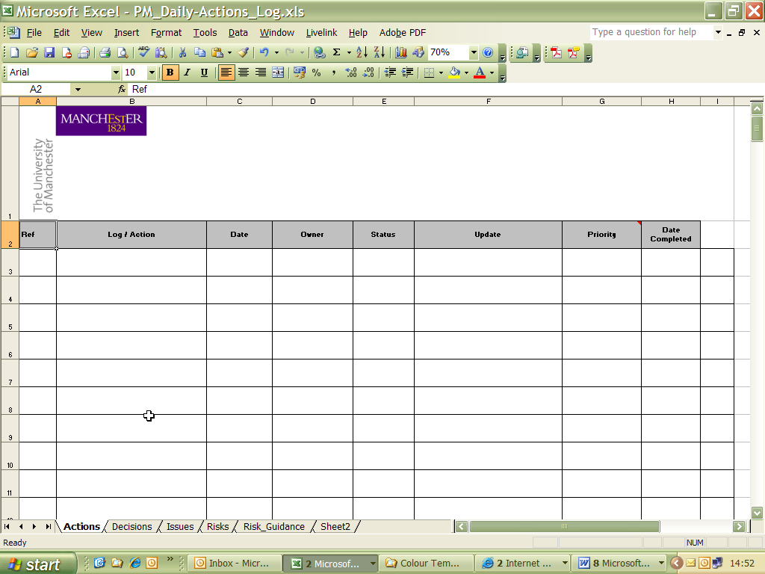

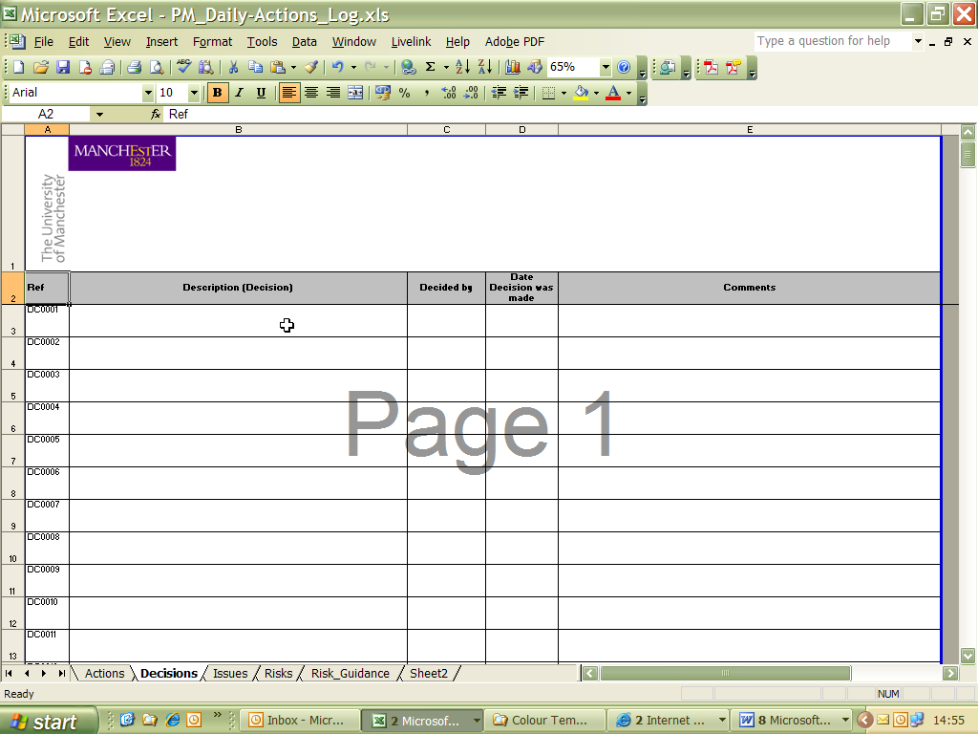

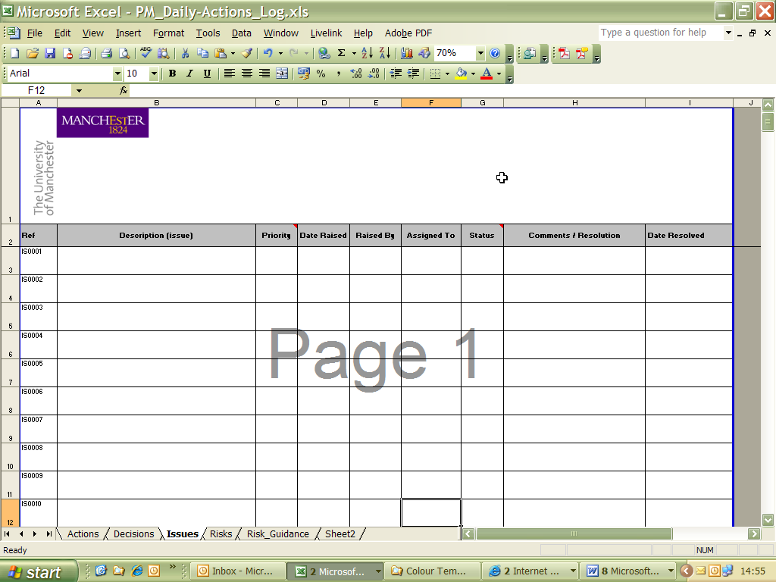

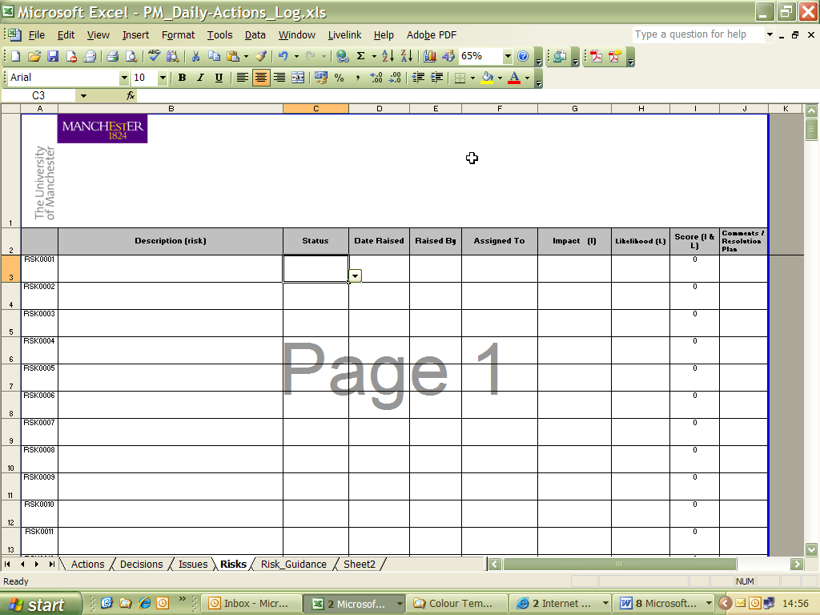

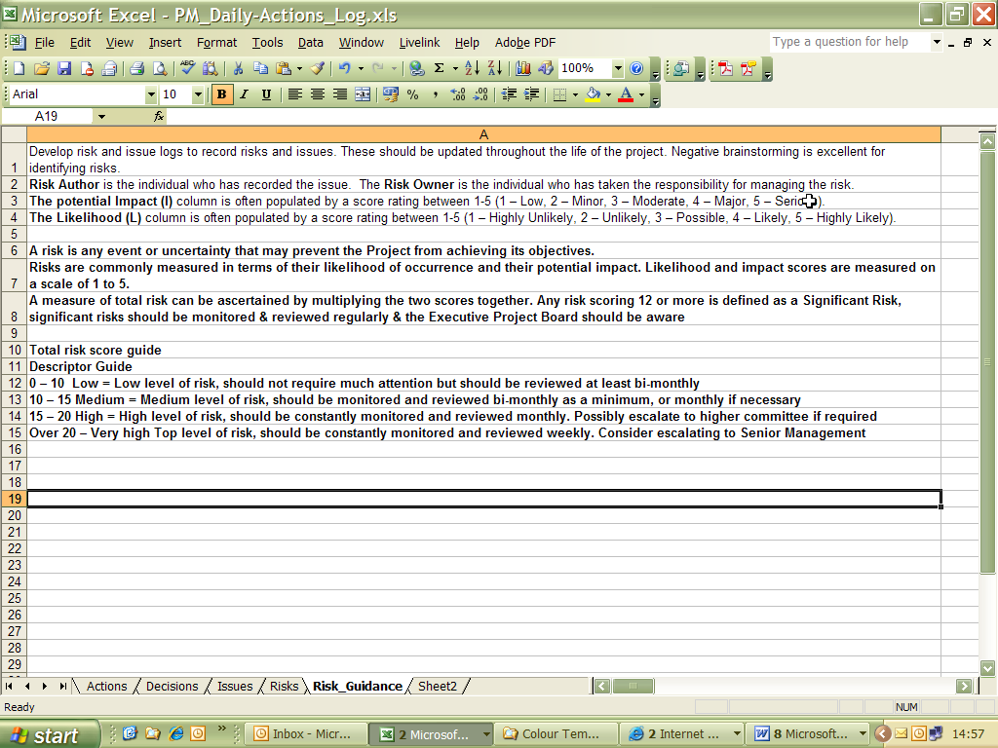

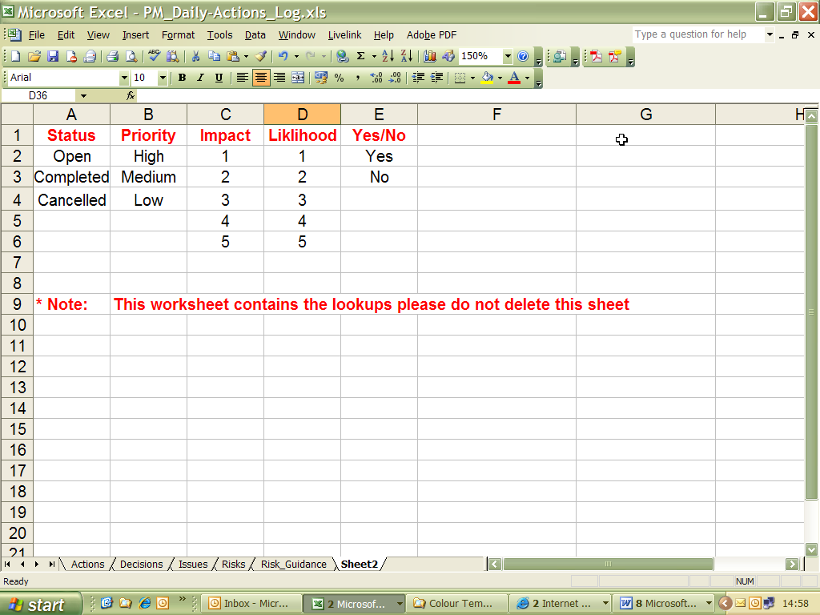

(Insert type of meeting) **Agenda**



|  |  |
| --- | --- |
| Project title: | Meeting Date: |
| Attendees: | Purpose of meeting: |

|  |  |  |
| --- | --- | --- |
| **No.** | **Agenda Item** | **Raised by** |
| **1.** | Review actions from last meeting |  |
| **2.** | Recurring item (eg Project progress) |  |
| **3.** | Recurring item (eg Risk register) |  |
| **4.** | Recurring item (eg Change request) |  |
| **5.** | Local items |  |
| **6.** | Date of next meeting |  |

(Insert type of meeting) **Minutes**



|  |  |
| --- | --- |
| Project Title: | Meeting date, time and venue: |
| Purpose of meeting: | Present: |

|  |  |  |  |  |
| --- | --- | --- | --- | --- |
| No  . | Agenda Item | Actions | By who | By when |
| **1.** |  |  |  |  |
| **2.** |  |  |  |  |
| **3.** |  |  |  |  |
| **4.** |  |  |  |  |
| **5.** |  |  |  |  |
| **6.** |  |  |  |  |
| **7.** |  |  |  |  |
|  | **Future meeting**  **dates:** |  |  |  |

**Project Management Checklist**



|  |  |  |  |  |  |
| --- | --- | --- | --- | --- | --- |
|  | **Conception** | **Y** | **N** | **N/A** | **Comment** |
| 1 | Developed the Business Case? |  |  |  |  |
| 2 | Is a full options appraisal necessary? |  |  |  |  |
| 3 | Is the project in line with the strategic plan? |  |  |  |  |
| 4 | Has the project received sign off by the sponsor or  project board? |  |  |  |  |
|  | **Definition** |  |  |  |  |
| 5 | Has a PID form been completed? |  |  |  |  |
| 6 | Are roles explicit and documented? |  |  |  |  |
| 7 | Are levels of authority clear? |  |  |  |  |
| 8 | Stakeholder analysis and communications plan put  in place? |  |  |  |  |
| 9 | Risk assessment and register complete? |  |  |  |  |
| 10 | Are you clear what’s driving the project – Quality,  Cost, Time? |  |  |  |  |

|  |  |  |  |  |  |
| --- | --- | --- | --- | --- | --- |
| 11 | Project review procedures been established? |  |  |  |  |
| 12 | Project kick-start complete? |  |  |  |  |
| 13 | Team selection – correct mix of skills established? |  |  |  |  |
| 14 | Broken project down into component parts – eg  WBS, PBS, CBS? |  |  |  |  |
| 15 | Are your estimates accurate? |  |  |  |  |
| 16 | Have you produced a Gantt chart with milestones? |  |  |  |  |
| 17 | Have you developed a project budget with advice from financial experts if needed? |  |  |  |  |
| 18 | Have you identified the critical path for the project? |  |  |  |  |
|  | **Implementation** |  |  |  |  |
| 19 | Are your quality control measures in place and working? |  |  |  |  |
| 20 | Are you clear who reports to whom and when? |  |  |  |  |
| 21 | Do you have a clear procedure for managing variations or changes and is it being used? |  |  |  |  |
| 22 | Have you developed a planned versus actual schedule and is it up to date? |  |  |  |  |
| 23 | Have you an agreed tolerance figure? |  |  |  |  |
|  | **Handover, Closedown & Review** |  |  |  |  |
| 24 | Does the project meet with customer acceptance  criteria? |  |  |  |  |
| 25 | Has the post project review been planned? |  |  |  |  |
| 26 | Has the learning been identified and lessons learned report circulated? |  |  |  |  |
| 27 | Is the project still delivering benefits? |  |  |  |  |



|  |  |
| --- | --- |
| **Title** | **Handover and Acceptance Record** |
| **Project** |  |
| **Date of plan** |  |
| **Project Manager** |  |

**Purpose**

The purpose is to record handover and acceptance of product (outcome, service, deliverable) at completion of project.

**Criteria for acceptance?**

**Deviations from acceptance criteria?**

**Additional comments on user acceptance?**

|  |  |  |  |  |  |
| --- | --- | --- | --- | --- | --- |
| **Sign off** | | | | | |
|  | **Name** | **Approve** | **Disapprove** | **Signature** | **Date** |
| **Sponsor** |  |  |  |  |  |
| **Senior User** |  |  |  |  |  |
| **Project Manager** |  |  |  |  |  |



|  |  |  |  |
| --- | --- | --- | --- |
| **Title** | **Benefits Review Plan & Benefits Realisation Review** | | |
| **Project** |  | | |
| **Date of plan** |  | **Date of review** |  |
| **Project Manager** |  | | |

**Purpose**

The purpose is to determine whether the expected benefits of the product (outcome, service, deliverable) have been realised, whether the product has caused any problems in use and how this is to be planned.

**Expected benefits as outlined in Business Case & PID?**

**How will the benefits be measured?**

**Resources required to complete review?**

**Benefits realised after handover? (Are these different to ‘expected benefits’ in 2 above**

**and if so how?)**

**Include any dis-benefits or problems caused?**

**The following two screen-shots are taken from the Lessons Learned and Action Plan Template which is available at the link below:**

<http://documents.manchester.ac.uk/display.aspx?DocID=14878>

