Staff Wellbeing Champion Bulletin Tuesday 30th April

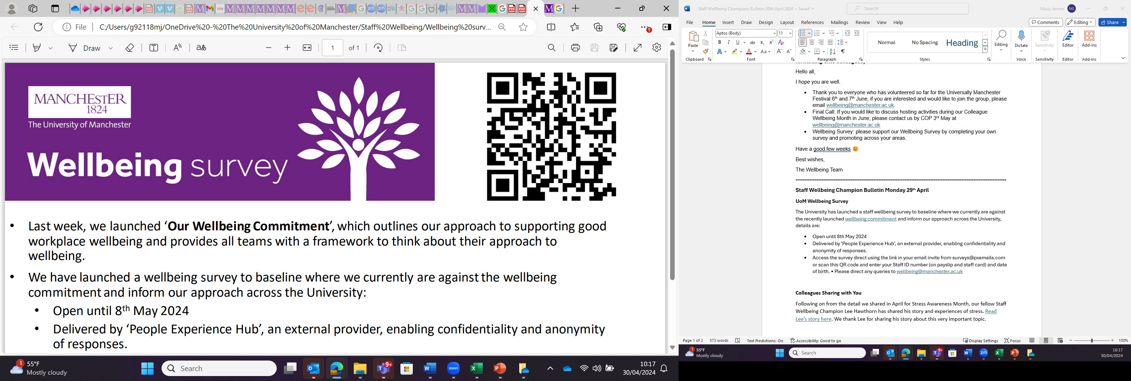
UoM Wellbeing Survey
The University has launched a staff wellbeing survey to baseline where we currently are against the recently launched wellbeing commitment and inform our approach across the University, details are:
- Open until 8th May 2024
- Delivered by ‘People Experience Hub’, an external provider, enabling confidentiality and anonymity of responses.
- Access the survey direct using the link in your email invite from surveys@pxemails.com or scan this QR code and enter your Staff ID number (on payslip and staff card) and date of birth.
- Please direct any queries to wellbeing@manchester.ac.uk

Colleagues Sharing with You
Following on from the detail we shared in April for Stress Awareness Month, our fellow Staff Wellbeing Champion Lee Hawthorn has shared his story and experiences of stress.
Please find Lee’s story attached to this email. We thank Lee for sharing his story about this very important topic.

Campaigns

Sustainability Action Month: Sustainability Action month aims to increase staff and students’ understanding of the climate crisis and to showcase easy ways to embed sustainable practices at work, on campus, and at home. Events are running until 9th May, here is how you can get involved.

Mental Health Awareness Week 13th – 19th May: the theme for Mental Health Awareness Week this year, set by the Mental Health Foundation, is 'movement: moving more for our mental health': encouraging people to find more moments for movement in their daily routines. This could be walking more, putting on your favourite music and having a boogie or doing chair exercises whilst sat down. These small windows of time all add up and work towards supporting our mental health. You can find resources to share with colleagues here.
The Central Wellbeing Team will not be doing any specific activity during this week as we have our Colleague Wellbeing Month in June so keep your eyes peeled for our programme when it goes live!

Dementia Action Week: 13th – 19th May: Dementia Action Week is an awareness raising campaign to encourage everyone to learn more about dementia. There are currently around 900,000 people with dementia in the UK and it is projected to be over 1million people with dementia in the UK by 2025. It is important we increase our awareness of what dementia is, signs, symptoms, treatments and what support is available for both the person directly impacted and the people caring for someone with dementia.

Webinar Catch-up
The Neurodivergent Wellbeing Webinar hosted by Neurodiversity Coach Liz Mulhall-Brewer Wednesday 24th April is now available to watch.
Neurodivergent Wellbeing Webinar recording and the PowerPoint slides are attached to this email.

Something to read: Tips for Effective Meetings: We’ve created a short five step meetings guide to support individuals, teams, and leaders with scheduling, planning and conducting meetings.

Wellbeing Choir
Dan Mcdwyer will be running another 12 – week block for the Wellbeing Choir, starting 8th April, so if you like to meet new people, sing, and have a laugh this is a great way to spend your lunch break.
For more information and to book please click here
Reflexology
Emma will be running Reflexology session on Thursday 16th May at the Therapy room, Wellbeing Rooms, Simon Building, between 8.00 – 12.30pm.
To book an appointment e-mail Emma Woodhall reflexologywithemma@gmail.com or Call 07934 718 822
About Emma
Purple Wave 10k friends and family
We have now opened the last few slots of the Manchester great run Purple Wave to Staff members friends and Family offering 10k places at £20.00 per person (normally £42.00+)
This will be your last chance to purchase a place as the closing date is the 7^{th of} May.
People can walk, jog, or run, if they do not want to enter but want to be part of the day people can volunteer to help Sport on the run up and on the event.
The day is a great atmosphere in the city centre it is a fun day out.
To book your 10k place please click Public and then Staff click here
To Volunteer please e-mail sportsvolunteer@manchester.ac.uk

