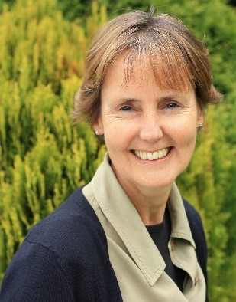
Sara works internationally in the humanitarian sector with organisations such as Medécins sans Frontières, WaterAid and Red Cross and Red Crescent societies and at the Universities of Oxford and Manchester in the UK.

In her work as facilitator and coach, she uses her understanding of the principles of dialogue and systems thinking to strengthen leadership capability and the underpinnings of climate justice within complex contexts.

Sara helps participants to learn from their contexts to discern where stability is present and where it is more complex. She has a very practical focussed style which helps people to look at their behaviours, impact and reactivity and how they can use their whole selves to supplement how they think and make decisions. Finding the right questions and staying with what those mean for a context can be more important than rushing to a solution to move on.

Sara is a qualified advanced practitioner in executive coaching (European Mentoring & Coaching Council - EMCC level 7). She has three daughters and loves hiking in the hills with her dog; an environment which offers space for creative, generative thinking and lots of fresh air in all weather.

