**Working in G.023 Spectroscopy Laboratory**

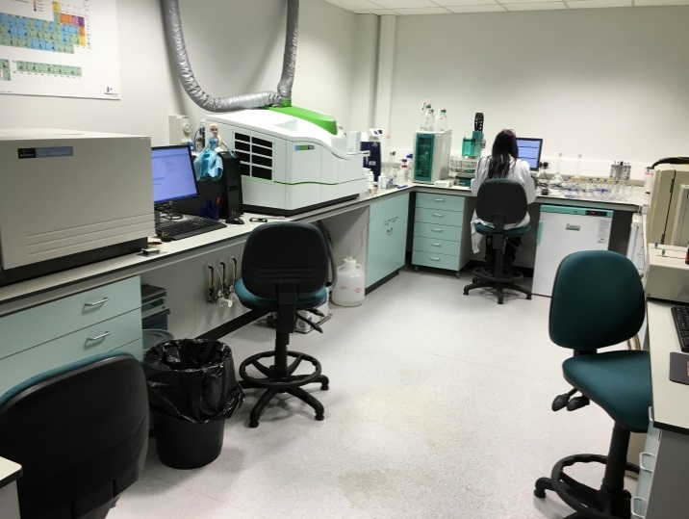

The following analytical equipment is situated in Spectroscopy Laboratory G.023:

* ICP-OES
* ICP-MS
* TOC
* Ion Chromatograph

Only authorised personnel may work in this laboratory or persons under the supervision of authorised staff. The authorised staff for this Laboratory are:

**John Moore**

**Jonathan Yarwood**

**Peter Ryan**

The operation of some of the instruments in this laboratory uses gases that are classed as asphyxiants. If these asphyxiants leak from the gas bottles or the pipework from the tanks, they will replace or reduce the concentration of oxygen in the air. If the oxygen concentration falls **THERE IS A HIGH RISK OF DEATH.**

The following table summarises the effects of oxygen depletion.

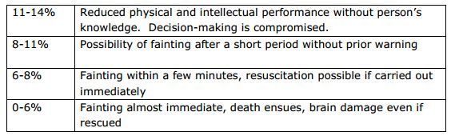

Symptoms of the possible onset of asphyxia can include:

• Rapid and gasping breath

• Rapid fatigue

• Nausea

• Vomiting

• Collapse or inability to move

• Unusual behaviour

The Spectroscopy Laboratory G.023 is fitted with an Oxygen Depletion Alarm. Should the alarm sound and beacon flash then the laboratory **MUST BE EVACUATED IMMEDIATELY!**

On evacuating the laboratory, the following procedure must be followed:

1. Ensure door to G.023 is closed
2. Do not re-enter the laboratory under any circumstances
3. Inform all other occupants of the Geography laboratories that they should evacuate from the laboratories.
4. Immediately inform by telephone the following services:

* Fire Brigade: X 9999
* Security: X 69966
* Estates Helpdesk: X 54999
* John Moore, Senior Research Technician X 53663
* Only enter G.028a if the oxygen depletion alarm and beacon IS NOT sounding or flashing. The argon supply can be isolated using by turning the following valve anticlockwise

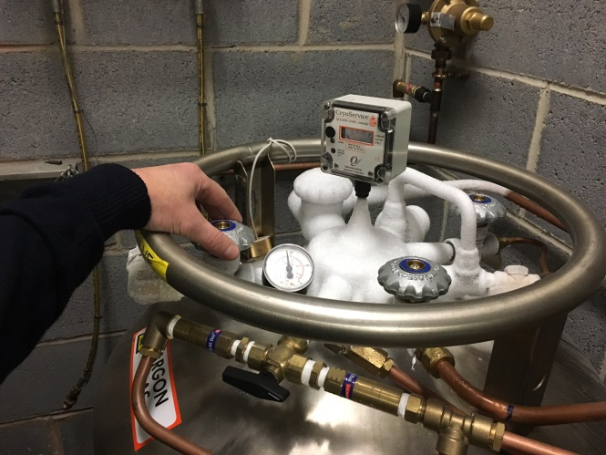

Argon isolation valve