

**Self-certification and Mitigating Circumstances in light of COVID-19**

**Guidance for Students**

**Contents**

1. Introduction 1

2. What are we doing to mitigate the impact of COVID-19? 1

3. Self-Certification 1

4. Mitigating Circumstances 2

5. Evidence 2

6. Students who have not been able to access learning materials 2

7. Disability Advisory and Support Service (DASS) registered students 3

8. Previously accepted mitigation 3

9. Interruptions 3

10. Support and Wellbeing 3

11. Student FAQs 3

This document should be read alongside:

* [Faculty of Humanities No Disadvantage Policy](https://www.humanities.manchester.ac.uk/about/covid19-notifications/corona-virus-guidance-hum-students/)
* [Calculating your baseline mark](https://www.humanities.manchester.ac.uk/about/covid19-notifications/corona-virus-guidance-hum-students/)
* [University of Manchester Self-certification Procedure](http://www.regulations.manchester.ac.uk/academic/self-certification-procedure/)
* [University of Manchester Policy on Mitigating Circumstances](http://www.regulations.manchester.ac.uk/policy-on-mitigating-circumstances/)

# 1. Introduction

This document outlines the arrangements for ‘self-certification’ and submitting an application for ‘mitigating circumstances’.

# 2. What are we doing to mitigate the impact of COVID-19?

We have put in place a number of measures prior to the exam period which are intended to address the mitigating circumstances related to COVID-19. The measures include:

* Open book exams with an extended period for completion
* Introduction of a ‘No Disadvantage’ policy that covers all of semester 2
* Further mitigation will be implemented at course unit/module level during moderation if required
* External Examiners will be asked to review performance for cohorts
* Review of performance in modules by Faculty Exam Boards/Faculty External Examiner
* University Exam Boards/University External Examiner will oversee Faculty Exam Boards

# 3. Self-Certification

If you are prevented from studying for up to and no more than seven calendar days you must contact your school or programme administrator and submit a student [self-certification of absence form](http://www.regulations.manchester.ac.uk/academic/self-certification-form/).

You should contact your school via email on first day of absence (or as soon as possible after absence) and submit the self-certification of absence form.

Self-Certification of illness covers absence from teaching and learning but not exams or assessment; it is a record of your illness (whether this relates to COVID-19 or not).

If you have significant medical circumstances lasting more than seven calendar days which has prevented you from engaging with learning activities or from completing exams or assessment you must complete a mitigating circumstances application; self-certification forms will not be accepted.

**4. Mitigating Circumstances**

The University defines mitigating circumstances as *‘unforeseeable or unpreventable circumstances that could have, or did have, a significant adverse effect on the academic performance of a student’*.

The adjustments to processes and policies that have been introduced for this academic year are intended to mitigate the impacts of the COVID-19 outbreak so you do not routinely need to submit a claim for mitigating circumstances.

Mitigating Circumstances applications are only required where the mitigation required goes significantly beyond that provided for through the [No-Disadvantage policy](https://www.humanities.manchester.ac.uk/about/covid19-notifications/corona-virus-guidance-hum-students/).

You will not need to submit an application for mitigating circumstances if you have been absent from learning during the period since the outset of the epidemic unless:

* + Ill health prevents you from engaging with assessment
  + You have not been able to access learning materials for the whole period of the epidemic.

You cannot submit mitigation for assessments that have already been completed without a credible and compelling explanation as to why the circumstances were not known before the beginning of the assessment period or why you were unable to complete or submit an application prior to the published date.

**5. Evidence**

**5.1 Self-certification**

No evidence or GP signature is required.

**5.2 Mitigating Circumstances Application**

There is no requirement for medical evidence to support any mitigating circumstances applications that cover the period since the University campus closed, due to the difficulty of obtaining medical appointments during the current pandemic; you may opt to include evidence where you have it. However, all other forms of evidence should be submitted as normal.

In your application you should outline the impact of the circumstances on your learning/assessment. Mitigating Circumstances Panels will review these impacts in evaluating your case.

**6. Students who have not been able to access learning materials**

If you have not been able to access learning materials for some of the time since teaching began remotely, you are expected to ‘catch up’ on learning opportunities when you are able to access online learning materials. Mitigation for this is included in the No Disadvantage Policy.

If you have not been able to access learning materials at all (for example because you do not have IT equipment or access to Broadband internet), then you can opt to either complete the assessments as required or you can apply to interrupt your studies. The No Disadvantage Policy will not apply to students who interrupt their studies and complete in a subsequent year.

Before applying to interrupt your studies:

If you are having difficulty accessing your online learning and assessment for whatever reason you should contact the new designated email address [helpmegetonline@manchester.ac.uk](mailto:helpmegetonline@manchester.ac.uk?subject=), or call +44 (0) 161 306 6199 (Monday to Friday during UK Office hours).  A team of staff are available to help you with your IT problems.

**7. Disability Advisory and Support Service (DASS) registered students**

If you have a disclosed disability, and have registered this with [DASS](http://www.dso.manchester.ac.uk/) and your support plan highlights attendance difficulties, you do not need to submit a student self-certification form if your short-term absence relates to your declared disability. However, if you miss a seminar/lecture etc. where a formal register is taken, you will be required to follow your School / Programme’s absence reporting procedures wherever possible.

**10. Support and Wellbeing**

Our support services are available to offer advice and guidance remotely, as they would on a face to face basis. You can find the full list of contacts on the [student support website](http://www.studentsupport.manchester.ac.uk/), which also includes lots of other resources to help support your wellbeing.

**11.** [**Student FAQs**](https://studentnews.manchester.ac.uk/2020/05/12/coronavirus-frequently-asked-questions/)

Correct as 13 May 2020

**I’m not feeling well, what should I do with regards to my study?**

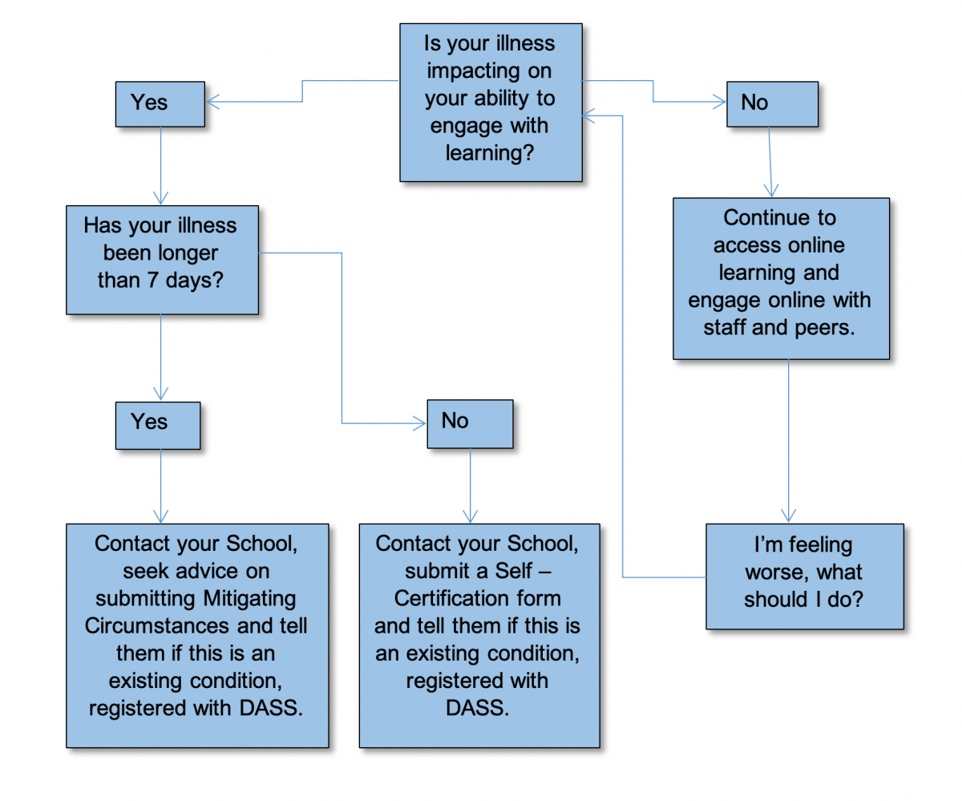

**Should I submit a request for mitigating circumstances to cover the impact of coronavirus?**

No, you don’t need to do this, as steps will be taken for all students across all programmes to minimise the academic impact of the COVID-19 outbreak.

You only need to submit a claim for Mitigating Circumstances if your illness or personal circumstances relating to COVID-19 is impacting on your ability to engage with the online learning resources resulting in you being unable to submit your assessment.

**There are issues with my health which are preventing me from engaging with online learning -what should I do?**

If you have been ill for seven days or less you can self-certificate using the [self-certification procedure](http://www.regulations.manchester.ac.uk/academic/self-certification-procedure/). If you have been ill for longer than seven days or you think you are not going to be better in time to complete your assessment, you should submit a claim for Mitigating Circumstances.

If you are too ill to engage with your studies online, you must contact your School office. In your email please make sure to include your name, your university number and the programme you are studying on. This will help us to keep an accurate record about who is affected and to give you further guidance.

**I’ve been ill for longer than seven days and this has impacted my ability to study and may impact my assessments – what should I do?**

You will need to submit a claim for mitigating circumstances to your School. You will not be required to submit any supporting evidence of your illness with your claim.

**I’ve been ill for longer than seven days and I have not been able to study – what should I do?**

If your period of illness will impact on you being able to complete your assessments or means that you will need to request an extension then you will need to submit a claim for mitigating circumstances to your School. You will not be required to submit any supporting evidence of your illness with your claim.

**I submitted my assignment/dissertation/did my presentation in the last few weeks can I make a claim?**

You will need to make a claim if you were ill at the time you completed the assignment or when you were making the presentation. If this is the case you need to submit a claim for mitigating circumstances.

You should not base your claim on simply having to now make the presentation on line nor that a member of the group was self-isolating or that others were returning home due to the virus – claims on this basis would not be upheld.

**What evidence will I need to submit with my Mitigating Circumstances or Self Certification claim?**

If you are self-certifying you will not need to submit any evidence.

For claims for Mitigating Circumstances relating to illness where you would normally be required to provide a doctor’s certificate or other medical evidence, the University has agreed to remove the requirement to provide this evidence for the rest of the academic session 2019/20. (This relates only to claims submitted after the start of the Covid-19 outbreak, once face-to-face teaching ceased on the University campus and teaching moved online).

**I’m self-isolating for 14 days should I submit Mitigating Circumstances or Self Certify?**

Providing you are well and working online you do not need to submit either. You only need to submit a claim for mitigating circumstances if you have been ill during your isolation and unable to work and this will impact on your ability to be able to submit any of your assessments.

**I’m worried about self-isolating, social distancing, and being able to access my on online learning. What should I do?**

We will do all we can to support you and your learning during this time. As far as possible all of your learning will be on-line and accessible, and relevant notes and materials will be uploaded into Blackboard. Staff will reply as promptly as possible to any specific requests you make, through email or Blackboard, for academic support.

**I have an existing condition, for which I am registered with DASS which has become worse and I am studying online/am too ill to study online?**

Please notify your School if the impact of the exacerbation of your condition means you need support and/or advice.

**Document Control**

|  |  |
| --- | --- |
| **Policy / Procedure Title:** | Self-certification and Mitigating Circumstances in light of COVID-19  Guidance for Students |
| **Date Approved:** |  |
| **Approving Body:** | Humanities Teaching and Learning Committee (COVID 19 Group) |
| **Version:** | May2020 final |
| **Supersedes:** |  |
| **Previous Review Dates:** |  |
| **Next Review Date:** | By Sept 2020 |
| **Related Statutes, Ordinances, General Regulations:** |  |
| **Related Policies / Procedures / Guidance:** | Faculty of Humanities No Disadvantage Policy  [Calculating your baseline mark](https://www.humanities.manchester.ac.uk/about/covid19-notifications/corona-virus-guidance-hum-students/)  University of Manchester Self-certification Procedure  [University of Manchester Policy on Mitigating Circumstances](http://www.regulations.manchester.ac.uk/policy-on-mitigating-circumstances/) |
| **Code of Practice:** |  |
| **Document Owner:** | Fiona Smyth |
| **Lead Contact:** | Lisa McAleese |

**Amendment history**

|  |  |  |
| --- | --- | --- |
| **Version** | **Date:** | **Reason for change:** |
|  |  |  |