# Projects and GL

## Review the source of funds corrections below and comment

### Example 1

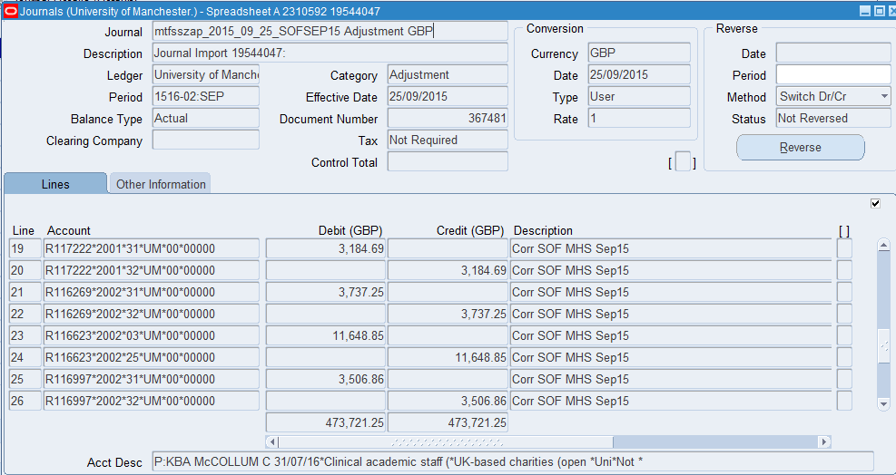

Example 2

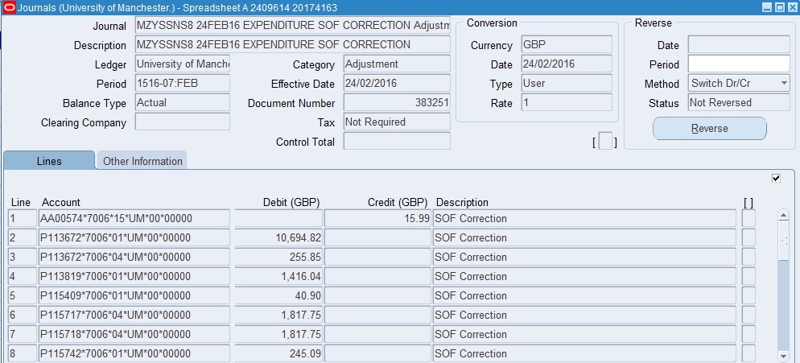 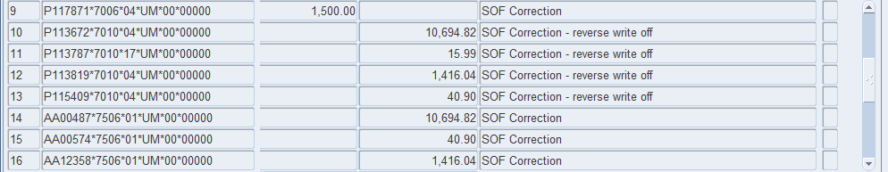 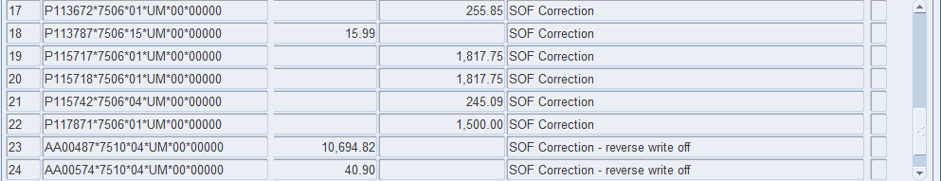 

### Example 3

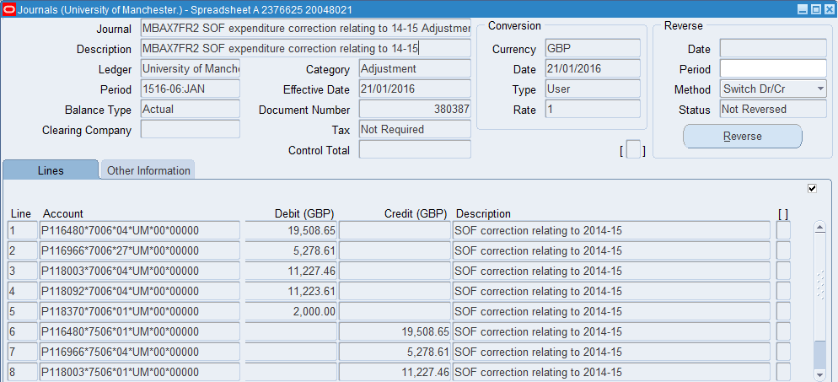 

### Example 4

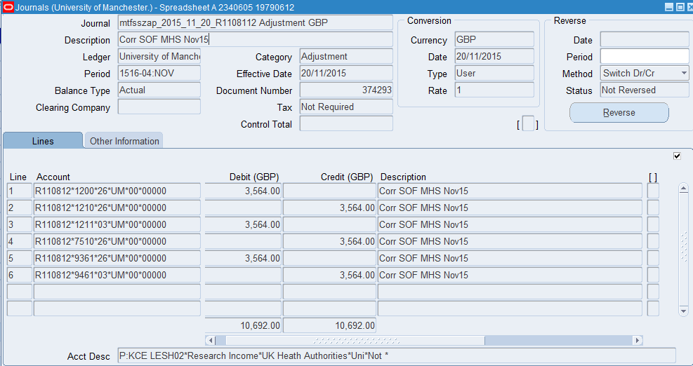

### Example 5

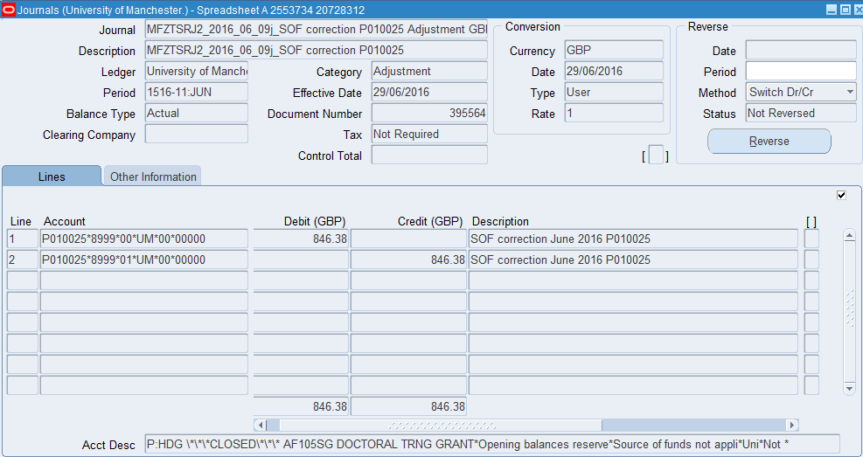

## Example 6:

## Grant starting in 2016



### Example 7



### Example 8

