TAB_col_white_background.eps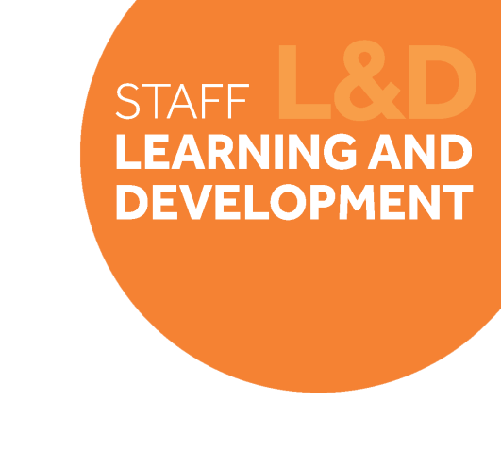

# Change Leadership Skills Framework: *Manage Others’ Responses to Change*

## Definition

*Manage Others’ Responses to Change* is about being able to recognise, respect and acknowledge others’ responses to change and help them adapt to it. It’s about having conversations with staff that extend beyond being just task-based to personal feelings and motives, as well as closely monitoring staff wellbeing and responding any concerns.

Behavioural indicators

1. I support others to understand the need for change and help them to adapt to it.
2. I talk to my staff about their feelings and motives, as well as the tasks they have to do.
3. I monitor other’s wellbeing and respond to signs of health issues.
4. 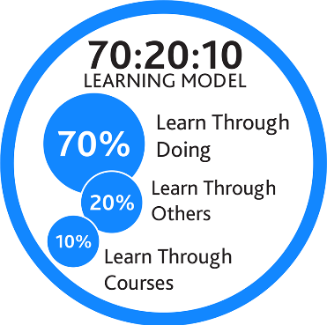 I recognise, respect and acknowledge others’ responses to change.

## Example on-the-job development activities *(70)*

* List the people in your team and how they are likely to be affected by the Technical Review. Speak to them about their concerns or worries and ask them how you can make them more comfortable with the change.
* Champion an area of your team/service to embrace a new way of working in line with the Technical Review. Create positive messages about the changes and recognise the roles individuals have made in bringing the change about.
* Introduce wellbeing and change as a regular item on your 1:1s with your team. Check in with individuals about how they are feeling, and what steps they can take to support their wellbeing.

|  |
| --- |
| *Capture your notes here:* |

## Suggested reflection / discussion questions *(20)*

Q: What are some of the factors that may be preventing your team from feeling positive and engaging with the Technical Review? Think of ways you can manage this to support your team.

Q: Reflect on the opportunities your team have to give feedback and contribute to the outcomes of the Technical Review. How much do you enable them to have their say, and what could you do more to enable this?

Q: Consider your experiences during Cohort 1 of the Technical Review; what did leaders do to support you or make the experience more challenging? How can you build your experiences and learning from this into the way you lead?

|  |
| --- |
| *Capture your notes here:* |

## Recommended learning resources *(10)*

|  |  |
| --- | --- |
| SL&D white block.png | Attend: [Leading People Through Change](https://app.manchester.ac.uk/training/profile.aspx?unitid=7915&parentId=4&returnId=4)  **Learning For All Course – 2.5hours** |
|  | Read: [Overcoming an Immunity to Change](https://app.goodpractice.net/#/manchester-tfl/s/8935fdca)  **L&D Toolkit - 6mins** |
| See the source image | Listen: [Leading Your Team Through Change](https://www.linkedin.com/learning/leading-your-team-through-change/leading-your-team-through-change-2?contextUrn=urn%3Ali%3AlyndaLearningCollection%3A1~AAAAAARzIHo%3D309213&u=74653818)  **LinkedIn Learning – 21mins** |

|  |
| --- |
| *Capture your notes here:* |