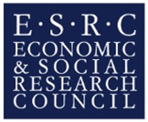

Collaborative Innovation Grants
2022-23

With support from the ESRC’s North West Social Science DTP, Methods North West (MNW) aims to become a regional hub for research methods innovation, celebrating the collective strength, depth and breadth of methodological expertise across the participating Universities of Manchester, Liverpool, Lancaster and Keele.
To this end, MNW has set aside a fund for collaborative projects events, initiatives and symposia that will support cutting-edge developments in research methods across the North West. Collaborative Innovation Grants are intended to support creative proposals that speak across disciplinary pathways and research fields and that evidence how the NWSSDTP is taking a lead in the application of cutting-edge methodology regionally, nationally and internationally. A successful proposal will therefore be:
- genuinely collaborative
- persuasively innovative
- meaningfully inclusive of PGR students
Where researchers are developing new research methods or are refining, re-inventing or finding novel ways to apply existing methods, Methods North West is keen to support that activity. Alternatively, funded projects may focus on contemporary research problems, questions or challenges and bring to bear participants’ expertise in a variety of research methods to develop innovative ways to address them. This might include, for example, work on decolonising research methods to break free from the intellectual legacies of colonialism, work on connecting with people and the issues they face across diverse life circumstances as well as ways of harnessing the proliferation of digital data and digital analytical tools to reshape methodological possibilities. Finally, we also support proposals which take qualitative, quantitative, digital/computational, investigative, creative/arts and interdisciplinary methods to new audiences. As of 2022/23, the CIG route is an open, responsive funding stream which can be applied for at any time through the year, with a 3-4 week turnaround on decisions.
In sum, then, proposals are invited from academics, early career and postgraduate researchers for funding to support activity in any of the following three areas:
  - Research-focused workshops/events emphasising methodological and intellectual innovation;
  - Practice- or impact-focused workshops/events seeking to engage people, communities and organisations;
  - Methods/advanced methods workshop development.
We particularly encourage creative proposals that seek to work across disciplinary pathways and research fields and speak to emerging areas of interest.
Applications are invited from staff and postgraduate researchers from across the four contributing institutions and must include participants from at least two of those institutions. One institution must be named as the Lead institution for the project. Student-led initiatives are welcome, but there must be a named academic contact in the lead institution.
To apply please complete the online Application Form. You should receive a response within two weeks of the deadline for applications. Enquiries should be directed to humanities-training@manchester.ac.uk with ‘Collaborative Innovation Grants’ in the subject line.

How much can be claimed?
Applications can normally be made for up to £2000 to cover all or part of the costs of a particular initiative,
What costs are eligible?
Eligible Costs:
- Costs related to working remotely such as training or web development
- Speakers’ costs (fees, travel and accommodation)
- Catering
- Stationery costs (flip charts, pens etc.)
- Travel costs for NWSSDTP students and other registered PGR students at any of the four institutions in the NWSSP.
- Specialist equipment and/or software

Ineligible Costs:
- Administrative costs (It is expected that institutions will utilise their administrative staff support on a reciprocal basis, or enlist the help of students for administrative tasks)

Structure of Events
Who can be involved?
Projects funded through the CIG scheme must have potential benefit to NWSSDTP-funded PGR students and should be open to all PGR students with relevant interests in the four NWSSDTP institutions. They can be led by academic staff in these institutions or by PGRs themselves. Applicants may wish to involve a wider, audience, for example, academics and PGR students outside the North West, and/or non-academic partners.
How should projects be organised?
MethodsNW will not be able to offer administrative support beyond publicising the project through its own and NWSSDTP networks. However, it is expected that institutions will utilise their administrative staff support on a reciprocal basis, or enlist the help of students for administrative tasks. Students can be involved in the organisation of these events, but there must be a named academic contact in the lead institution.
What format should these projects take?
This is at the discretion of the organisers. You may opt to arrange a conference/workshop/colloquium or to run something more informal or interactive. In a time when face-to-face events or unlikely alternative formats are welcome and grants can be used to develop alternative strategies for collaborative working. Participants can be academic staff or students, or externals. Staff from institutions outside of the North West can be brought in to speak, and their costs may be funded from the CIG.

Application Form Guidance
Date and Time: If the exact date and time is not yet known, please give an indication of when the activities will take place (e.g. the month or the term).
Key Contact: this will normally be the lead applicant and organiser(s) of the project. They can be staff or PGR students. However, one of the criteria for assessing CIG applications is that they are ‘meaningfully inclusive of PGR students’ and a good way to do this is to include PGRs as organisers.
Lead Institution: Although we aim to encourage collaboration between HEI’ and with non-HEI partners, for administrative purposes one of the four NWSSDTP HEI’s must be named as lead Institution.
Institutional Contact: Four administrative purposes it is important that each funded project has a named member of academic staff in the lead institution who is willing to act as a contact even if they are not actively involved in developing the initiative. Normally this will be the institutional lead for methodsNW in the lead institution:
Keele University: Anita Hayes, (Director of Links@Keele), links@keele.ac.uk

University of Lancaster: Gary Potter, (Director of methods@Lancaster), Methods@Lancaster G.potter2@lancaster.ac.uk

University of Liverpool: Michael Mair, (Director of Engage@Liverpool), engage@liverpool.ac.uk / Michael.Mair@liverpool.ac.uk

University of Manchester: Emma Banister (Director of Methods@manchester), methods@manchester.ac.uk

Collaborating Institutions: Projects must include participants from at least two of the four NWSSDTP institutions, but need not be restricted to them. This list does not need to be exhaustive at this stage.
Brief Project description (Elevator Pitch): What is the problem or methodological innovation your project will address?
Background and Rationale: Give a concise description of why this project should be considered for a Collaborative Innovation Grant.
Plan of activities: Outline a plan of activities for which the CIG funding will be used. Please detail here the structure the project will take, who will be involved (if known), a preliminary schedule (if known), if staff/students outside the NWSSDTP will be invited, if this fits into a wider programme of events.
Target Audience: Please give a rough indication of the audience the project is primarily aimed at. For example researchers, PGR students, policy makers etc.
How are PGR students involved? How will the project benefit PGR students? If possible please indicate the breakdown between NWSSDTP, (or NWDTC) students and non-ESRC funded students who will be involved. Priority will be given to projects that involve one or more NWSSDTP students or NWDTC students.
Amount claimed for: This can be up to £2000 though smaller grants are encouraged. If you have an idea that would require larger amounts of funding please contact your institutional methodsNW lead to discuss options.
Claiming your CIG money: Successful applicants should be aware that for administrative purposes expenditure will need to be covered by the lead institution (usually through the applicants department, school or faculty) in the first instance and reclaimed from methodsNW. Applicants are advised to confirm with local administrative/finance staff that appropriate arrangements can be put in place. The process for claiming grants from methodsNW is summarised in the diagram below:
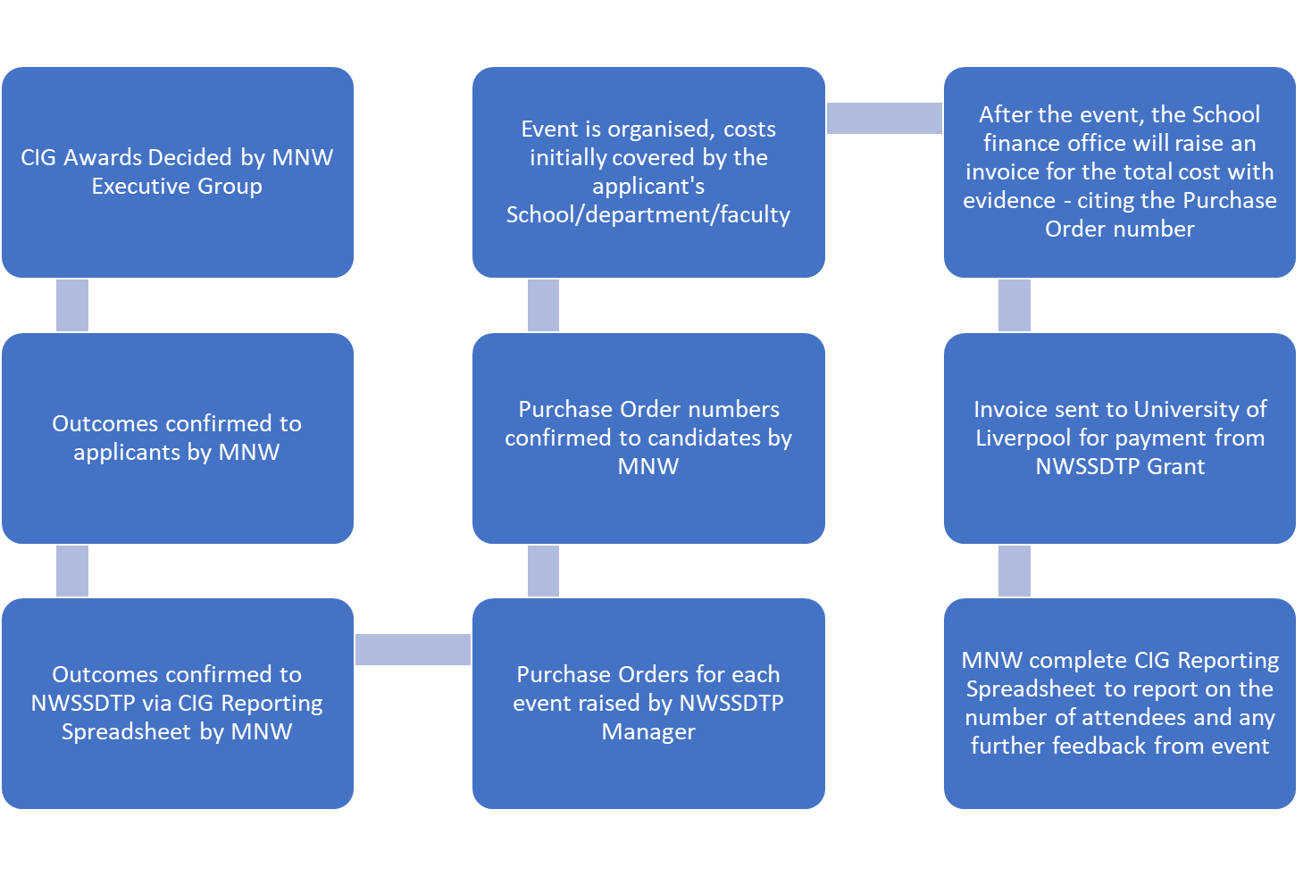

Please note: Publicity materials should carry the words ‘Supported by the ESRC through MethodsNW and the NWSSDTP’.

