L&D Objective | What do I want/need to learn or do better? | What will I do to achieve this? | What resources or support will I need? | How will I know if I have succeeded? | Target dates for  review or completion
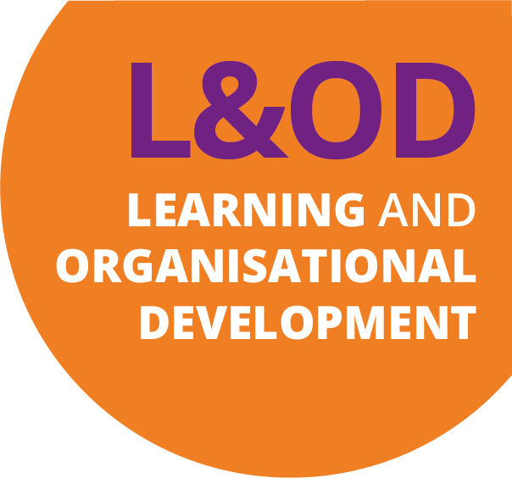
Personal Development Plan

Name: From: To:
Planned outcomes:
0 – 6 months

0-6 months

L&D Objective | What do I want/need to learn or do better? | What will I do to achieve this? | What resources or support will I need? | How will I know if I have succeeded? | Target dates for  review or completion
Personal Development Plan

Name: From: To:
Planned outcomes:
6 – 12 months

0-6 months

