Voucher process for public contributors: additional guidance

Due to the work of a Patient and Public Involvement and Engagement (PPIE) working group involving academic representatives, public contributors and faculty and central PS colleagues, there has been a change to voucher forms and processes.

Find out more on the [vouchers webpage](https://www.staffnet.manchester.ac.uk/finance/purchasing/vouchers/).

We have created additional information below which can be sent to public contributors to advise them on how to redeem their vouchers.

**Staff:** to order a voucher, you will need to send the email address for the public contributor. As this is personal information, please ensure that you have their permission before sending. They will then receive an email directly from the vouchers team via their email: [vouchers@manchester.ac.uk.](mailto:vouchers@manchester.ac.uk) Please inform them in advance.

The following assumes that they have been sent the below email:

Thank you, message, (including the name and date of the activity you took part in).

* Your Voucher Code(s): xxx
* Code Value: xxx
* Voucher Code Expiry Date: xx/xx/xxxx
* The link to take you to the correct part of the love2shop website is: [[www.love2shoprewards.co.uk](https://www.love2shoprewards.co.uk)](https://www.love2shoprewards.co.uk). Please use this address only - if you google LOVE2SHOP and follow their instructions it will ask you to set up an account.

Things to be aware of before you start

This is a **love2shop voucher**. It will need to be **activated** before you can use it.

When you activate the voucher, it will ask you to choose whether you would like to receive a:

* traditional love to shop voucher that you can use in several different shops.

Or

* a voucher for a particular shop.

Some of the options you will be shown are for:

* a digital e-gift card only - This means that a new voucher code for a particular shop will be sent to your e-mail address. This should arrive the same day.
* a physical card only – this means a card will be posted to your address. This can take a few days to arrive.
* Combination of a digital e-gift cards and a physical card – you can split the value of your voucher.

To activate and choose your voucher

1. 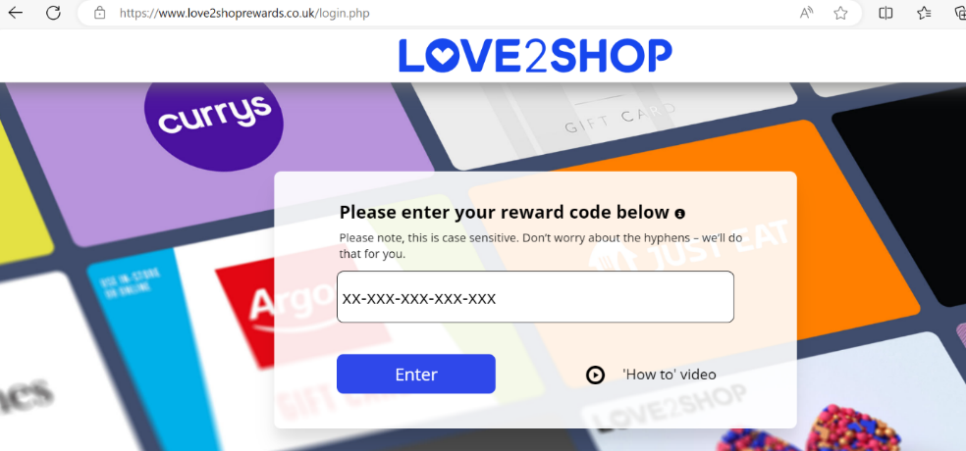Go to www.love2shoprewards.co.uk
2. Type your code shown above into this box (you can copy and paste this if you prefer). There is a video of the instructions next to this box. Watch this before you click enter or follow the instructions below.
3. You should be able to see the amount on your card at the top right of the screen.
4. Scroll down the page and look at the different vouchers you can choose from. To see if it is a digital e-gift card or physical card, or if you have the choice, you can either:
   1. click on each card. This will tell you which type of card it is. If this card will allow you to choose between a physical card or a digital card, you will see two different tabs with these options on them.
   2. click on the text at the top of the screen that says ‘e-gift cards’ or ‘physical gift cards’ to only see the cards from that group. This is shown just above the image of all the cards.
5. When you know which gift card you would like:
   1. Click on the card of your choice.
   2. Select either the ‘physical card’ or ‘digital e-gift card’ option (if it gives you the choice).
   3. Enter the amount you would like the card to be for (don’t go over the amount in the e-mail above).
   4. Enter the number of vouchers
   5. Click ‘Add to basket’
6. Check the details are correct and add your delivery details (e-mail address or delivery address depending on the type of voucher you have chosen).
7. Click “place order”