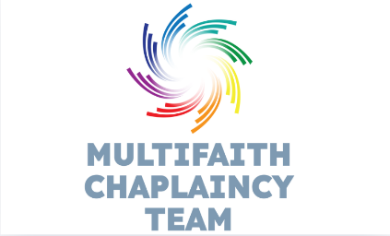
Information about Friday prayers (updated September 2025)

In collaboration with Manchester Metropolitan University, our Muslim Chaplin and colleagues at the Sugden Centre, we have established Jummah Prayer at the Sugden Centre on Fridays during term times for colleagues and students.
For the 2025/26 academic year, prayers will be available for the following dates:
- Friday 26 September 2025 to Friday 12 December 2025
- Friday 23 January 2026 to Friday 27 March 2026
- Friday 25 April 2026 to Friday 29 May 2026

The timings will differ slightly, please note below:

26th September to 31st October | 1.15pm-1.45pm | 2.05pm - 2.30pm
31st October to 30th March | 12.15pm -12.45pm | 1.05pm - 1.30pm
April to May | 1.15pm-1.45pm | 2.05pm - 2.30pm

