|  |
| --- |
| Coping with...  A screenshot of a computer  AI-generated content may be incorrect.Self-esteem challenges |
| In this section we will look more at understanding your experiences of self-harm. We will work out a plan together to help you with these. This section aims to help you to:   1. **Find out more about self-harm** 2. **Understand how self-harm affects you** 3. **Plan how to deal with self-harm**   Please go through the worksheets at your own pace, there’s no pressure to finish it quickly. You can always take a break and come back to it later. If there is anything you are unsure about you can ask for support from the mental health professional you are working with. |

# SECTION 1

**Understanding self-esteem**

This section aims to help you to:

* Find out more about self-esteem
* Understand how self-esteem can affect you
* Work together to try to improve your self-esteem



**An important note**

Looking at our self-esteem and what has influenced it can be a difficult process. It may bring back difficult memories and result in difficult emotions. It can be worth it though, as having a negative view of oneself is also difficult to live with.

This means that it is important to work through this section at your own pace. Please make sure that you discuss the material covered and its impact with your nurse.

Good self-esteem is not something that happens overnight, it requires ongoing effort. Hopefully this section may be a starting point for viewing yourself in a more positive way.

**What is self-esteem?**

Self-esteem is the opinion we have of ourselves and/or the value we place on ourselves. It may be that we feel good about ourselves in certain areas or situations, but bad in others. What is important is how we generally see ourselves.

This can be good, e.g. believing ‘I am a good person’ and ‘I am worthwhile’. It can also be negative, e.g. believing ‘I am a bad person’ or ‘I am useless’.

If our opinion of ourselves is generally negative, this is called ‘low self-esteem’. Not everyone who experiences mental health problems has low self-esteem, but if you do, it might be something you would like to work on.



**How does our self-esteem develop?**

Our early life experiences can shape who we are, or who we think we are. Experiences we have as an adult can also have a big impact. We often get a variety of messages, some good and some not so good. These messages can come from relatives, carers, friends, teachers, and partners.

**Childhood**

*For example, an art teacher at school may have been really impressed by a painting we did, and showed it to the class (a positive message). We may have had opposite experiences from school bullies though, e.g. if they made fun of us for not being very good at sports (a negative message).*

**Adult**

*As adults we continue to have experiences that can shape our self-esteem. We may have experiences of people saying positive things about our work, at home or in the workplace. We may have friends who show that they enjoy spending time with us, or value what we say. We may also be bullied because of things that we do or don’t do, or the way we look. This may be at a place of work, in the street or in certain groups.*

**Currently**

*We may also have people around us who criticise us. This is not as easy to recognise as bullying. It may come across in things people say, e.g. ‘you’re so lazy’, ‘you need to pull yourself together’. It could also be shown in things they do, e.g. always assuming we can’t do things for ourselves, not asking our opinion, talking over us or ignoring us.*

All of these different experiences add together to influence our self-esteem. Negative experiences are likely to lead to negative opinions about ourselves or ‘low self-esteem’.



**How can mental heath problems impact on our self-esteem?**

People who have mental health problems often develop low self-esteem. This could be because:

*When someone is unwell they may criticise themselves for having difficulties. They may tell themselves ‘It’s my fault’, ‘I’m useless’, ‘I’m a waste of space’. For example, they may act out of character, and then tell themselves off for acting this way.*

*Others can be unkind to people because of their difficulties. There may also be negative messages from society in general, e.g. through the news, the papers etc. These may suggest that people with mental health problems are ‘different’, ‘to be avoided’, ‘damaged’ or ‘dangerous’. Some people start to believe these messages, which can have a big impact on self-esteem.*

**Experiences in psychosis that may affect self-esteem**

Some experiences of psychosis may lead to low self-esteem. For example, you may hear voices that say negative things about you, or believe that people are thinking about you negatively. These experiences can affect self-esteem just as negative thoughts about yourself do.

Low self-esteem and experiences of psychosis can affect each other. They both impact on each other, and this is usually in a very negative way.

Additional guided self-help may help you with experiences of psychosis that affect your self-esteem. You could speak to your nurse about looking at these.



**Understanding low self-esteem**

Negative opinions of ourselves or ‘low self-esteem’ can have a major impact on our lives. This is because our **thoughts** or opinions about ourselves affect our **feelings** and **behaviour**. The cognitive behavioural model can be helpful in understanding problems. This can explain how thoughts, feelings and behaviours are linked in low self-esteem.

First, we will look at thoughts related to low self-esteem.

**Thoughts**

Some common thoughts in low self-esteem are listed on the next page. You could tick the ones that apply to you. You could also note how strongly you believe each thought out of 100 (0 = not at all, 100 = could not be stronger). You may find that none of these apply to you but you still feel negative towards yourself. You could make a note of them in the spaces in the table.



|  |  |  |
| --- | --- | --- |
| **Common thoughts in low self-esteem** | | |
|  | **Please tick** | **Strength of belief (0-100%)** |
| I am not good enough |  |  |
| I am not important |  |  |
| I am stupid |  |  |
| I am worthless |  |  |
| I am unlovable |  |  |
| I am bad |  |  |
| I am inferior |  |  |
| I am boring |  |  |
| I am a failure |  |  |
| I am useless |  |  |
| I am weak |  |  |
| I am pathetic |  |  |
| I am unlikeable |  |  |
| I am ugly |  |  |
| **Please add your own examples below:** | | |
|  |  |  |
|  |  |  |
|  |  |  |
|  |  |  |
|  |  |  |



Some people find it easy to identify thoughts. Others find it is not as easy as it sounds. The thoughts we have about ourselves have often been around for a long time. They are part of us and the way we think, so it can be hard to think about them objectively. If you find it difficult, the ***diary method*** may help you. Even if you find it easy, it may be helpful to use a diary to think through a difficult event.

First we will show you an example. This should help you to complete your own diary.

**Mike**

Mike was asked by his nurse to keep diaries during the first few weeks of therapy. This was to help him to identify triggers, thoughts, feelings and behaviours in relation to his low self-esteem. An example of Mike’s diary is shown below.

|  |
| --- |
| 1. **Triggers**    * What was the situation?    * Where were you?    * What were you doing?    * What happened?    * Who were you with? |
| At the post office to buy some stamps. There was a big queue of people waiting and the person next to me started going on about the fact that a number of post offices were going to be closed. He then started going on about politics. |
| 1. **Thoughts**    * What thoughts, ideas or images went through your mind?   If this is true what does this say about you, others, the world, the future? Rate how much you believed each thought was true on a scale of 0-100% |
| He’s going to ask me something and I wont be able to answer (80%) I should know about these things (90%)  I look really anxious (100%) I’m useless (100% |
| 1. **Feelings**    * How did you feel?    * Describe each feeling in one word   Rate how distressing each of these feelings were on a scale of 0-100% |
| Anxious (75%)  Depressed (60%) |



(Mike’s example continued)

|  |
| --- |
| 1. **Behaviours**    * What did you do?    * What action did you take?    * What helped you to cope? |
| Avoided eye contact  Tried to change the conversation  Agreed as if I knew what he was talking about  Left the post office and decided to go back when it was quieter |

**Using the diary method for yourself**

On the next page there is a blank thought diary for you to complete. You can use the notes below to help you with filling it in. If you like, you could go through this with your nurse. There are extra copies of the diary at the end of this section. If you need any more, please ask your nurse.

Think back to a recent time when you had negative thoughts about yourself or about a situation or event. Write these down in the **thoughts** section.

Now think back to the situation or event (trigger). Write down in the **trigger** section what was happening, who was there, where you were etc.

Then try to remember what thoughts you had about yourself or the situation. Finally, note the emotions (feelings) you felt at this time in the **feelings** section. This may be one emotion or a number of different ones.

We will look at behaviours later in this section, so leave the last column blank for now.



|  |  |  |  |
| --- | --- | --- | --- |
| 1. **Triggers** | 1. **Thoughts** | 1. **Feelings** | 1. **Behaviours** |
| * What was the situation? * Where were you? * What were you doing? * What happened? * Who were you with? | * What thoughts, ideas or images went through your mind? * If this is true what does this say about you, others, the world, the future? * Rate how much you believed each thought was true on a scale of 0-100% | * How did you feel? * Describe each feeling in one word * Rate how distressing each of these feelings were on a scale of 0-100% | * What did you do? * What action did you take? * What helped you to cope? |
|  |  |  |  |
|  |  |  |  |
|  |  |  |  |
|  |  |  |  |
|  |  |  |  |

Don’t worry if you are still finding it difficult to use these diaries. When people have very strong emotions, their brain can switch off and be unable to think things through. This

is why people talk about being ‘lost for words’, having a ‘mental block’ or being ‘struck dumb’. If this is the case for you, you may wish to speak with your nurse about it so you can work it out together.

In some situations, emotions (feelings) seem to come first. Sometimes they come after thoughts. Sometimes, thoughts and feelings seem to come all at once. We will look at feelings and emotions next.

**Feelings and emotions**

When people have low self-esteem, they are more likely to experience unpleasant feelings and emotions. You may have already recorded some of these in your diary. Some common feelings and emotions in low self-esteem are listed below. You could tick the ones that apply to you. Try to note how strongly you feel this out of 100 (0 = not at all, 100 = could not be more) in the next column. You may find there are other feelings that you experience. If so, please try to add them to the table.

|  |  |  |
| --- | --- | --- |
| **Common feelings in low self-esteem** | | |
|  | **Please tick** | **Strength of belief (0-100%)** |
| Sadness |  |  |
| Guilt |  |  |
| Low mood/depression |  |  |
| Anxiety |  |  |
| Shame |  |  |
| Frustration |  |  |
| Anger |  |  |
| **Please add your own examples below:** | | |
|  |  |  |
|  |  |  |
|  |  |  |
|  |  |  |
|  |  |  |



Now you have ticked the boxes, are there any emotions you can add to the ‘feelings’ column of your thought diary? If so, go back and add them to the diary.

When we have certain thoughts and feelings, this can make us want to ‘do’ a range of things. We will cover this in the next section.

**Behaviours**

When people have low self-esteem, their negative thoughts and feelings can affect their behaviours. Some behaviours common to low self-esteem are listed on the next page. Please tick the ones that apply to you. Try to note how often you do this behaviour out of 100 (0 = not at all, 100 = all the time). If you do other behaviours that are not listed, try to add them to the table.

Once you have done this, go back to your thought diary, and add the behaviours in the column that we left blank before.



|  |  |  |
| --- | --- | --- |
| **Common behaviours in low self-esteem** | | |
|  | **Please tick** | **How often (0-100%)** |
| Finding it hard to speak up for yourself |  |  |
| Putting others first |  |  |
| Avoiding situations or events |  |  |
| Avoiding meeting people |  |  |
| Trying to do things perfectly |  |  |
| Avoiding eye contact |  |  |
| Seeking reassurance from others |  |  |
| Avoiding making decisions |  |  |
| Using alcohol, drugs or medication to manage difficult situations |  |  |
| Keep people at arms length |  |  |
| Hiding your ‘true self’ |  |  |
| Trying to cover up your physical appearance |  |  |
| Keeping your emotions under tight control |  |  |
| Reliving things that you have done wrong |  |  |
| **Please add your own examples below:** | | |
|  |  |  |
|  |  |  |
|  |  |  |
|  |  |  |
|  |  |  |



# SECTION 2

**Understanding Vicious Circles**

This section aims to help you to:

* Understand the links between thoughts, feelings and behaviours
* Work though some of your own examples



The cognitive behavioural model can help us to understand problems. With low self-esteem, thoughts, feelings and behaviours are all linked together. The examples below and opposite show how each affects the other.



|  |
| --- |
| **Mike**  When Mike was young his father left home and didn’t stay in touch with the family. After a few years his mother remarried. His new stepfather was very critical towards him. Mike could do nothing right. His stepfather would shout at him for the slightest thing. Mike began to believe it when his stepfather told him that he was useless. Mike left home as soon as he could and got his own flat. He had friends who he played football and went to the pub with, but they were not very close friends.  One night in the pub, Mike met a girl who he used to go to school with, and they arranged to go out. It soon became clear that she wanted to have a relationship with Mike. Mike liked her but he **thought** he was not good enough for her. This made him feel very anxious and ashamed (**feelings**).  At first, he would have a drink before he went out, would avoid all conversation about himself and would take a long time to return her call. Eventually he stopped returning her calls altogether and stopped seeing her (**behaviours**). Because Mike stopped seeing Julie, this made him believe that he was not good enough even more, and closed the vicious circle. The diagram on the next page shows how his thoughts, feelings and behaviours interlinked. |

**Mike’s vicious circle**

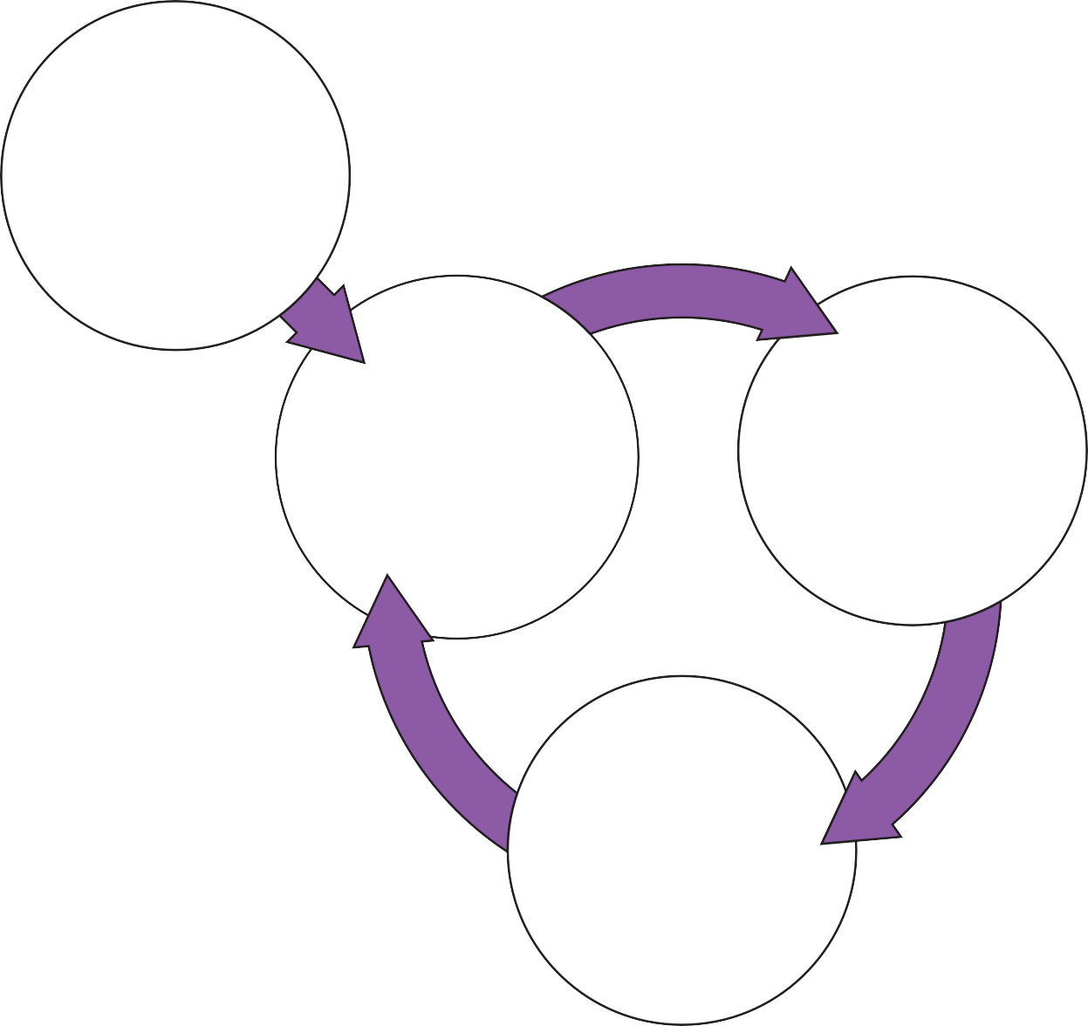

**Triggers**

Chance to have a relationship

**Thoughts**

If she really knew the real me she would reject me

I am not good enough

**Feelings**

Anxious Ashamed

**Behaviours**

Drink to calm nerves Avoid the telephone Not talk about self Avoid serious relationships



**Overcoming low self-esteem**

The first step to overcoming low self-esteem is to identify **triggers**, **thoughts**, **feelings** and **behaviours**. You may have identified some of these in the previous exercises. The next step is to think about how these experiences relate to each other for you. You can do this by filling in the blank diagram (below). Don’t worry if you find this difficult. If you like, your nurse can help you with it. Try to fill in the boxes using the information from your ‘thought diary’, or think about another situation. Use Julie and Mike’s examples for ideas.

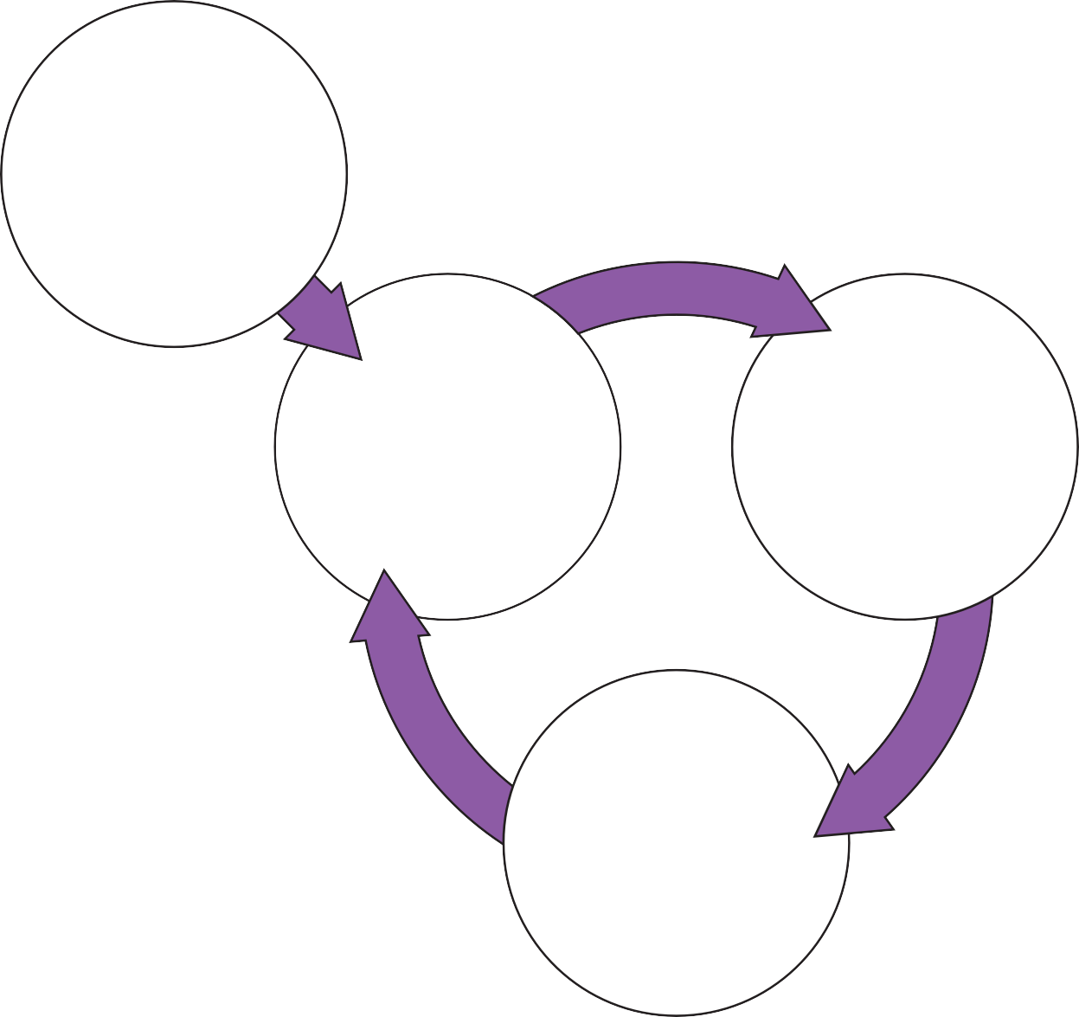

**Trigger**

**Thoughts**

**Feelings**

**Behaviours**



Some people react in a similar way to every difficult situation or event. For example, a person may always react to a range of situations by thinking in certain ways about

themselves (I’m useless), feeling a certain way (depressed), and behaving in a certain way (avoiding situations). Other people act very differently in different situations. For example, on one occasion they may avoid things, on another they may throw themselves into something, and on another they may drink or take drugs. If this is the case for you, try to write down a number of examples that capture your range of thoughts, emotions and behaviours.

Please ask your nurse if you need more blank diaries.

You have now identified triggers, thoughts, feelings and behaviours, and worked out how they impact on each other. We will now look at things that may be helpful in dealing with the difficulties that you are experiencing.



# SECTION 3

**Checking Out Negative Thoughts**

This section aims to help you to:

* Track your thinking
  + - * + Overcome negative thoughts



**Checking out negative thoughts or opinions about self**

One useful way of dealing with negative thoughts about yourself is to learn to look at thoughts more objectively.

Thoughts associated with low self-esteem tend to be:

* Automatic (involuntary)
* Believable
* Habitual (a bad habit)
* Unreasonable and unhelpful

Because thoughts in low self-esteem are automatic, the first step to overcoming them is to become more aware of them. Because they are believable, the second step is to begin to look at them in a more balanced way. This means looking objectively at the thoughts to see whether or not they are true. We often think that thoughts are facts.

For example, consider these thoughts:

* ***My friends think that I am boring • I am useless***

These are just thoughts, so believing that your friends think you are boring doesn’t mean that they do. In the same way, thinking that you are useless is only a thought, it does not make it fact. When your self-esteem is low, these negative thoughts about yourself don’t feel like just thoughts, they feel like facts. They feel like they are the truth about us, and our current situation. Try to remember that they are just thoughts, not fact. Using seven- section thought diaries can help you to view negative thoughts about yourself more realistically. Next, we will look at how to do this.

**Step 1: Identifying negative thoughts about yourself**

Hopefully you will now have had some practice at using the thought diary method. For the next week or so, try to use the diary every time you notice yourself feeling any of the strong negative emotions you ticked earlier. Use sections 1-3 of the thought diary on to write down the event, how you felt, and thoughts that were going through your mind. Try to note how strong your emotions are and how much you believe each thought. This will help you to become more aware of what your negative thoughts

about yourself are, how much you believe them, and how they affect your feelings and behaviours. There are extra copies of this at the end of this section ( If you need any more, please ask your nurse).



**Step 2: Checking out negative thoughts about yourself**

Once you can identify negative thoughts about yourself, you can then begin checking out how realistic they are. Choose one thought to work on first. The thought you pick may be the strongest one or the one you experience most often. It may be the one that you feel most emotion about - the choice is yours. Circle the thought you are going to focus on.

Now complete sections 4 and 5 of the thought diary. These sections ask you to give your evidence for and against the negative thought. Checking out negative thoughts takes practice. Mike found that the following strategies helped. They might help you too!

**The courtroom technique**

Mike’s nurse asked him to pretend that the negative thought about himself was in the dock at court. He asked him to look at the evidence for and evidence against the

thought. Mike was also asked to be as objective as possible. Here is an example of how Mike used the courtroom technique. His anxious thought to be tested was ‘I’m useless’.

|  |  |
| --- | --- |
| **Thought to be tested: ‘I’m useless’** | |
| **Prosecution (Evidence for)** | **Defence (Evidence against)** |
| * I’m not good at conversation * I don’t keep up with politics * I do get really anxious | * I had managed to get through all my paperwork for the week * I had remembered to send a card for my nephew’s birthday * Other people get anxious - it’s not just me |





**Step 3: Thinking about things more rationally**

Now you have checked out your thoughts, you could try to think of a more balanced thought. Mike used the questions below to help him think about his thoughts in a more balanced way. Your nurse could help you to think about these things.

* What real evidence do I have to support these thoughts?
* Are these thoughts helpful?
* What thoughts might be more helpful?
* Am I confusing thoughts with facts?
* Am I being too hard on myself?
* If a friend in the same situation told me this negative thought would I agree?
* How would someone else view this?

Try to think of a more balanced response, and write this in column 6.

**Step 4: Rate how you feel now**

Write down how you feel now in section 7. Rate how strongly you feel the emotions. It may be that you still feel the same kind of emotion you did at the start, or you may feel a different one. Has checking your thoughts out in this way changed the way you feel? If so what do you make of this?

Don’t worry if you are finding it difficult to check out your thoughts or find that the diaries are not working for you. This might take time and practice. You could discuss any problems with doing this with your nurse. The next page shows Mike’s completed thought diary.



|  |
| --- |
| **1. Triggers** |
| At the post office to buy some stamps. There was a big queue of people waiting and the person next to me started going on about the fact that a number post offices were going to be closed. He then started going on about politics. |
| **2. Feelings**  Rate how distressing each of these feelings were on a scale of 0-100% |
| Anxious (75%) |
| **3. Thoughts**  Rate how much you believed each thought was true on a scale of 0-100% |
| He’s going to ask me something and I wont be able to answer (80%) I should know about these things (90%)  I look really anxious (100%) I’m useless (100%) |
| **4. Evidence for this thought**  Circle the thought you want to test from section 3.  Write only the factual evidence you have to support this thought. |
| I’m not good at conversation I don’t keep up with politics  I get really anxious |
| **5. Evidence against this thought**  Use the strategies in the Recovery Guide to help you discover evidence that does not support the thought |
| I had managed to get through all my paperwork for the week I had remembered to send a card for my nephew’s birthday Other people get anxious - it’s not just me |
| **6. More balanced response**  Is there another way to explain the situation?  Rate how much you believe the more balanced response on a scale of 0 to 100% |
| I may get anxious but many people do - and just because I don’t know much about politics it does not make me a bad person (80%) |
| **7. How do you feel now?**  Rate each of these feelings on a scale of 0 to 100% |
| Anxious (25%)  Calm (40%) |



|  |
| --- |
| **1. Triggers** |
|  |
| **2. Feelings**  Rate how distressing each of these feelings were on a scale of 0-100% |
|  |
| **3. Thoughts**  Rate how much you believed each thought was true on a scale of 0-100% |
|  |
| **4. Evidence for this thought**  Circle the thought you want to test from section 3.  Write only the factual evidence you have to support this thought. |
|  |
| **5. Evidence against this thought**  Use the strategies in the Recovery Guide to help you discover evidence that does not support the thought |
|  |
| **6. More balanced Response**  Is there another way to explain the situation?  Rate how much you believe the more balanced response on a scale of 0 to 100% |
|  |
| **7. How do you feel now?**  Rate each of these feelings on a scale of 0 to 100% |
|  |

# SECTION  4

**Checking Out Negative Thoughts & Coping Strategies**

This section aims to help you to:

* Change how you respond to negative thoughts



**Checking out your view of yourself with behaviours**

Another way to check out your views of yourself is to change your behaviours in response to them. Some people find it easier than others to change their **behaviours**. If you find it difficult, a first helpful step is to fill in a thought diary. This can help you to develop a more balanced view of the situation, and reduce some of the difficult feelings before you change your behaviour.

When people have low self-esteem, they tend to make anxious predictions about what they can or can’t do, what other people will think of them or what might happen in

the future. For example, when Mike’s CPN suggested that he go to a meeting about voluntary work, Mike had the anxious thought ‘If I go to the meeting about voluntary work I will be put on the spot and won’t know what to say. Everyone will realise how useless I am’.

The problem with predictions like this is that they stop you from doing anything to find out whether or not they are true. This means that you begin to believe them more, avoid more things, feel more negative about yourself, and so on. One way of getting out of this vicious circle is to change your behaviours. In Mike’s case this would be to attend the meeting.

It can be very scary to face things we are scared of, but using a ***behavioural experiment*** can help you to find out how true the predictions actually are. With the help of his nurse, Mike set up an experiment to test out his anxious prediction that he would not be able to successfully go to the volunteer meeting. This is shown in the diary on the next page.



|  |  |
| --- | --- |
| **An example of Mike’s Behavioural Experiment Diary** | |
| **Step 1** | Write down the thought that you want to test below. Rate how much you currently believe this thought to be true on a scale of 0-100%. |
| **Thought:**  ‘If I go to the meeting about voluntary work I will be put on the spot and won’t know what to say. Everyone will see how useless I am’.  **Belief....... 100%** | |
| **Step 2** | Think of a way to check out the thought. Write down how you plan to test the thought. |
| **Experiment to test the belief. What are you going to do?**  Go to meeting.  **Given your thought what do you predict will happen?**  Someone will ask me a question and I won’t know what to say, I will get anxious and have to leave. | |
| **Step 3** | Identify any problems and solutions. Write down what problems might get in the way of checking it out. How can you overcome these? |
| **What might make the experiment difficult? How might you solve this?**  If I am too anxious  I could arrive early and settle myself before the meeting starts. I could sit in a place towards the back or the side. I could tell myself ‘everyone gets anxious, especially at meetings where they don’t know people. | |
| **Step 4** | Outcome. Write down what actually happened. What was the result of the experiment? |
| Went to the meeting, arrived early and sat towards the back but it was ok. My anxiety was high but it went down and I took some leaflets away to think about | |
| **Step 5** | How much did the outcome support the thought to be tested? Write down whether what really happened fitted with your original prediction. |
| I was anxious but it did not stop me getting something out of the meeting. It did not overwhelm me and I was able to stay until the end.  There were other people there who looked anxious as well and did not say anything People seemed nice and were pleasant towards me | |
| **Step 6** | Write down how much you believe the thought to be tested now from 0-100%. |
| **Thought:**  ‘If I go to the meeting about voluntary work I will be put on the spot and won’t know what to say. Everyone will see how useless I am’.  **Belief....... 30%** | |



|  |  |
| --- | --- |
| **An example of Mike’s Behavioural Experiment Diary** *(continued)* | |
| **Step 7** | What do you make of this? Write down any alternative thoughts. |
| **Alternative thought:**  I can go along to meetings and get something out of them Some people are nice to me  **Belief....... 70%** | |

**Checking out your own anxious thoughts with behaviours**

There is a blank copy of the behavioural experiment diary on the next page and extra copies at the end of this section. If you need any more, please ask your nurse.

Don’t worry if you find it difficult to plan or carry out a behavioural experiment. Many people find it difficult. You could speak with your nurse about it and try to work out a plan together.

We have now shown you how to check out your thoughts using thought diaries and behavioural experiments. It is helpful if you use these exercises regularly. Remember, the way you think about yourself has been around for a long time. It may take time and practice to change it, but it will be worthwhile in the end.



|  |  |
| --- | --- |
| **Behavioural Experiment Diary** | |
| **Step 1** | Write down the thought that you want to test below. Rate how much you currently believe this thought to be true on a scale of 0-100%. |
| **Thought:**  **Belief....... %** | |
| **Step 2** | Think of a way to check out the thought. Write down how you plan to test the thought. |
| **Experiment to test the belief. What are you going to do? Given your thought what do you predict will happen?** | |
| **Step 3** | Identify any problems and solutions. Write down what problems might get in the way of checking it out. How can you overcome these? |
| **What might make the experiment difficult? How might you solve this?** | |
| **Step 4** | Outcome. Write down what actually happened. What was the result of the experiment? |
|  | |
| **Step 5** | How much did the outcome support the thought to be tested? Write down whether what really happened fitted with your original prediction. |
|  | |
| **Step 6** | Write down how much you believe the thought to be tested now from 0-100%. |
| **Thought:**  **Belief....... %** | |
| **Step 7** | What do you make of this? Write down any alternative thoughts. |
| **Alternative thought:** | |



# SECTION 5

**New Ways of Thinking**

This section aims to help you to:

* Create a balanced view of yourself



**New ways of viewing yourself**

We have seen that negative thoughts about yourself can be unhelpful and can cause you distress. They can make you behave in ways that are not very helpful. You may still have a lot of thoughts and memories that make you feel negative towards yourself. These thoughts and memories can come back, especially when you have strong negative emotions. It can be helpful to do something to counteract this.

It may be useful to think of your mind in the following way:

Your brain is like a filing cabinet that stores information and memories. At the moment, because of past experiences, there are lots of files in a drawer marked, ‘I’m a failure/ useless/worthless’ (or whatever it is you tend to say to yourself). Years and years of evidence have been collected there.

The more we look for evidence for a negative view of ourselves, the more we find. If you have no drawers marked ‘I’m an okay person’ (or something similar), there will be nowhere to store files that could support a more positive view of yourself. This means that positive pieces of information and memories can be lost.

Hopefully, you will be able to create a new drawer that you can name as something more realistic and balanced. You can then start to fill it with new positive things.

**Creating a balanced view of yourself**

The negative views we have of ourselves can be very strong. This means that we need to write down good things and keep them safe so that we don’t forget them. If you record things on a daily basis, over time the evidence will become helpful. Also, in times of strong negative moods, it can be useful to remind ourselves of these positive things by looking through our book.

**Step 1. Find or buy a book**

You are important. Your positive memories and experiences don’t deserve to be jotted down on scraps of paper and left here and there. They are going to be the basis of a new and more balanced you. Find or buy a notebook for this exercise, something you can keep safe in a certain place. This could be in your home or on your person. If you plan to keep the book with you, find one that is easy to carry.



**Step 2. Develop a balanced belief/thought about yourself**

Try to think of a more balanced view of yourself, e.g. ‘I’m okay’, ‘like other people I find some things difficult but I have many positive qualities’. Try to avoid overly positive statements. Most people are not nice, friendly or caring all of the time, so overly positive statements are difficult to live up to. Don’t worry if you find this difficult to do. You could discuss it with your nurse and try to develop a balanced belief or thought together.

Now write it down on the first page of your book.

**Step 3. Collect information to support the statement**

You could start with things you remember from the past, e.g. a teacher saying something positive to you, or a friend making time for you. You may remember examples of you being thoughtful or kind, or of people being thoughtful and kind to you. Try to think about positive things that your friends, carers or family would say about you. Give yourself credit for all the things you do, including coping with some really difficult experiences, and being a survivor.

Take time each day to record things that support the new thought/belief. Write down as much detail as you can, as this will help you to remember things later. You may decide to write things down as soon as they occur or at the end of the day. There are positives and negatives with any strategy, so find the one that works best for you. All of this may sound a lot of hard work but remember - you are important, and the way you think about yourself has a massive impact on your life - it is time for you to start to look after your self-esteem and help it grow.

**Step 4. Use your book**

As well as recording information, it can help to read through your book when you are feeling low. This may help you to counteract the flood of negative material that comes to mind at these times. The more detail you have recorded, the more the material will mean to you.

Each step is hard at first, but the more we do this, the easier and more meaningful it becomes.



**Looking after yourself**

In order to feel better about yourself, it is important that you treat yourself well. This could involve many different things, such as:

* Going somewhere you have always wanted to visit
* Listening to some favourite music
* Having a warm bath
* Preparing a nice meal
* Doing some exercise
* Seeing a friend
* Playing with your children (if you have children)

It may even involve things that at first glance seem to be more of a task. They may be things that you have been avoiding (e.g. Mike had been putting off sorting out his bedroom), but you may be surprised how good you feel after doing them.

It can be helpful to plan activities to make you feel better about yourself. You could use the table on the next page to help you with this. Before you plan your activities, make sure they are manageable. Try not to set your targets too high. You may wish to speak with your nurse and do it together.



|  |  |  |
| --- | --- | --- |
| **Things I can do to look after myself** | | |
| **Activity** | **When are you going to do it?** | **How did you get on with it?** |
|  |  |  |
|  |  |  |
|  |  |  |
|  |  |  |
|  |  |  |
|  |  |  |
|  |  |  |

If you find this useful please ask your nurse for extra sheets to use.

Hopefully, you will now have some ideas about how to improve your self-esteem. It is important to remember that we all need to work at keeping up our self-esteem. Things don’t just change over night, but with continued effort we hope you will begin to see yourself in a kinder and more helpful way.



# SECTION 6

**Reviewing Your Progress**

This section aims to help you to think about:

* Any changes you have made
* Changes you would like to make in the future



**This is a good time to review the work you have done so far. It is useful to see whether you have achieved what you wanted to by working on your self-esteem. You can then move onto considering what this means to you (see below).**



Changes made in dealing with Self-esteem

You may also want to consider:

What has helped in your work with Self-esteem?

What has made this work more difficult?

Together with your nurse, you can decide whether you want to continue to work on Self-esteem or focus on other areas.

**What this means to you**

If you have made progress in dealing with Self-esteem, it may be useful to think about what difference this makes to your life. You may want to consider:

The good things about dealing with Self-esteem:



Working on your low self-esteem may have helped you with your recovery. Has dealing with low self-esteem helped you to do things that are important to you? What difference has this made to your life?

Meaningful changes to life as a result of dealing with low self-esteem

You may still have changes you want to make. If so, you could write these in the space below and discuss them with your nurse.

Changes I would still like to make:

It can be a good idea to think about what is stopping you making these changes. You may want to write some ideas down below:

Things stopping me from making changes:

Hopefully, you will now have an idea of the progress you have made so far and what you need to work on next. You may have decided that your work on dealing with low self-esteem is complete. You may choose to work on another area (e.g. depression) or towards a Recovery goal (e.g. finding activities that you enjoy).



# SECTION 7

**Extra Worksheets**

* Thought diary
* Balanced thinking
* Behavioural experiments



|  |  |  |  |
| --- | --- | --- | --- |
| 1. **Triggers** | 1. **Thoughts** | 1. **Feelings** | 1. **Behaviours** |
| * What was the situation? * Where were you? * What were you doing? * What happened? * Who were you with? | * What thoughts, ideas or images went through your mind? * If this is true what does this say about you, others, the world, the future? * Rate how much you believed each thought was true on a scale of 0-100% | * How did you feel? * Describe each feeling in one word * Rate how distressing each of these feelings were on a scale of 0-100% | * What did you do? * What action did you take? * What helped you to cope? |
|  |  |  |  |
|  |  |  |  |
|  |  |  |  |
|  |  |  |  |
|  |  |  |  |

**Thought Diary**

|  |  |  |  |
| --- | --- | --- | --- |
| 1. **Triggers** | 1. **Thoughts** | 1. **Feelings** | 1. **Behaviours** |
| * What was the situation? * Where were you? * What were you doing? * What happened? * Who were you with? | * What thoughts, ideas or images went through your mind? * If this is true what does this say about you, others, the world, the future? * Rate how much you believed each thought was true on a scale of 0-100% | * How did you feel? * Describe each feeling in one word * Rate how distressing each of these feelings were on a scale of 0-100% | * What did you do? * What action did you take? * What helped you to cope? |
|  |  |  |  |
|  |  |  |  |
|  |  |  |  |
|  |  |  |  |
|  |  |  |  |

**Thought Diary**

|  |  |  |  |
| --- | --- | --- | --- |
| 1. **Triggers** | 1. **Thoughts** | 1. **Feelings** | 1. **Behaviours** |
| * What was the situation? * Where were you? * What were you doing? * What happened? * Who were you with? | * What thoughts, ideas or images went through your mind? * If this is true what does this say about you, others, the world, the future? * Rate how much you believed each thought was true on a scale of 0-100% | * How did you feel? * Describe each feeling in one word * Rate how distressing each of these feelings were on a scale of 0-100% | * What did you do? * What action did you take? * What helped you to cope? |
|  |  |  |  |
|  |  |  |  |
|  |  |  |  |
|  |  |  |  |
|  |  |  |  |

**Thought Diary**

|  |  |  |  |
| --- | --- | --- | --- |
| 1. **Triggers** | 1. **Thoughts** | 1. **Feelings** | 1. **Behaviours** |
| * What was the situation? * Where were you? * What were you doing? * What happened? * Who were you with? | * What thoughts, ideas or images went through your mind? * If this is true what does this say about you, others, the world, the future? * Rate how much you believed each thought was true on a scale of 0-100% | * How did you feel? * Describe each feeling in one word * Rate how distressing each of these feelings were on a scale of 0-100% | * What did you do? * What action did you take? * What helped you to cope? |
|  |  |  |  |
|  |  |  |  |
|  |  |  |  |
|  |  |  |  |
|  |  |  |  |

**Thought Diary**

**Balanced Thinking**

|  |
| --- |
| **1. Triggers** |
|  |
| **2. Feelings**  Rate how distressing each of these feelings were on a scale of 0-100% |
|  |
| **3. Thoughts**  Rate how much you believed each thought was true on a scale of 0-100% |
|  |
| **4. Evidence for this thought**  Circle the thought you want to test from section 3.  Write only the factual evidence you have to support this thought. |
|  |
| **5. Evidence against this thought**  Use the strategies in the Recovery Guide to help you discover evidence that does not support the thought |
|  |
| **6. More balanced Response**  Is there another way to explain the situation?  Rate how much you believe the more balanced response on a scale of 0 to 100% |
|  |
| **7. How do you feel now?**  Rate each of these feelings on a scale of 0 to 100% |
|  |

**Balanced Thinking**

|  |
| --- |
| **1. Triggers** |
|  |
| **2. Feelings**  Rate how distressing each of these feelings were on a scale of 0-100% |
|  |
| **3. Thoughts**  Rate how much you believed each thought was true on a scale of 0-100% |
|  |
| **4. Evidence for this thought**  Circle the thought you want to test from section 3.  Write only the factual evidence you have to support this thought. |
|  |
| **5. Evidence against this thought**  Use the strategies in the Recovery Guide to help you discover evidence that does not support the thought |
|  |
| **6. More balanced Response**  Is there another way to explain the situation?  Rate how much you believe the more balanced response on a scale of 0 to 100% |
|  |
| **7. How do you feel now?**  Rate each of these feelings on a scale of 0 to 100% |
|  |

**Balanced Thinking**

|  |
| --- |
| **1. Triggers** |
|  |
| **2. Feelings**  Rate how distressing each of these feelings were on a scale of 0-100% |
|  |
| **3. Thoughts**  Rate how much you believed each thought was true on a scale of 0-100% |
|  |
| **4. Evidence for this thought**  Circle the thought you want to test from section 3.  Write only the factual evidence you have to support this thought. |
|  |
| **5. Evidence against this thought**  Use the strategies in the Recovery Guide to help you discover evidence that does not support the thought |
|  |
| **6. More balanced Response**  Is there another way to explain the situation?  Rate how much you believe the more balanced response on a scale of 0 to 100% |
|  |
| **7. How do you feel now?**  Rate each of these feelings on a scale of 0 to 100% |
|  |

**Balanced Thinking**

|  |
| --- |
| **1. Triggers** |
|  |
| **2. Feelings**  Rate how distressing each of these feelings were on a scale of 0-100% |
|  |
| **3. Thoughts**  Rate how much you believed each thought was true on a scale of 0-100% |
|  |
| **4. Evidence for this thought**  Circle the thought you want to test from section 3.  Write only the factual evidence you have to support this thought. |
|  |
| **5. Evidence against this thought**  Use the strategies in the Recovery Guide to help you discover evidence that does not support the thought |
|  |
| **6. More balanced Response**  Is there another way to explain the situation?  Rate how much you believe the more balanced response on a scale of 0 to 100% |
|  |
| **7. How do you feel now?**  Rate each of these feelings on a scale of 0 to 100% |
|  |

**Behavioural Experiment**

|  |  |
| --- | --- |
| **Behavioural Experiment Diary** | |
| **Step 1** | Write down the thought that you want to test below. Rate how much you currently believe this thought to be true on a scale of 0-100%. |
| **Thought:**  **Belief....... %** | |
| **Step 2** | Think of a way to check out the thought. Write down how you plan to test the thought. |
| **Experiment to test the belief. What are you going to do? Given your thought what do you predict will happen?** | |
| **Step 3** | Identify any problems and solutions. Write down what problems might get in the way of checking it out. How can you overcome these? |
| **What might make the experiment difficult? How might you solve this?** | |
| **Step 4** | Outcome. Write down what actually happened. What was the result of the experiment? |
|  | |
| **Step 5** | How much did the outcome support the thought to be tested? Write down whether what really happened fitted with your original prediction. |
|  | |
| **Step 6** | Write down how much you believe the thought to be tested now from 0-100%. |
| **Thought:**  **Belief....... %** | |
| **Step 7** | What do you make of this? Write down any alternative thoughts. |
| **Alternative thought:** | |

**Behavioural Experiment**

|  |  |
| --- | --- |
| **Behavioural Experiment Diary** | |
| **Step 1** | Write down the thought that you want to test below. Rate how much you currently believe this thought to be true on a scale of 0-100%. |
| **Thought:**  **Belief....... %** | |
| **Step 2** | Think of a way to check out the thought. Write down how you plan to test the thought. |
| **Experiment to test the belief. What are you going to do? Given your thought what do you predict will happen?** | |
| **Step 3** | Identify any problems and solutions. Write down what problems might get in the way of checking it out. How can you overcome these? |
| **What might make the experiment difficult? How might you solve this?** | |
| **Step 4** | Outcome. Write down what actually happened. What was the result of the experiment? |
|  | |
| **Step 5** | How much did the outcome support the thought to be tested? Write down whether what really happened fitted with your original prediction. |
|  | |
| **Step 6** | Write down how much you believe the thought to be tested now from 0-100%. |
| **Thought:**  **Belief....... %** | |
| **Step 7** | What do you make of this? Write down any alternative thoughts. |
| **Alternative thought:** | |

**Behavioural Thought**

|  |  |
| --- | --- |
| **Behavioural Experiment Diary** | |
| **Step 1** | Write down the thought that you want to test below. Rate how much you currently believe this thought to be true on a scale of 0-100%. |
| **Thought:**  **Belief....... %** | |
| **Step 2** | Think of a way to check out the thought. Write down how you plan to test the thought. |
| **Experiment to test the belief. What are you going to do? Given your thought what do you predict will happen?** | |
| **Step 3** | Identify any problems and solutions. Write down what problems might get in the way of checking it out. How can you overcome these? |
| **What might make the experiment difficult? How might you solve this?** | |
| **Step 4** | Outcome. Write down what actually happened. What was the result of the experiment? |
|  | |
| **Step 5** | How much did the outcome support the thought to be tested? Write down whether what really happened fitted with your original prediction. |
|  | |
| **Step 6** | Write down how much you believe the thought to be tested now from 0-100%. |
| **Thought:**  **Belief....... %** | |
| **Step 7** | What do you make of this? Write down any alternative thoughts. |
| **Alternative thought:** | |

**Behavioural Thought**

|  |  |
| --- | --- |
| **Behavioural Experiment Diary** | |
| **Step 1** | Write down the thought that you want to test below. Rate how much you currently believe this thought to be true on a scale of 0-100%. |
| **Thought:**  **Belief....... %** | |
| **Step 2** | Think of a way to check out the thought. Write down how you plan to test the thought. |
| **Experiment to test the belief. What are you going to do? Given your thought what do you predict will happen?** | |
| **Step 3** | Identify any problems and solutions. Write down what problems might get in the way of checking it out. How can you overcome these? |
| **What might make the experiment difficult? How might you solve this?** | |
| **Step 4** | Outcome. Write down what actually happened. What was the result of the experiment? |
|  | |
| **Step 5** | How much did the outcome support the thought to be tested? Write down whether what really happened fitted with your original prediction. |
|  | |
| **Step 6** | Write down how much you believe the thought to be tested now from 0-100%. |
| **Thought:**  **Belief....... %** | |
| **Step 7** | What do you make of this? Write down any alternative thoughts. |
| **Alternative thought:** | |