From: Equality And Diversity <equalityanddiversity@manchester.ac.uk>
Sent: Monday, July 10, 2023 4:09 PM
To: DISABLED-STAFF@listserv.manchester.ac.uk
Subject: [DISABLED-STAFF] Staff Network Group Digest: July 2023

A quick roundup of useful info for our network members this July:

Disability Pride Month

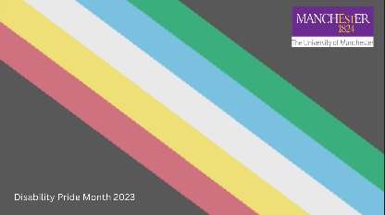
Throughout July we are marking Disability Pride Month.
Some events have already taken place in conjunction with this important celebration, but there are still things coming up and ways to contribute:
We’re attaching the Disability Pride backdrop which can be used for your video calls.
And also our colleagues at MMU have this event coming up this week: https://www.eventbrite.co.uk/e/the-ramblings-of-a-registered-blind-audhd-rhino-tickets-662288311167 [eventbrite.co.uk]
Some more events in the items below.

Blog Contribution


Do you know about our blog?:
https://uomequalityanddiversity.wordpress.com/data-stories/
We’re looking for contributions for August from you! What does it mean to you to be a member of a staff network group? We want opinions, long pieces, short pieces to be able to contribute to a piece for next month where we celebrate all our networks as part of our diversity calendar.
Please send your contributions to: Sami Karamalla-Gaiballa sami.karamalla-gaiballa@manchester.ac.uk

Disabilities Day of Development

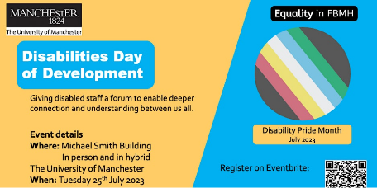
The School of Biological Sciences and School of Medical Science Equality, Diversity and Inclusion Committee teams have come together to present a Double Bill ‘Day of Development’ focused around garnering a deeper connection and understanding with disabled staff on Tuesday July 25th. Attendees will be able to attend one or the other, or even the full day, at their choice. This can be done in person, or in hybrid, with a luncheon for those attending in person.

Full details and tickets are available here: https://www.eventbrite.co.uk/e/disabilities-day-of-development-tickets-664455663777
This event is open to all. They are also looking for volunteers to perform short but highly valuable tasks to enable the day to run smoothly. Please get in touch with andrew.angus-whiteoak@manchester.ac.uk should you be interested in helping.

Wellbeing Focus Groups

We know how important wellbeing is. This is a committed priority that’s part of our People and Organisational Development (P&OD) Strategy and we want to further understand how we can ensure colleagues can thrive at work.
From next week, we’re running a series of wellbeing focus groups, where we’ll discuss what we can do in the future to help everyone feel good at work and feel good about their work. What you say will help us to develop our commitment to colleague wellbeing, across the University.
Each session lasts 1hour 30 minutes. Most focus groups are online, but we also have some face-to-face sessions. Ten spaces are available per session on a first-come, first-served basis. If you find you cannot reserve a space, that session may be full, so please try an alternative or get in touch with wellbeing@manchester.ac.uk.

We’re very keen to include people who represent the many different roles and levels in every Faculty and Directorate. All we ask is that you have your manager’s approval to attend.

Dates and times
Tuesday, 11 July - Roscoe Building, Training Room 1
- 9:30am - sign up to attend 11:30am - sign up to attend
Monday, 17 July - online sessions
- 11:30am - book your place 2:30pm - book your place
Tuesday, 18 July - online sessions
- 10:30am - book your place 2:30pm - book your place
Tuesday, 25 July - Roscoe Building, Training Room 1
- 10am - sign up to attend 2pm - sign up to attend

Neurodiversity ‘Flip the Script’ Event

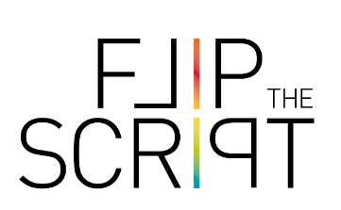
Cinzia Greco is looking for participants for lei Neurodiversity 'Flip the script' Event which aims to have short 'lived experience' stories from neurodivergent people about their work experiences and about what could be done to make the University work context more inclusive of neurodivergent needs than it is currently.

The event has been scheduled for July 25 at 2pm, in the Michael Smith Building and online (ticket information TBC).
This is an event promoted by EDI group of the School of Medical Sciences The idea is to have an event focused on how to make neurotypical space more accessible rather than on how neurodivergent people can adapt to neurotypical spaces.

Please contact Cinzia cinzia.greco@manchester.ac.uk for more information, or to participate in this event.

FSE Appeal


Our colleagues in Solids and Structures in SoE (FSE) are having their away day this coming Friday, the 14th of July. They have a slot 4-5pm that they would like to focus on EDI content.
Would any network group members be willing to talk about their experience of being in a network (ideally working in FSE, but not essential) and the benefits of being part of your network. It’s also the opportunity to talk about awareness raising events or other activities you may have been involved in.
The venue is Kimpton Clocktower Hotel, Manchester
Please contact Gwilym Jones gwilym.jones@manchester.ac.uk if you are able to help.

Jobtrain Improvements

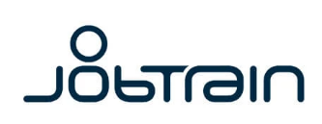
For anyone involved in recruitment, you’ll need to know about important changes and improvements being made to our recruitment system, JobTrain
Full details can be seen in this StaffNet Article:
- Get ready for improvements to Jobtrain, our online recruitment system | StaffNet | The University of Manchester

New Network


A reminder about a new network we’ve been approached to set up. The one question survey is open until 20th July to gather interest about a vegan network: https://www.qualtrics.manchester.ac.uk/jfe/form/SV_8AJAyAPgn8H0KFM

The Vegan Staff Network welcomes anyone interested in helping improve the lives of animals. Veganism is not just a diet, it is an ethical approach to life that informs every decision from pension investments to social justice issues. After decades of research it is increasingly clear that the treatment of animals affects how humans treat one another, such as links between meat and toxic masculinity to the neo-colonial imposition of animal-intensive diets on plant-centric cultures in the Global South. The Vegan Staff Network will be a place for discussion and initiatives around FoodOnCampus, introducing a Vegan-Friendly pension option, improving University curricula, and other ways to advance an intersectional agenda that includes veganism at its heart.

Other news and upcoming important dates:

International Non-binary Person’s Day 14th July: International Non-Binary Day
Muharram: 15-18 July: https://en.wikipedia.org/wiki/Muharram
Manchester Pride: August 25/26/27: www.pride.manchester.ac.uk
International Day for the Remembrance of the Slave Trade and its Abolition: 23rd August: https://www.unesco.org/en/days/slave-trade-remembrance

That’s all for July – as always – if you would like anything included here, please let us know: equalityanddiversity@manchester.ac.uk
And just a reminder that if you are on different LISTSERVs you will only receive this message once.

G.035, John Owens Building, The University of Manchester, Oxford Road, Manchester M13 9PL
Find out more about the team:
