

**Understanding your Programme Regulations**

A printable copy of your programme regulations can be found on this site by navigating to **Subject Area Information**

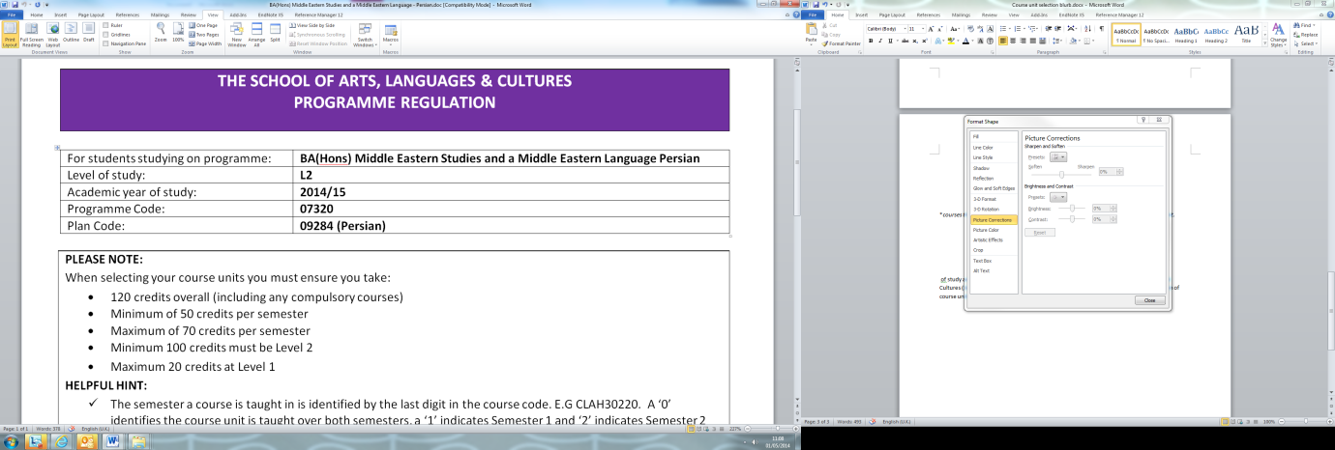

Check you are looking at the correct regulation for your programme, plan and level

Carefully read the guidance notes so you are aware of any restrictions

Each requirement of the regulation is outlined by separate numerical steps

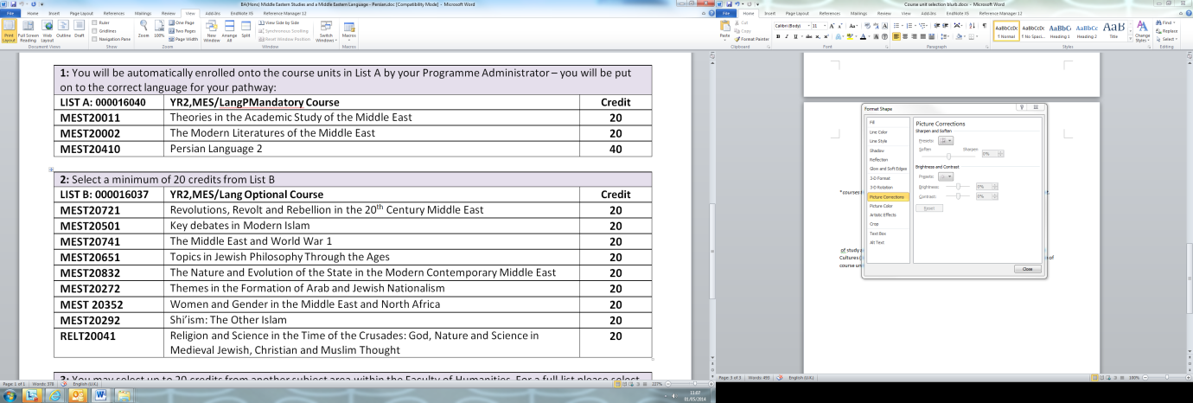

Each step details the amount of credits you can select from each course list

Navigate to your **My Manchester** portal to read course descriptions and to browse all courses

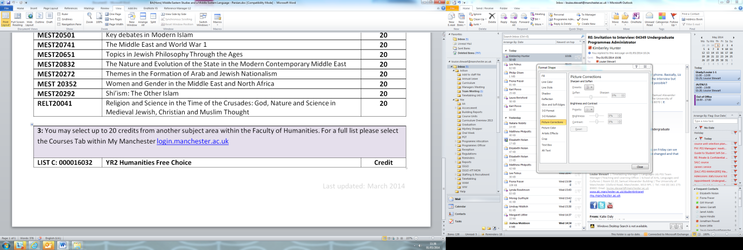

To read course descriptors please navigate to your **My Manchester** web portal and select **My Courses**