** STUDENT RECORD FORM**

**Please complete this form and bring it with you on Monday 21st September 2020. You will need it to collect your arrival pack.**

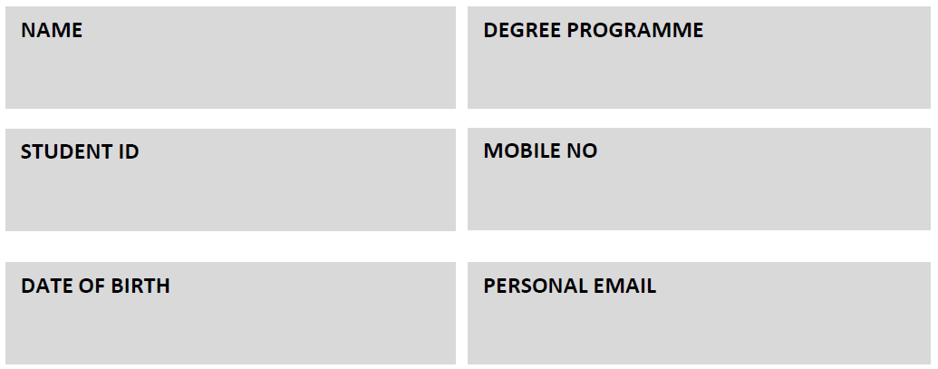

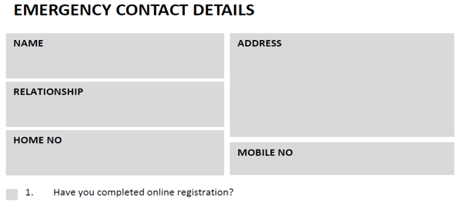

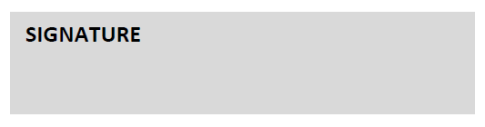**DECLARATION** I confirm that I have familiarised myself with the Online Undergraduate Handbook and will use this as my first source of information. I understand that photographs may be taken at AMBS events (such as the Welcome Week Party, student balls and graduation reception) and agree to the use of my image(s), in printed publicity or promotional literature produced by The University of Manchester, including leaflets, posters, newsletters and other display material; on The University of Manchester’s website and other social media sites, including Facebook, Twitter, Instagram and YouTube; and in any publicity material about our services sent to the news media.