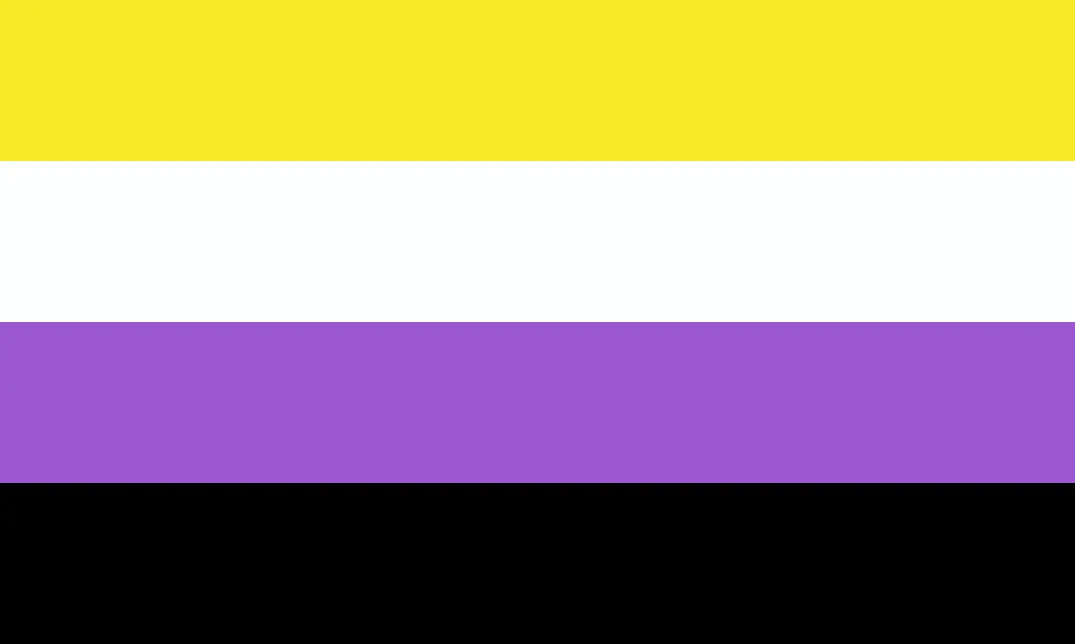

I‌nternational non-binary people's day has been celebrated on 14 July since 2012.  This date was chosen because it falls at the midpoint between International Women's Day (8 March) and International Men's Day (19 November).

**What does being ‘non-binary’ mean?**

Being ‘non-binary’, sometimes referred to as ‘enby’ is simply an umbrella term that includes all people who do not identify wholly as a ‘man’ or a ‘woman’ There are many ways to be non-binary including identifying as both a man and a woman, somewhere in between, or having no gender at all.

A few common non-binary identities are:  
**Agender** – either not having a gender or being gender neutral  
**Bi-gender** – having aspects of more than one gender, either at different times or at the same time  
**Gender-fluid** – having a gender identity that changes over time  
**Gender-queer** – this can be used as an umbrella term for non-binary identities or can be used as a gender identity itself

**Are Enbies legally recognised?**

While some countries, such as Australia, Germany, India, and Canada do recognise enbies there is no such legal recognition in the UK. When asked about recognition for non-binary people in the Gender Recognition Act a statement from the UK Government in May 2021 cited practical considerations as the reason for the continued requirement for people to identify as either a man or a woman:

“The Government noted that there were complex practical consequences for other areas of the law, service provision and public life if provision were to be made for non-binary gender recognition in the GRA.”

However these practical limitations have been overcome in some areas, for example in 2017 the Metropolitan Police issued two warrant cards to a bi-gender officer on their force.

**Is this a new concept?**

Being non-binary can be dismissed by some as a new fad, born from a western identity-obsessed culture - however non-binary people have been recognised and recorded round the world. In India non-binary people have been mentioned in Hindu texts dating back over 2000 years, and many cultures, such as some Native American peoples, Hawaiians, and Tahitians, have a history of inclusion of a third gender in their societies’ roles.

**What do Enbies look like?**

Being non-binary is a gender identity, i.e. a personal sense of gender, rather than any prescribed way of looking, acting, or being.  
Some enbies may choose to express their gender in ways not considered traditional for the gender they were assigned at birth, some may dress and act male or female at different times or act in a more gender-neutral way, but many also act in ways that seem to conform to the gender they have been assigned.

**Are Enbies transgender?**

This is a very difficult question to answer as often transgender is defined as being those people whose gender is not the same as the one they were assigned at birth – a definition that includes all enbies.

However not all enbies define themselves as trans, either because they are comfortable conforming to the norms for their assigned gender or, in the case of many agender people, they consider themselves neither transgender nor cis-gender.

**What pronouns do Enbies use?**

Many enbies use they/them pronouns but many also prefer other gender-neutral pronouns, are happy with gendered pronouns, or simply do not care what pronouns are used. As is the case with everyone if in doubt – ask.

**What can I do to support?**

* [update your pronouns](https://view.officeapps.live.com/op/view.aspx?src=https%3A%2F%2Fdocuments.manchester.ac.uk%2Fdisplay.aspx%3FDocID%3D71169&wdOrigin=BROWSELINK) on your signature and Microsoft Teams screen
* use a non-binary pride flag backdrop for your video calls on 14 July
* [become an ALLOUT Ally](https://www.staffnet.manchester.ac.uk/equality-diversity-inclusion/staff-networks/beeproud/become-an-ally/)
* Stonewall have a [useful article](https://www.stonewall.org.uk/news/10-ways-step-ally-non-binary-people#:~:text=14%20July%20is%20International%20Non,who%20identify%20as%20non%2Dbinary.) advising on how to be an ally.

**Useful links**

**Inclusive Language**[**https://documents.manchester.ac.uk/display.aspx?DocID=70856**](https://documents.manchester.ac.uk/display.aspx?DocID=70856)

**National Centre of Transgender Equality (U.S.)**[**https://transequality.org/issues/resources/understanding-non-binary-people-how-to-be-respectful-and-supportive**](https://transequality.org/issues/resources/understanding-non-binary-people-how-to-be-respectful-and-supportive)

**Wikipedia**[**https://en.wikipedia.org/wiki/Non-binary_gender**](https://en.wikipedia.org/wiki/Non-binary_gender)