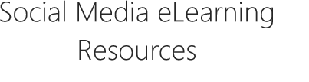
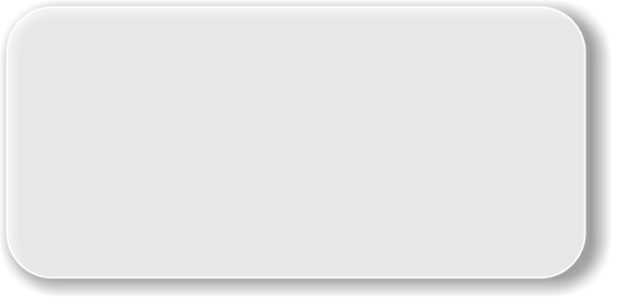



Module One Resources
University of Manchester social media team email address:
mailto: socialmedia@Manchester.ac.uk
University of Manchester social media intranet web page:
https://www.staffnet.manchester.ac.uk/communications-and-marketing/digital/social-media/
University of Manchester social media directory:
https://www.manchester.ac.uk/connect/social-media/
‘We are Social’ data reporting site, where you can find all the reports:
https://datareportal.com/

Module Two Resources
Profile and cover photo guidance:
https://documents.manchester.ac.uk/DocuInfo.aspx?DocID=48717
Verification of accounts:
https://help.twitter.com/en/managing-your-account/about-twitter-verified-accounts
https://help.instagram.com/369148866843923
https://www.facebook.com/business/help/2058515294227817?id=180505742745347
Social Media Naming Conventions
https://documents.manchester.ac.uk/DocuInfo.aspx?DocID=44158
Information about Twitter Verified Accounts
https://help.twitter.com/en/managing-your-account/about-twitter-verified-accounts
Social Media guidelines
https://www.staffnet.manchester.ac.uk/brand/visual-identity/guidelines/social-media/
Social Media Channel Request Form
https://forms.office.com/Pages/ResponsePage.aspx?id=B8tSwU5hu0qBivA1z6kadwDt38Xe2jlCjTO_rD3qabhUMUszWFFKOE8zS0FXRzZZSElKNkwxTDI0My4u
Social Media channel Audit Table
https://livemanchesterac.sharepoint.com/:w:/s/cmlt/smlt/EbEMlr9Oy3xJjYRnaSDzEs0BLmzocICn13pld86Yz4ibyg?e=Qdkuct
University of Manchester Twitter Account
https://twitter.com/OfficialUoM

Module Three Resources
University of Manchester Instagram Account
https://www.instagram.com/officialUoM/
Example of story video content from a student take over.
https://www.instagram.com/stories/highlights/18129793849169405/
Marcus Rashford Story
https://www.instagram.com/stories/highlights/17901788540323626/
Question and answer on dissertation tips Story
https://www.instagram.com/stories/highlights/17969423749486758/
Key information quickly Story
https://www.instagram.com/stories/highlights/17905908175834287/
Study away from campus Story
https://www.instagram.com/stories/highlights/17969423749486758/
Marcus Rashford Doctorate Story
https://twitter.com/OfficialUoM/status/1446173178263490575
Accessibility guidance
https://www.staffnet.manchester.ac.uk/communications-and-marketing/digital/web-accessibility/subtitles/
Academic researcher video
https://youtu.be/I5VnWXEFo94
Accessibility video
https://youtu.be/F0po-fdXkLo
COVID-19 Social Media Guidance Video -Toni
https://www.instagram.com/tv/CFkWZAwosnB/
The University of Manchester TikTok
https://www.tiktok.com/@officialuom/
Social Media Team Email
socialmedia@manchester.ac.uk.
Student TikTok Story 1
https://www.tiktok.com/@officialuom/video/7091378432868683014?is_copy_url=1&is_from_webapp=v1&lang=en
Student TikTok Story 2
https://www.tiktok.com/@officialuom/video/7080257880015834374?is_copy_url=1&is_from_webapp=v1&lang=en
Student TikTok Story 3
https://www.tiktok.com/@officialuom/video/7036360888114285829?is_copy_url=1&is_from_webapp=v1&lang=en
Image size guide
https://blog.hootsuite.com/social-media-image-sizes-guide/
Social media accessibility video
https://youtu.be/KDCkQ4d2J2M

IT Services [Adobe Creative Cloud]
https://www.applications.itservices.manchester.ac.uk/show_product.php?id=333
StaffNet subtitle guidance
https://www.staffnet.manchester.ac.uk/communications-and-marketing/digital/web-accessibility/subtitles/
Twitter Media Studio
https://twitter.com/i/flow/login?input_flow_data=%7B%22requested_variant%22%3A%22eyJyZWRpcmVjdF9hZnRlcl9sb2dpbiI6Imh0dHBzOi8vc3R1ZGlvLnR3aXR0ZXIuY29tIn0%3D%22%7D
Tweetdeck
https://tweetdeck.twitter.com/
Hootsuite
https://www.hootsuite.com/
Facebook Creator Studio
https://business.facebook.com/creatorstudio/home
Add Instagram to Facebook Creator Studio
https://www.facebook.com/business/help/1125825714110549?id=420299598837059
Awareness Days Calendar [Website]
Awareness Days Events Calendar - US, UK & International Awareness Days
Social media content video
https://youtu.be/pdBQctFFKgA

Module Four Resources
Facebook Business Suite
https://www.facebook.com/business/help/942827662903020?id=916550222172854
Instagram Insights
https://help.instagram.com/1533933820244654

Twitter Analytics
https://analytics.twitter.com
Furthering Your Development as a Social Media Practitioner
Social Media Micro Suite -updated guidance, best practice and FAQs
https://www.staffnet.manchester.ac.uk/communications-and-marketing/digital/social-media/
Tips for Academics – Promoting your research via social media
https://www.staffnet.manchester.ac.uk/promoting-your-research/promote-your-work/social-media/
Tips for Academics – Humanities research, communications support
https://www.staffnet.manchester.ac.uk/humanities/support-services/communications-and-marketing/who-we-are/research-communications/resources/
Monthly content pack - email us to be added to mailing list – submit content before last Wednesday of the month. The content pack gets shared with social media colleagues around the University and is an opportunity to share news on events and campaigns.
Introduce yourself to your local social media lead. You can find their contact details at the bottom of this webpage:
https://www.staffnet.manchester.ac.uk/communications-and-marketing/digital/social-media/
If you need design support, visit the design request booking form.
If looking to hire an external company to make content for you, look at our approved suppliers list.
If you need support with filming on campus, please contact Media Services.
External Training Opportunities
Google Analytics Academy - a qualification is available on completion
Facebook Blueprint
LinkedIn Learning - a LinkedIn qualification is available upon completion
Twitter training
Get started on Instagram for Business
Hootsuite academy - tips on how to use Hootsuite but also social media in general
Geekout newsletter for Social Media Managers - keep up to date with best practice

