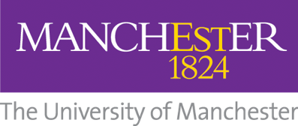

Guidance for Downloading Cadmus Assignments with Feedback:

IMPORTANT: Students can NOT currently download any Cadmus assignments with feedback

Please contact digitallearning@manchester.ac.uk to request this assignment with feedback.

NOTE: Please supply the Course Code and the name of the assignment in your request.

