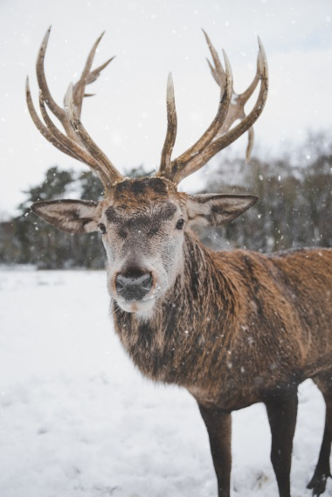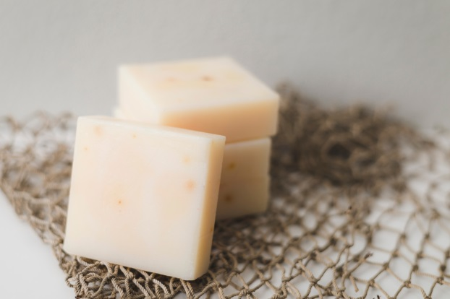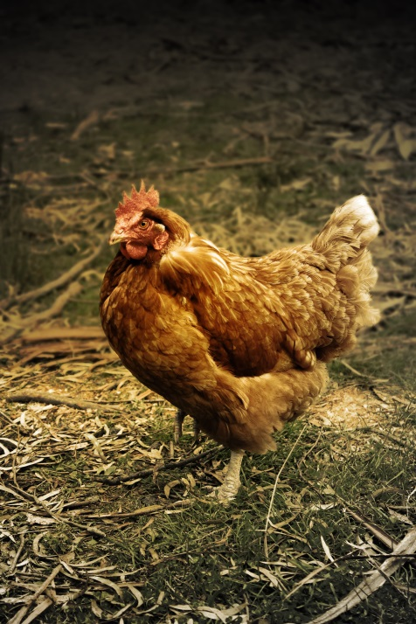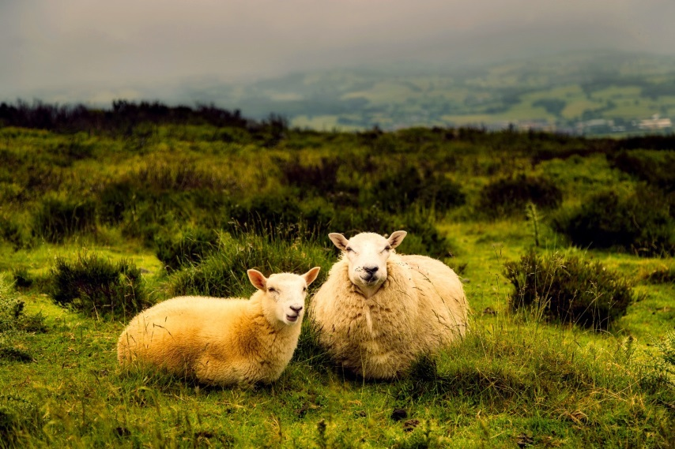

Red deer

Cheese

Chicken

Sheep

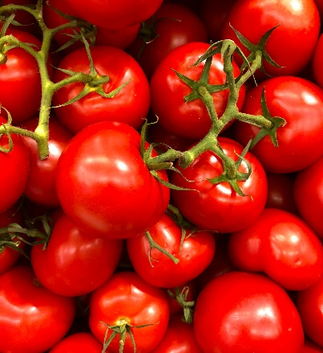

Potatoes

Tomatoes

Cereals

Cows

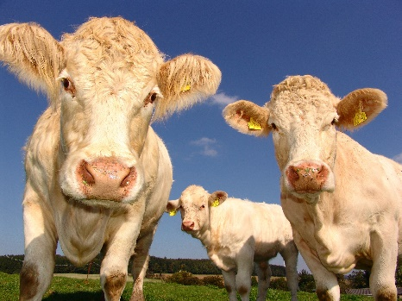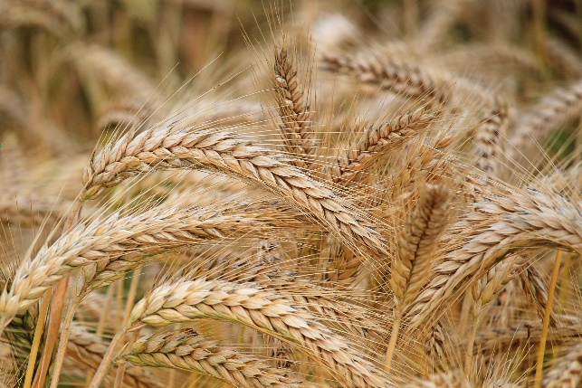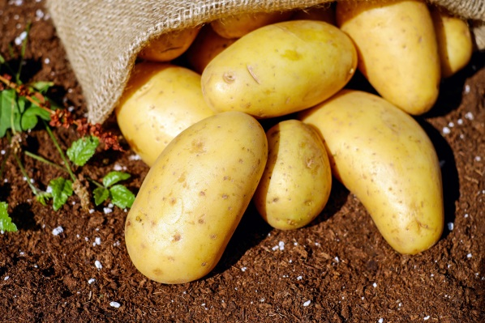

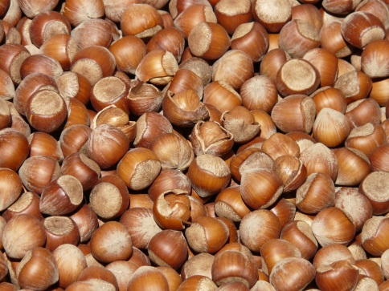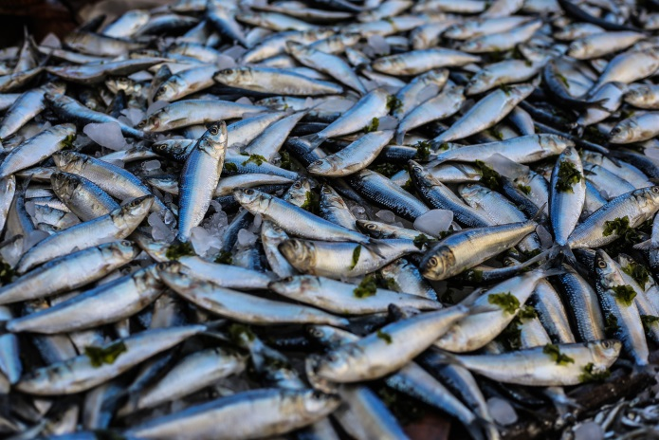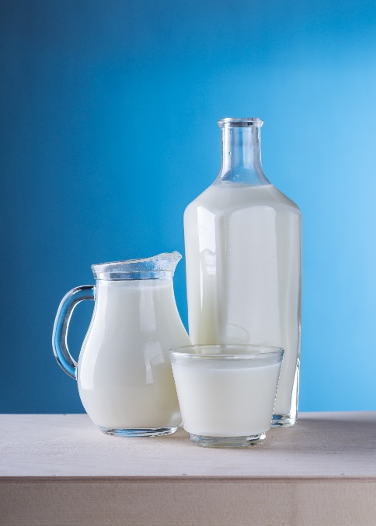

Hazelnuts

Fish

Milk

**Red Deer**

Maybe…

Red deer were living in the wild in the British Neolithic, and people did hunt them for food. However, people were not keeping them on farms.

**Cheese**

Yes!

Keeping sheep and cows meant people could use their milk to make cheese.

**Chicken**

No!

Chickens come from Asia originally, and were only brought to Britain in the Iron Age (about 2100 years ago).

**Sheep**

Yes!

As people started farming in the Neolithic, new animals were brought into Britain, including sheep, which people kept on their farms.

**Potatoes**

No!

Potatoes come from South America, and were only brought to Britain about 500 years ago.

**Tomatoes**

No!

Tomatoes come from South America, and were only brought to Britain about 500 years ago.

**Cereals**

Yes!

People started growing plants in fields for the first time in the Neolithic, and cereals like wheat and barley were really important foods.

**Cows**

Yes!

As people started farming in the Neolithic, new animals were brought into Britain. Cows were particularly important, especially at the start of the Neolithic.

**Hazelnuts**

Maybe…

Hazelnuts would be growing wild in the woodlands and forests in Neolithic Britain, and they would be important sources of food, but people were not growing them on their farms.

**Fish**

Maybe…

The lakes, rivers and seas in the Neolithic would have lots of wild fish in them, which people could catch. But, people were not keeping them, like we do on ‘fish farms’ today.

**Milk**

Yes!

Keeping sheep and cows in the Neolithic meant that people could drink their milk.